Importing Shapefiles using GeoRaptor
The GeoRaptor Plugin offers a solution for importing shapefiles into Biotics in SQL Developer. I have been using this to help me because still developing the skills for creating metadata and creating indices.
Access GeoRaptor through the menu bar under View or in your Connections by right clicking tables, scroll to GeoRaptor, click import shapefile

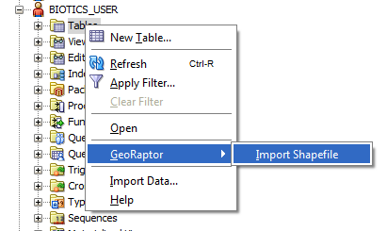

This brings up the shapefile loader. Here, you’ll want to 1) add the appropriate SRID (this needs to be the same as all the other shapes in your Biotics tables), 2) create a geometry column name, and 3) add the shapefile to the loader. Do not worry about checking create metadata or create spatial index. On every instance I check these boxes, I successfully upload the shape but the metadata and index fail.
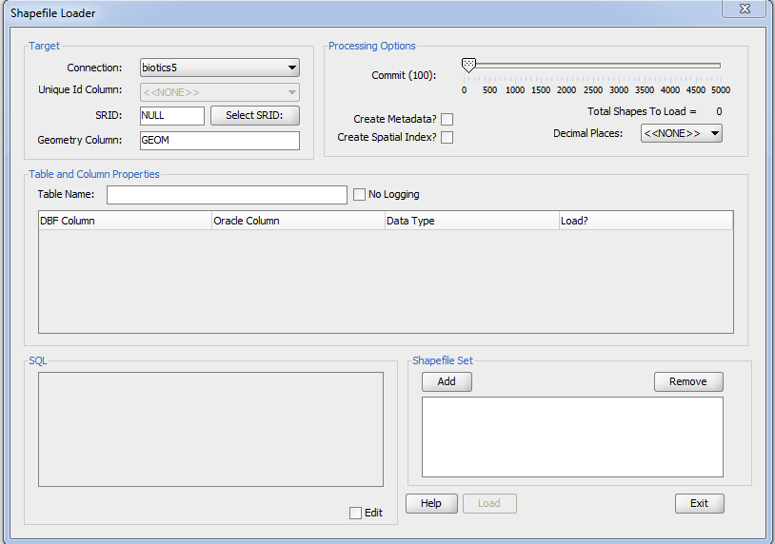

Press load and wait (this file took a few minutes).

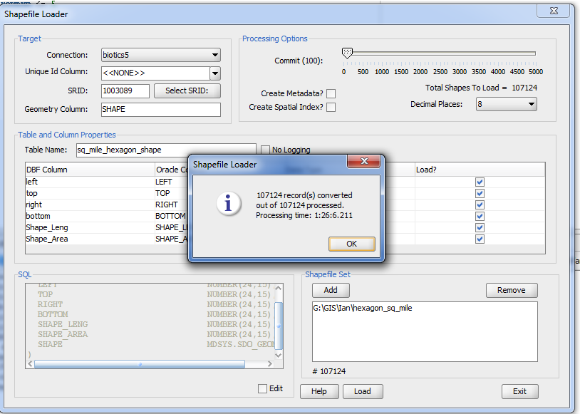

Click Ok and then exit the shapefile loader.

Note: GeoRaptor loaded your shapefile in the Connections, Biotics5 tables, which is not the biotics_user tables. Any queries with the newly uploaded shapefile will need to place biotics_dlink as a prefix to the table:
select biotics_dlink.sq_mile_hexagon_shape.* from biotics_dlink.sq_mile_hexagon_shape

Once the shapefile is loaded into Biotics in this (what I like to think of as a) temporary state, because you still have the capability of manipulating the shape whereas in BIOTICS_USER you have less privileges.

Now try a spatial join:
SELECT eo.eo_id, ky.shape FROM eo_shape eo, biotics_dlink.sq_mile_hexagon_shape ky WHERE sdo_relate (ky.shape, eo.shape, ‘mask=ANYINTERACT’) = ‘TRUE’
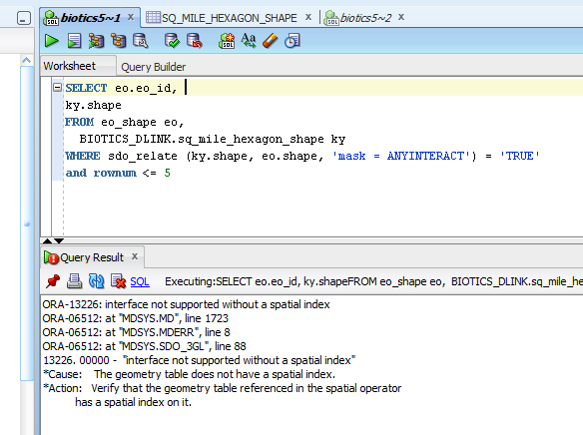

The query fails claiming no spatial index:

Right click your imported shapefile, GeoRaptor, Manage Metadata:

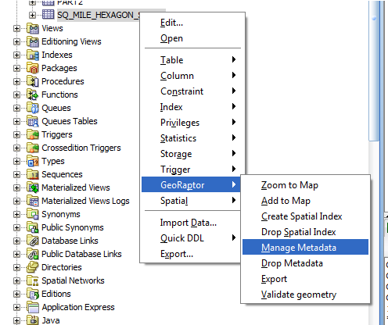

On the SDO_GEOM_METADATA window you will to reenter your SRID, Calulate Elements, Apply Changes, Close

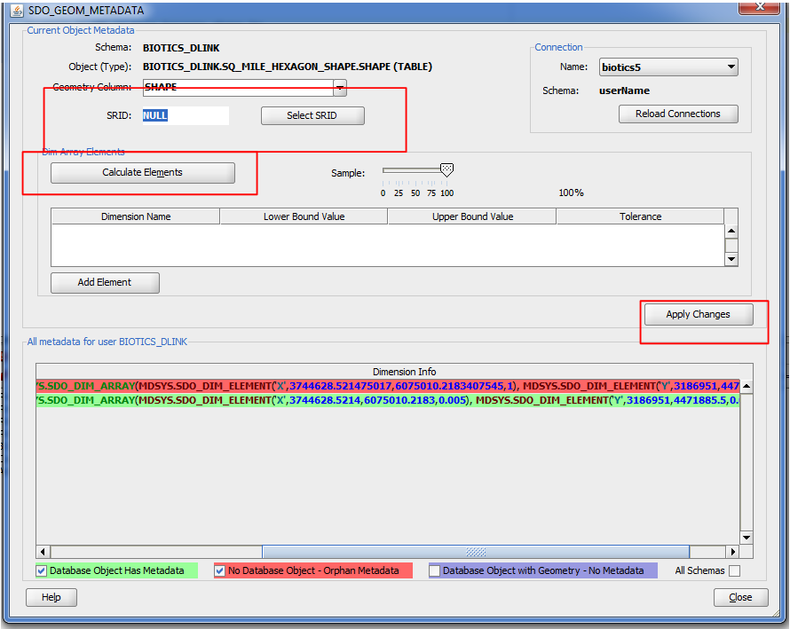

Now that metadata is created, it is necessary to create a spatial index for the shape.

Right click the table, GeoRaptor, Create Spatial Index:

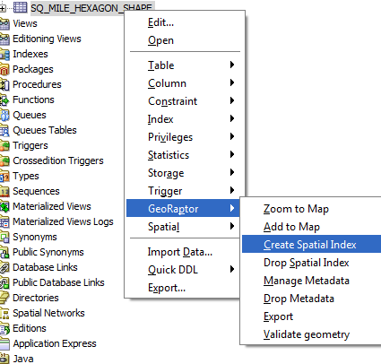

On the GeoRaptor Create Index window, make sure the column name is your geometry column (shape). Click Create Index, close.
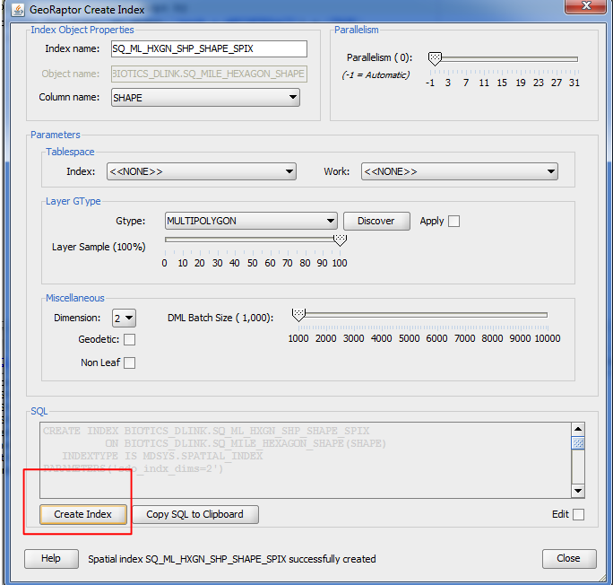

Try to run the Spatial Join again:

