Georaptor Plugin for SQL Developer
Ian Horn
ian.horn@ky.gov

GeoRaptor is a Spatial Viewer extension or plug-in for Oracle SQL Developer, similar to SQL Developer’s built-in spatial viewer, but with some added functions. The developer has maintained updates to GeoRaptor, but has not made the plug-in available for SQL Developer 4.X. Easy instructions for installing can also be found here: https://sites.google.com/site/mygeoraptor/installation

Requirements: SQL Developer 3.X with appropriate JDK (you can even use SQL developer on a Mac without all the Oracle Client setup).

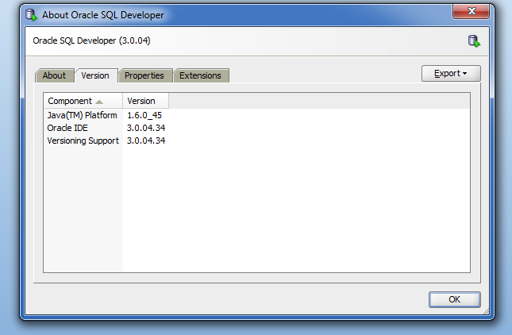

The simplest way to install GeoRaptor by checking for updates through the help menu:

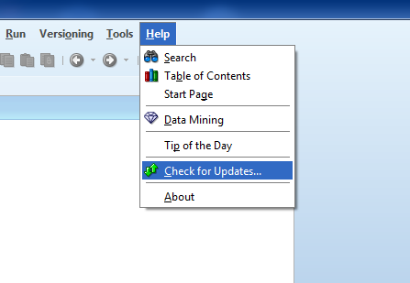

Click the Next button:
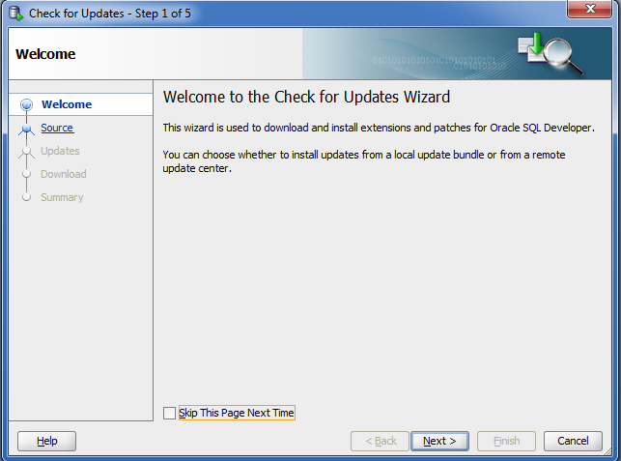

Click Add

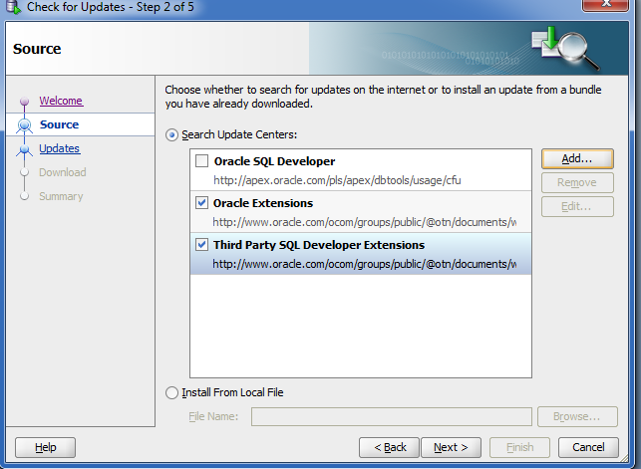

After clicking Add, type ‘GeoRaptor’ into name, and type (copy and paste) this http://georaptor.sourceforge.net/install.xml into location:

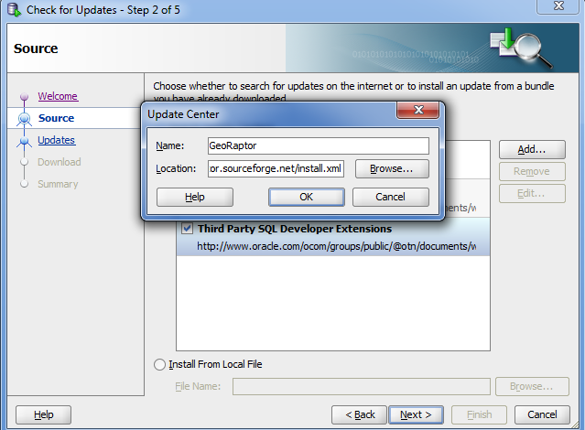

Click ok, and click Next until you ‘Finish’ and then manually restart SQL Devloper
You should now have GeoRaptor available the menu bar under View or by right clicking your tables:

