Display calculated rank status in Biotics
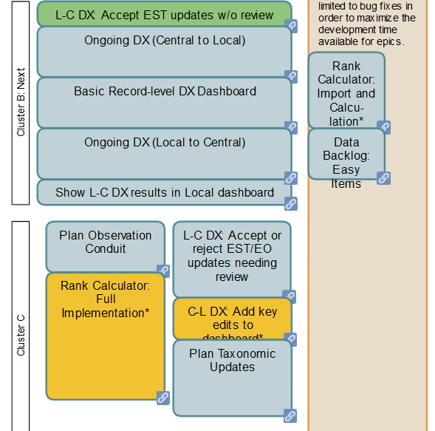
In the Biotics development roadmap, most of you agreed that it would be useful to implement certain aspects of rank automation prior to the much larger task of fully implementing the rank calculator in Biotics. These are specified in the "Rank Calculator: Import and Calculation" epic circled in the section of the roadmap at right. Note that the "Rank Calculator: Full Implementation" epic is later, at the bottom left in orange.
We are now preparing to implement the "Rank Calculator: Import and Calculation" epic, and we need your feedback on the "Calculation" piece. This is simply a calculation of rank based on the rank factor fields in Biotics. The same rank calculation logic that is in the rank calculator will be used, but no other functionality of the rank calculator will be replicated at this time.
The wireframes below show the proposed implementation in the Biotics User Interface at all three levels (in the Element G/N/S Ranking table). Please let us know what you think, and also answer these specific questions:
- Are you a regular user of the rank calculator?
- We decided that automatic recalculation when a rank factor value is updated is preferable to a “Calculate Rank” button. Do you agree?
- We thought the new “Date Calculated” field could be useful for things like checking to see if the Calculated Rank was updated without updating the Assigned Rank or Rank Review Date fields. But it could also be confusing and distract from the more important Rank Change and Rank Review Date fields. What’s your opinion?
- Is it too confusing to have 3 rank fields (Dynamically Calculated, Calculated, and Assigned)? Is there any way we could make it less confusing? (We do think it’s still useful to store in the database the Calculated Rank used to assign a rank, separate from a dynamic calculation which will change without full rank factor review.)
- Threats Calculator requirements have not yet been developed, but we do plan to add to Biotics the calculation of individual threat impacts in the threats grid and the calculation of overall threat impact are planned. The trigger for calculated overall threat impact will likely be with a button, but input about implementation of this is welcome now (or let us know if you would like to provide input when we have a mockup).
NOTE: this implementation does NOT replace the current workflow that is used with Excel Rank Calculator; rather, it provides an alternate work flow that can be used alone or in conjunction with the Excel Rank Calculator.

Mockup of changes to
Element Ranking Window, Conservation Status section
(global example, but will be the same at national and subnational levels)
"Rank Calculation" is a new Field Group (box).
Click to overwrite "Calculated Rank" field with Dynamically Calculated Rank value.

Biotics updates Dynamically Calculated Rank when rank factors are updated. Display only.

This field already exists. Value is saved to database when record is saved.

New field to track when "Calculated Rank" field was last updated.

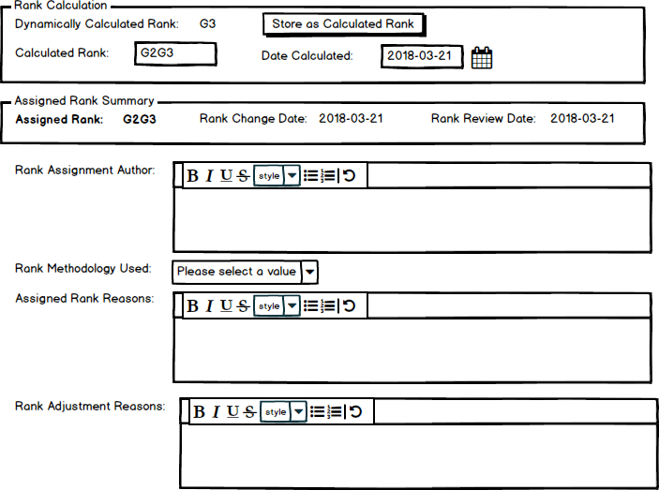

Rank change and review dates moved next to assigned rank and placed in box. These fields are only editable in the Tracking record.

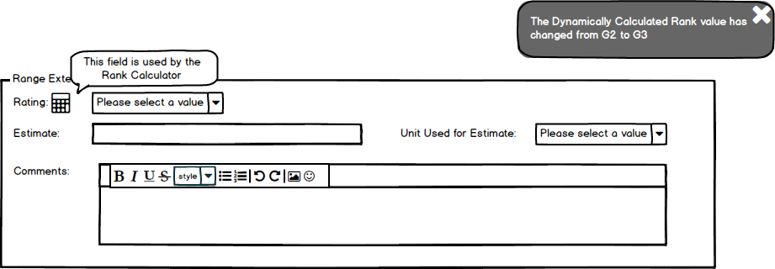
An icon (actual icon TBD) will be displayed next to the label for each field used by the rank calculator. When you hover over the icon, a tooltip will explain its meaning.

If the change to a status factor value results in a change to the Dynamically Calculated Rank, an informational message is displayed that summarizes the change. It will remain visible for 5 seconds, unless user opts to dismiss it sooner.

Mockup of changes to
Element Ranking Window for each field that contributes to calculated rank

