Using the survey dashboards
Welcome to the dashboard(s), which will allow users to view/edit/qc the results of the survey, collected in the field, via Survey123.
Filter the data displayed within the Survey summary (list) by applying one or more filters. By default, all data is displayed.
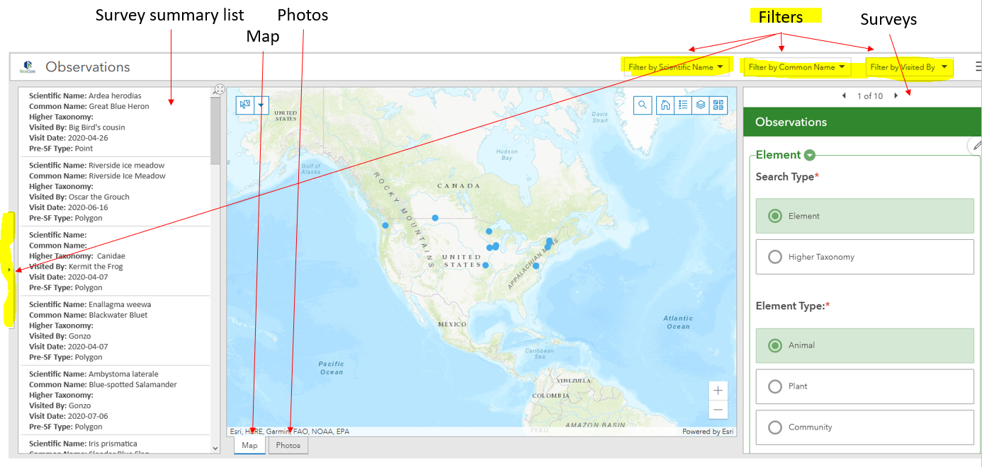
Select a record within the Survey summary list to view the Survey result, zoom to the record within the Map and display any Photos associated with the survey record.
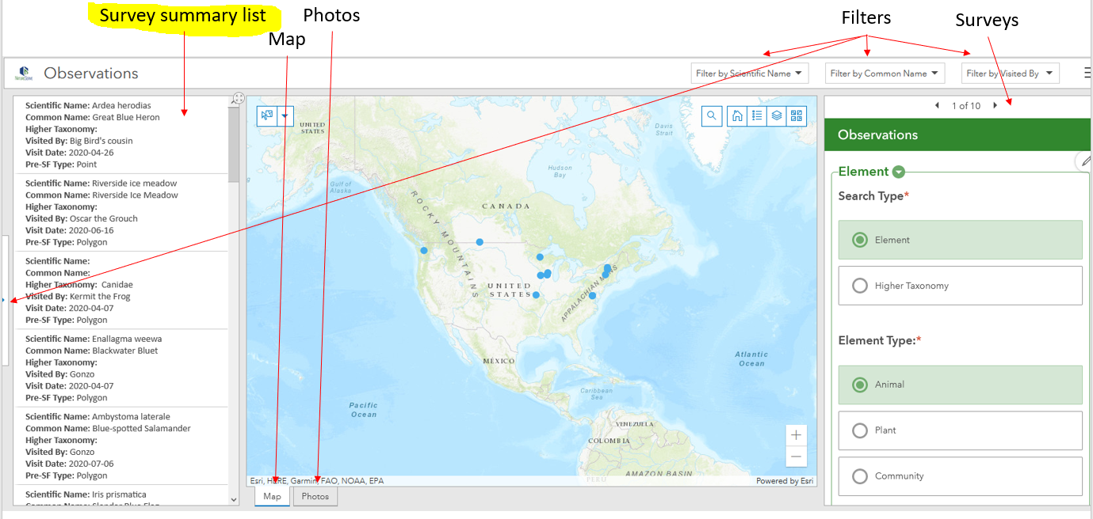
Use the various Map tools to:
- Find address or place
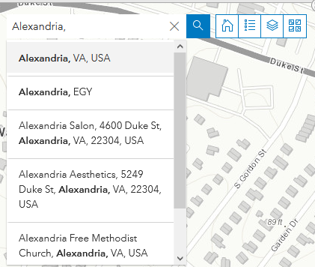
- Return to the original extent of the Map 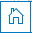
- View the legend 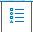
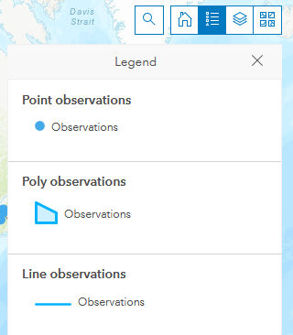
- Turn on /off layer visibility
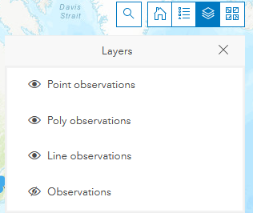
- Change the basemap
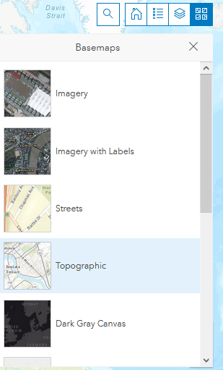
- Select records 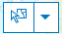 to zoom to the record’s location in the Map and filter the data within the Survey summary list to the selected record(s).
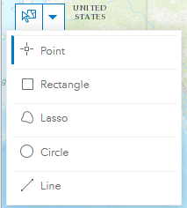
- Edit the survey 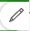 and then click Submit 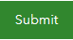 at the bottom of the survey.
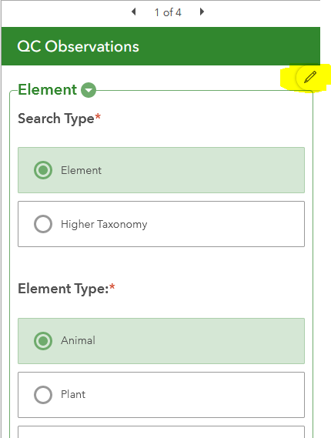
Within the QC dashboard, from the Batch edit tab, click the Batch Attribute Editor 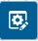 icon and the preferred selection tool. Select the records to edit and enter the desired values. Click Save to update the values for the selected features.
