Utilizing OGR to export spatial and tabular data via command line

The following information was provided by Greg Krakow, at Georgia Nongame Conservation Section. This document provides instructions regarding the installation and use of the free and open source GDAL utility, ogr2ogr, for exporting Biotics 5 data to ESRI shapefiles, geodatabases and tables for local use. The scripts can be placed in simple Windows batch (.bat) files to automatically run using Windows Scheduled Tasks.

NOTE: ogr2ogr does NOT support CLOB fields (i.e. eo_data, gen_desc,…) so in order to include a CLOB field, it must first be converted to a string. Following is an example utilizing EO_DATA:
dbms_lob.substr(EO.EO_DATA,255) as EO_DATA

And included in a select statement :
select eo_shape.shape, eo_shape.eo_id, dbms_lob.substr(EO.EO_DATA,255) as EO_DATA from eo_shape, eo where eo_shape.eo_id=eo.eo_id

Software Requirements:
- Oracle client
- GDAL

Installing OGR and other required software
- Download and install Windows binaries for GDAL and extensions for Oracle and ESRI file geodatabases.
  - Within an internet browser, go to https://www.gisinternals.com/release.php and select the Download of the latest release for your Windows version (32- or 64- bit)
  - Download the following 3 files from that webpage , noting that versions (numbers) will differ:
- gdal-xxxx-core.msi
- gdal-xxxx-filegdb.msi
- gdal-xxxx-oracle.msi
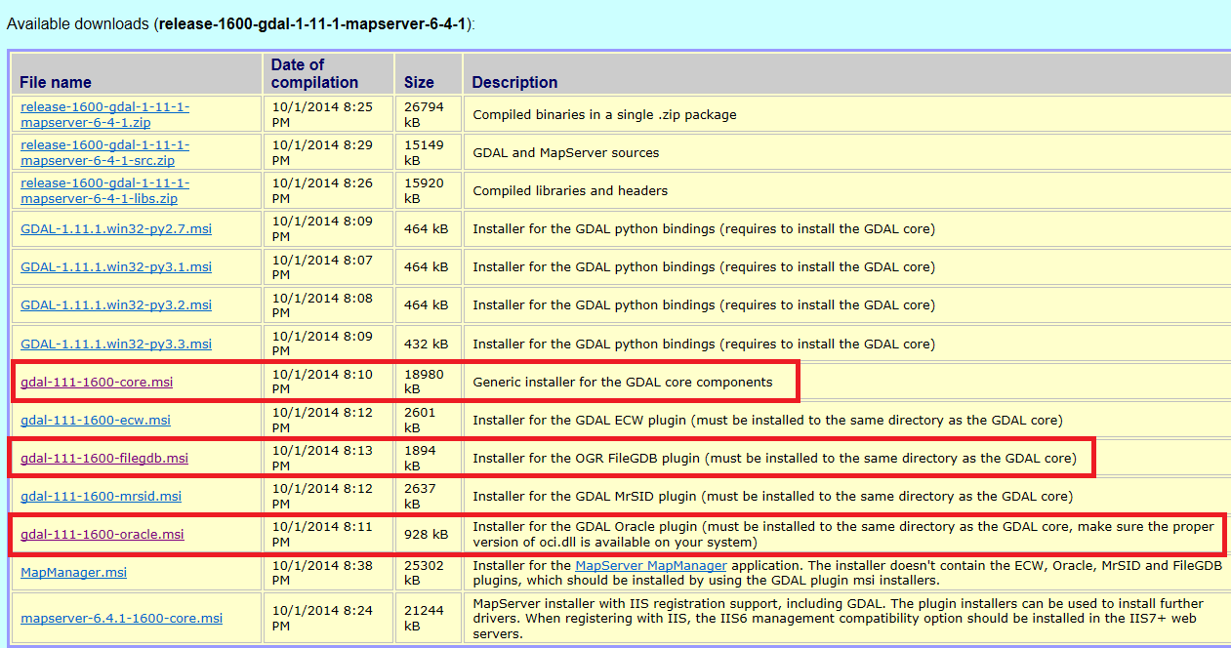
- Install the three 3 windows msi files:
- In Windows Explorer, double-click the gdal-xxxx-core.msi file.
- Check Accept license.
- Click on Typical Installation
- Click Install
- Repeat step 3 for the gdal-xxxx-filegdb.msi & gdal-xxxx-oracle.msi files.
- Add the GDAL path to the Windows PATH environmental variable and create a new environmental variable called GDAL_DATA.
  - From Windows Explorer right click on Computer and select Properties.
  - On the right side of the Computer properties window click on the Change settings.
  - Within the System Properties dialog, navigate to the Advanced tab, and click Environmental Variables.
  - Within the System variables section, select the Path variable and click the Edit button.
  - On the keyboard, click the End key to go to the end of the PATH string.
  - Add a semicolon at the end of the text string and then add the complete folder name where the org2ogr.exe is located. If you are using the 32 bit version It should be: C:\Program Files (x86)\GDAL. Click OK.
TIP: Navigate to GDAL in Windows Explorer and then right click on GDAL in the address bar at the top of the window and select Copy address as text to put the proper path into windows clipboard as text to paste into the Environmental Variable editing window.
  - Within the System variables section, click the New button.
    - Enter Variable name: GDAL_DATA
    - Enter Variable value: C:\Program Files (x86)\GDAL\gdal-data
  - Click OK, OK, OK to save the appended PATH variable and new GDAL_DATA variable to your Windows system.
- Test the setup:
  - Open a Windows Command Prompt window.
  - Within the Command Prompt window, type ogr2ogr and press Enter. You should see text displaying help for ogr2ogr displayed in the window.
  - If you get a message 'ogr2ogr' is not recognized as an internal or external command, operable program or batch file then something went wrong when you added the PATH variable. Check the Environmental Variables:
    - Within the Command Prompt, type: PATH and press Enter. You should see C:\Program Files (x86)\GDAL at the end of the path text string.
    - Within the Command Prompt, type: ECHO %GDAL_DATA% and press Enter. You should receive C:\Program Files (x86)\GDAL\gdal-data from the command prompt.
- Install the latest Oracle client, if not already installed. Users of Biotics that view/update Biotics 5 data in Crystal Reports, Access, SQL, SQLDeveloper, TORA, Toad, Excel, or other programs should already have this installed.

Utlizing OGR to export shapefiles and data from Biotics 5
Following are some useful examples; further information and export options can be found at http://www.gdal.org/ogr2ogr.html.
The following command line script exports the results of an Oracle Spatial SQL query of the entire EO_SHAPE table to:
- an ESRI Shapefile:
ogr2ogr -f "ESRI Shapefile" c:/temp/eo_shape.shp -lco SHPT=POLYGON OCI:biotics_report/password@biotics5:EO_SHAPE -a_srs EPSG:26918 –progress

Explanation of command line switches for the above:
- -f "ESRI Shapefile" c:/temp/eo_shape.shp: Create a file, c:/temp/eo_shape.shp, of format ESRI ShapeFile
- -lco SHPT=POLYGON: Convert 3D polygonz (XYZ) to 2D polygon (XY). Required for editing in some older programs like ArcView 3.x
- OCI:biotics_report/PASSWORD@biotics5:EO_SHAPE: Use OCI (Oracle Call Interface) to connect to Oracle database and return view, EO_SHAPE. NOTE: File name must be upper case. Several tables may be exported by separating the names with commas.-
- -a_srs EPSG:26918: Assign the projection to create a prj.*, projection file, by assigning it a spatial reference system. The spatial reference system should indicate that used within Biotics 5 as the state projection. To determine this, export a managed layer (EO, SF, MA, or Site) from Biotics 5 and view the shapefile Properties in ArcCatalog. Navigate to the XY Coordinate System tab in the Shapefile Properties dialog – the number is identified as the WKID (3089 in the screenshot below). NOTE: –t_srs srs_def: used to project to a different projection than the state projection used in Biotics 5.
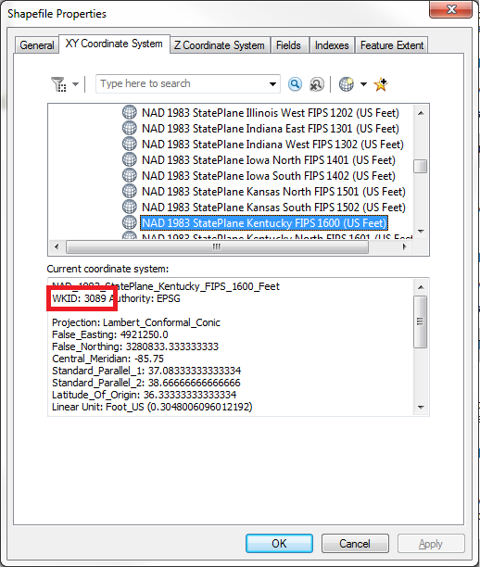
- -progress: show a progress bar.

- an ESRI ArcGIS 10.x Geodatabase:
ogr2ogr -update -overwrite -nlt multipolygon -nln eo_shape -f FileGDB c:/temp/test.gdb OCI:biotics_report/password@biotics5:EO_SHAPE -a_srs EPSG:26918 -progress

Explanation of command line switches for the above:
- update: Open existing output datasource in update mode rather than trying to create a new one
- overwrite: Delete the output layer and recreate it empty
- nlt type: Define the geometry type for the created layer. One of NONE, GEOMETRY, POINT, LINESTRING, POLYGON, GEOMETRYCOLLECTION, MULTIPOINT, MULTIPOLYGON or MULTILINESTRING. And CIRCULARSTRING, COMPOUNDCURVE, CURVEPOLYGON, MULTICURVE and MULTISURFACE for GDAL 2.0 non-linear geometry types. Add "25D" to the name to get 2.5D versions. Starting with GDAL 1.10, PROMOTE_TO_MULTI can be used to automatically promote layers that mix polygon or multipolygons to multipolygons, and layers that mix linestrings or multilinestrings to multilinestrings. Can be useful when converting shapefiles to PostGIS (and other target drivers) that implements strict checks for geometry type. Starting with GDAL 2.0, CONVERT_TO_LINEAR can be used to to convert non-linear geometries types into linear geometries by approximating them.
NOTE: To insure that spatial comparisons return the correct results, use the MULTIPOINT, MULTIPOLYGON, and MULTILINESTRING options rather than their singular counterparts or all features of a multi-part feature will not be selected unless using SELECT BY (i.e. versus INTERSECT). See BX-3353.
- nln name: Assign an alternate name to the new layer
- -f FileGDB c:/temp/test.gdb: Create a file, c:/temp/test.gdb, of format ESRI geodatabase
- OCI:biotics_report/PASSWORD@biotics5:EO_SHAPE: Use OCI (Oracle Call Interface) to connect to Oracle database and return view, EO_SHAPE. NOTE: File name must be upper case. Several tables may be exported by separating the names with commas.-
- -a_srs EPSG:26918: Assign the projection to create a prj.*, projection file, by assigning it a spatial reference system. The spatial reference system should indicate that used within Biotics 5 as the state projection. If your system utilizes a custom projection, contact NatureServe for this number. NOTE: –t_srs srs_def: should be used to project to a different projection than the state projection used in Biotics 5.
- -progress: show a progress bar.

The following exports the same thing but utilizes an SQL statement – this allows the user to utilize a WHERE clause or more complex query:
ogr2ogr -f "ESRI Shapefile" c:/temp/eo_shape.shp -lco SHPT=POLYGON OCI:biotics_report/password@biotics5 -sql "select * from eo_shape" -a_srs EPSG:26918 -progress
Explanation of command line switches for the above:
- -sql "select * from eo_shape": Use an Oracle SQL select statement to create data table for export from database. For testing add “where rownum < 5” to sql statement.

You can also use ogr2ogr to export non spatial tables from Oracle (dbf, sqlite, csv and many more). The exported table can then be joined to the exported shapefile/geodatabase. The following exports a csv table that opens in Excel, Access and many other spreadsheets and databases – the first statement exports the entire table, the second does as well, but utilizes a SQL statement to define the outgoing data.
ogr2ogr -f CSV c:\temp\tableName.csv OCI:biotics_report/password@biotics5:EO_VIEW_ALL_ATT -progress

ogr2ogr -f CSV c:\temp\sqlSelect.csv OCI:biotics_report/password@biotics5 -sql "select * from EO_VIEW_STD_ATT" -PROGRESS
ERRORs similar to the following can be ignored. The script seems to run correctly in spite of these.
ERROR 1: ORA-04043: object AA_EO does not exist in OCIDescribeAny
Alternatively, export to a shapefile utilizing a SQL select statement which queries the EO_SHAPE table as well as the EO_VIEW_ALL_ATT_MAP view to get a shapefile containing the desired data already joined to the shapes selected. This example replicates the Mapper function “Export Spatial Data” with “Element Occurrences”.
ogr2ogr -f "ESRI Shapefile" c:/temp/ eo_shape_join.shp -lco SHPT=POLYGON OCI:biotics_report/password@biotics5 -sql "select eo_shape.shape, eo_view_all_att_map.* from eo_shape, eo_view_all_att_map where eo_shape.eo_id=eo_view_all_att_map.eo_id" -a_srs EPSG:26918 -progress

To create a Windows batch (*.BAT) file just create a text file with the ogr2ogr command in the file. You may want to delete some files first before ogr2ogr runs. Place the following batch file text in a text file and save it with a *.bat extension. You can then have the user double click on it to execute and extract data as needed from Biotics5. Alternaticely, set Windows Task Scheduler to execute the batch file in the middle of the night to help reduce bandwidth usage during working hours and save staff time for when they may need the output.
::::::::::: START OF BATCH FILE ::::::::::::::::::::
REM batch file lines starting with REM or :: at the beginning are not executed
REM Delete all csv files from c:\tmp2
del c:\tmp2\del *.csv
REM Extract AA_ES and AA_EO views from Bioitcs5 as comma delimited CSV files and place in C:\tmp2
ogr2ogr -update -overwrite -f CSV c:\tmp2 OCI:biotics_report/PASSWORD@biotics5:AA_ES,AA_EO -nlt NONE -lco SEPARATOR=TAB –progress
::::::::::::: END OF BATCH FILE :::::::::::::::::::::

Sample batch file for exporting shapefiles:
::::::::::: START OF BATCH FILE ::::::::::::::::::::
REM Delete eo_del.shp shapefile and all of its parts from c:\tmp
del c:\tmp\eo_del.*
REM Export the AA_EO_DEL spatial view from Biotics5 into a 2D shapefile named eo_del.shp that
REM has a projection file for UTM Zone 17N NAD83 (EPSG:26917) and that will load into ArcView 3.3.
ogr2ogr -f "ESRI Shapefile" c:/tmp/eo_del.shp -lco SHPT=POLYGON OCI:biotics_report/PASSWORD@biotics5 -sql "select * from aa_eo_del where rownum < 10" -a_srs EPSG:26917 -progress
::::::::::::: END OF BATCH FILE :::::::::::::::::::::

Troubleshooting
Encountered a set of issues here after installing latest GDAL, among the errors I got:
ERROR 1: PROJ: proj_as_wkt: Cannot find proj.db
ERROR 1: PROJ: proj_create_from_wkt: Cannot find proj.db
Fixed these by adding an additional system environment variable: PROJ_LIB and setting it to C:\Program Files (x86)\GDAL\projlib, which is where GDAL's projection database is located.
Information provided by Chris Fontenot.

