Collect Data via Survey123
Contents
Install the Survey123 field app 1
Collect Data 1
Location 1
Sketch 2
Vertex 2
Copy a collection and edit it (if there are two elements in the same location): 4
Copy 5
Favorite answers 6
Retrieve collections from a previous session 7
Edit existing data 9

Install the Survey123 field app
According to Esri documentation:
- Click the survey link or take a picture of the QR code, provided as instructed in the Share the survey for data collection section
- Follow the prompt to download and install the Survey123 field app.
- After installation, the Observation survey should open automatically.

Collect Data
Once the user follows the instructions above regarding installation, the Observations survey will automatically be listed within My Surveys in the Survey123 field app for subsequent use.
- Within the Survey123 for ArcGIS app, click the Observations survey.
- Within the Observations survey, click Collect to start entering data.
NOTE: Voice to text works within the Survey123 mobile app. Just click the microphone button (or appropriate for your device) and talk!
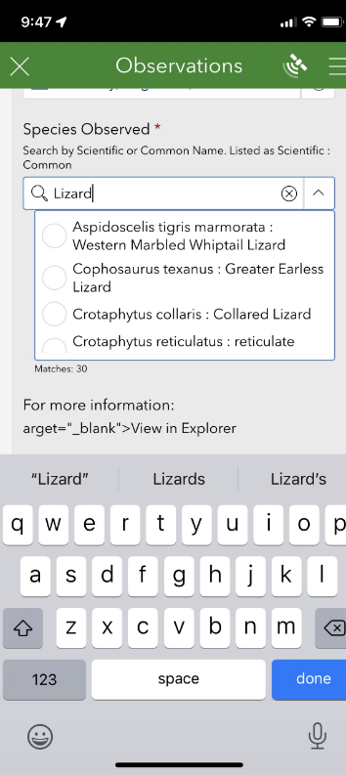

Location
Based on the Conceptual Feature Type and Locational Uncertainty Type entered, the Location of Element will either be defined by a Point, Line or Polygon, according to the Spatial Feature Development Summary.
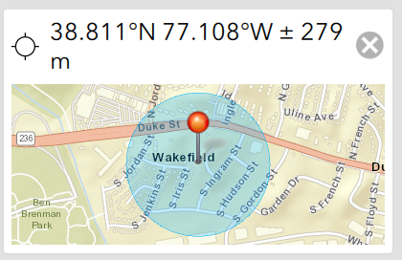

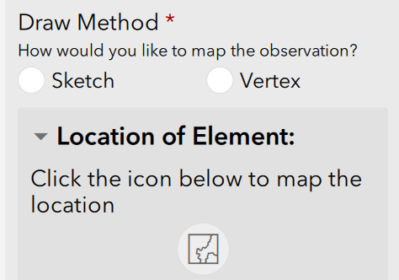
Line and polygon features have the option to draw the location via Sketch (free-form digitize) or Vertex.

Sketch
The Sketch method is used to capture the geometry in a single motion, with the capture completing once the user has stopped drawing this single line. To begin capturing Sketch geometry, tap the Sketch button in the lower left of the map page and tap the map. When you have finished sketching the geometry, stop tapping the map. The geometry is then complete, with the geoshape connecting the beginning and end of the shape if necessary. The length of a geotrace, or the area and perimeter for a geoshape, is displayed below the map.
The Sketch method also provides a smart shape option, which attempts to simplify your sketched geometry into an ellipse, rectangle, or triangle. To use smart sketching, tap the Smart Shape button in the lower left corner of the map page, and tap the map to begin sketching. If your sketch is recognizable as an ellipse, rectangle, or triangle, the app automatically converts it. If your sketch doesn't resemble one of these shapes, no geometry is drawn.

Vertex
The Vertex method allows more precise geometric capture of a line or shape by streaming and/or placing vertices that connect together. To begin capturing Vertex geometry, tap the Vertex button in the lower left of the map page and tap the map to place your first vertex or the Follow button to begin streaming. While streaming, line or area vertices are captured at a nominated minimum distance interval as you move around. The default minimum distance interval is 10 meters, but this can be changed by the survey author. For more information, see Capture methods.
More vertices can be placed manually by tapping the map again or tapping the Capture Vertex at Location button to place a vertex at your device's location (this enables you to map an area or transect as you walk). To move the map instead of placing vertices, tap the Pan and Zoom button to change map interactions to navigation mode. You can then capture a vertex at the map's central point with the Capture Vertex at Crosshair button . If at any point you place a vertex at the wrong position, tap the Undo button in the lower right to remove the last vertex placed, drag the point to move it to a new location, or drag the point to the Delete button that appears in the upper left of the map window.
When you're done, you can tap the Confirm button to accept this geometry and move back to your survey.
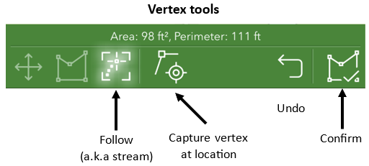
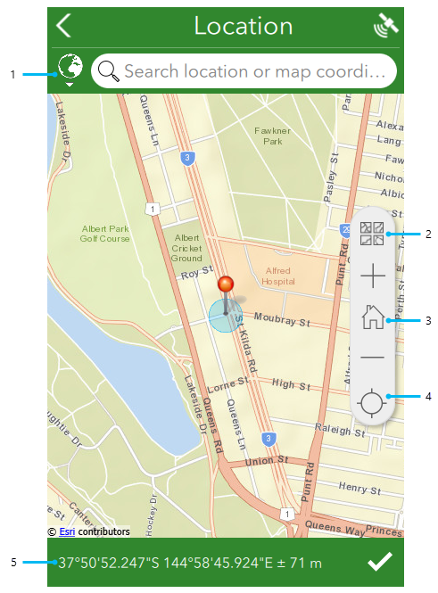
Sketch tools
Sketch
Undo
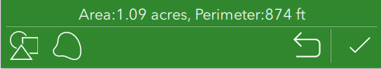
Smart shape
Confirm

According to the Quick reference, callouts in the image above are detailed as follows:
- The geosearch bar allows you to locate an address or point of interest by searching for it, before snapping your geopoint and map to that location. The globe icon next to the search bar provides options to limit the extent of the geosearch capability, and to change the geocoder being used. For more information, see Geosearch and geocode.
- The Basemap button provides a number of alternative basemaps to the default, for a range of different purposes. This is also where any directly associated basemaps can be selected.
NOTE: Should you require basemaps for offline use, see the Prepare basemaps for offline use and Use offline basemaps topics.
- Home returns the map marker to where the survey creator has defined a home location. If no home location has been defined, it instead returns the marker to the user's location.
- The Location icon is first displayed in black, indicating the location sensor is disabled. Select the button to switch to Navigation mode , enabling Location and tracking the device's current location. Moving the map marker from here, either directly on the map or by changing the coordinates, changes the location and coordinates of the answer, but the device's location remains visible as a pulsing blue dot while doing so. When this happens, the button switches to an Active Location icon ; select it to return to Navigation .
- The coordinates of your current location are listed here, using the coordinate format that has been set for that survey in Survey123 Connect. Pressing the area copies the location coordinates into the geosearch bar, allowing you to define a different location. Altitude is also included here if it has been enabled for the question. For more information, see Geopoints. In addition, pressing and holding these coordinates will perform a reverse geocode to give you the location, placed above the coordinates. As with the coordinates, pressing the location will copy it into the geosearch bar.

Copy a collection and edit it (if there are two elements in the same location):
There are two ways to copy data from a single collection to replicate it in subsequent collections, to minimize data entry.
- Copy
- Favorite answers

Copy
The following functionality is only feasible if, within Survey123 Connect, the Enable Sent folder option is indicated prior to publishing.
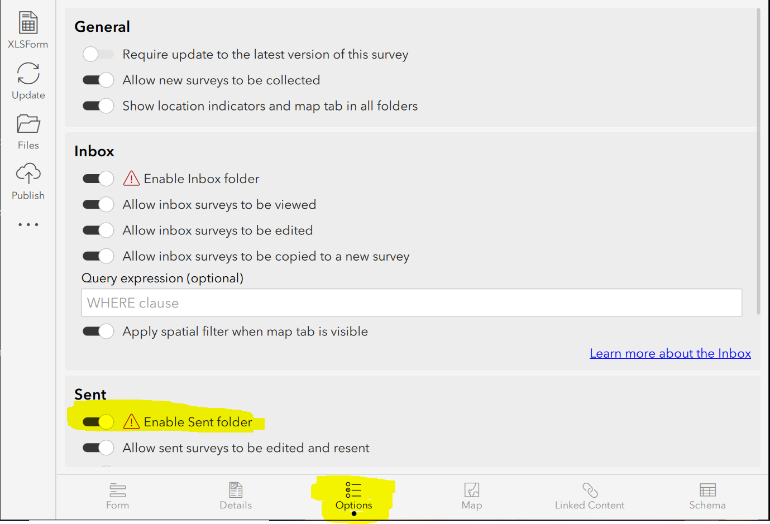
- After having sent in the original collection, go to the Sent section
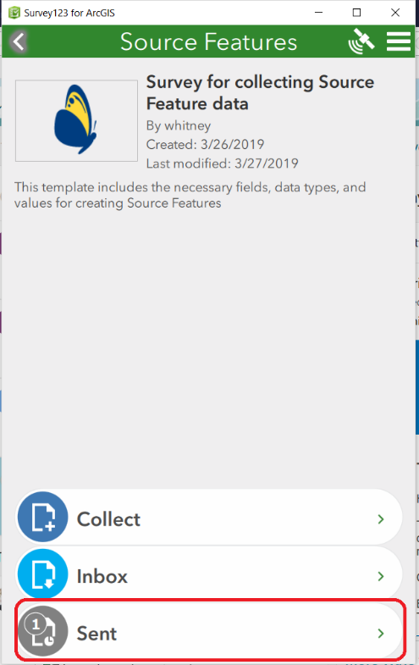
- Select the data collected via the List or Map and click Copy the sent data to a new survey.
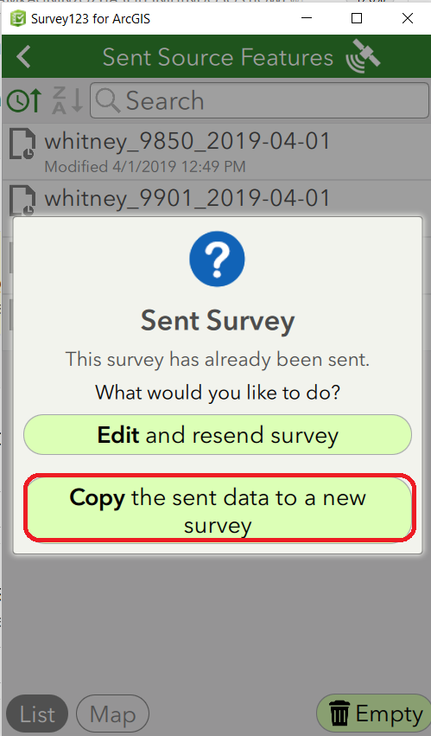
  - Edit the data for the second collection.
  - Repeat as necessary!

Favorite answers
Favorite answers facilitate entering repetitive information in subsequent surveys. NOTE: Favorite answers do not include the location information.
- Complete a survey response with your preferred answers.
- Before submitting the response, using the menu in the upper right corner, choose Set as favorite answers to set the current state of your survey to act as your favorite answers. The saved survey is now marked with a star icon in the Sent list.
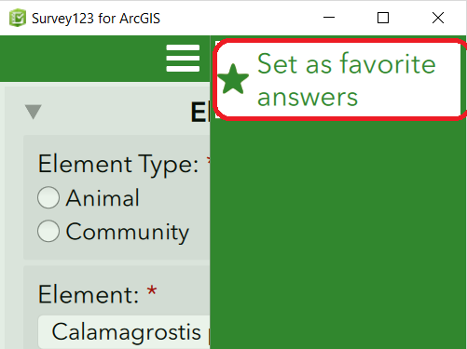
- Once you've set your favorite answers, the Paste answers from favorite menu becomes available. Select it to enter your favorite answers into your new survey.
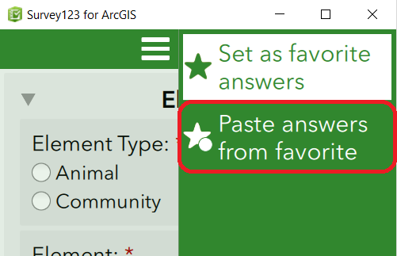
- To change your favorite answers, enter changes into your current survey and click Set as favorite answers.

Retrieve collections from a previous session
The following functionality is only feasible if, within Survey123 Connect, the Inbox mode setting is set to Enabled – The Inbox folder will be available for this survey, prior to publishing. The data available within the Inbox (for example, data collected on another day or by another user) is defined by the Where, if specified.
- From the Inbox
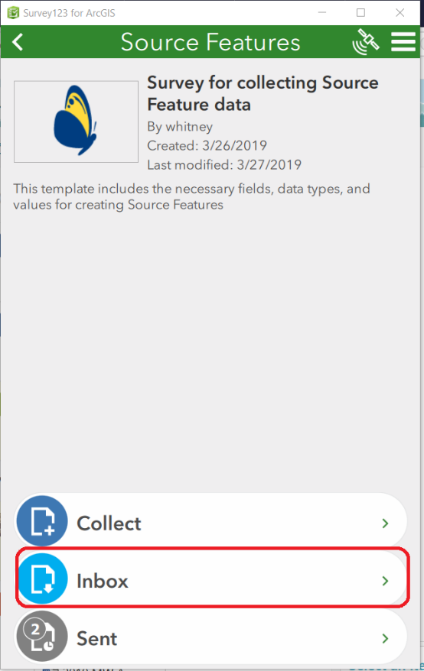
  - Click Refresh
  - Select the desired collection via the List or Map view
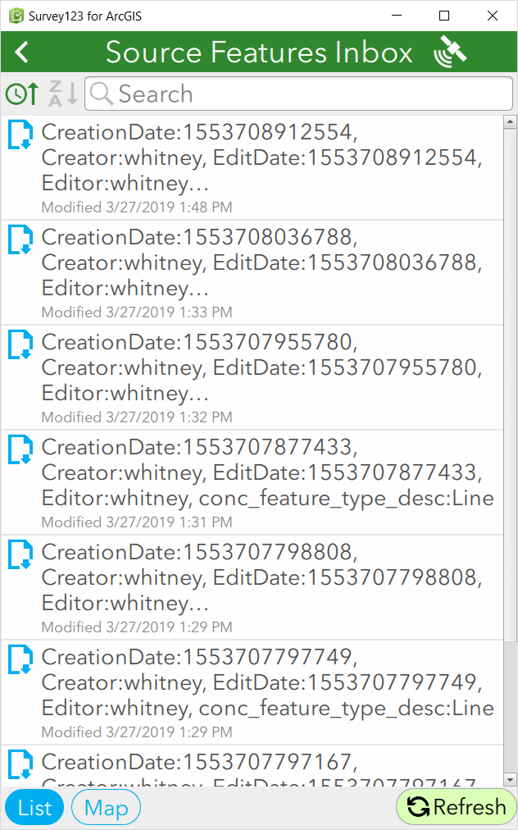
  - Edit as desired.

Edit existing data
Again, whether data within the Sent and Inbox are available are determined by the Settings defined in the Inbox and Sent Surveys settings in Survey123 Connect.
- Select Outbox (if not Sent), Sent (if already Sent), as shown below, or Inbox (if sent in a previous session):
- Select the data collected, via the List or Map, and click Edit and resend survey.
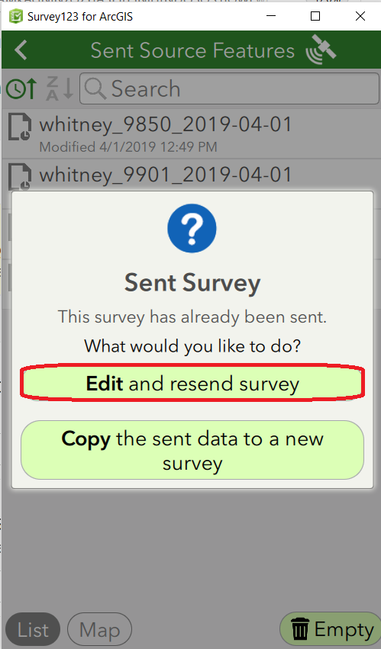
- Edit the data as desired.

