Observations survey (v1.4) in Survey123
This Observations survey is based on the Biological Observation Data Standard. Additional information regarding the standard can be found here.
Contents
Privileges necessary to publish your own survey 4
Request from the Tennesse Division of Natural Areas 4
Create, Configure & Publish the Observations Survey 5
Create the Survey 5
Configure the Survey Settings 5
Publish the Survey 10
Add csv files to ArcGIS.com and link them to the survey 12
Create Offline Basemaps 16
Share the Survey for Data Collection 16
Data Collection 19
Install the Survey123 field app 19
Collect Data 20
Location 21
Use offline basemaps 23
Download a linked map package in the Survey123 field app 23
Use a map package in the Survey123 field app 25
Copy a collection and edit it (if there are two elements in the same location): 27
Copy 27
Favorite answers 29
Retrieve collections from a previous session 29
Edit existing data 31
Update Survey and Republish 33
Update the files in ArcGIS Online 36
Changes to survey questions 37
Creating the Dashboard* 40
Determine the id of the Survey Form* 41
In ArcGIS Online 41
In ArcGIS Survey123 42
Edit the Observations Web Map* 42
Create the Dashboard* 48
Create a List of Observations* 50
Add the Photos/Audio Recordings* 54
Add the Survey* 57
Add a Header* 59
Configure Actions of Survey summary list to include new elements* 62
Configure Actions of Map to Filter new elements* 64
Configure the dashboard* 65
Create additional versions of the Dashboard for QC or Review only purposes (OPTIONAL)* 69
Create a view only version of the dashboard (OPTIONAL)* 69
Create a QC version of the dashboard (OPTIONAL)* 70
Include Batch Edit tool in Dashboard* (OPTIONAL) 81
Create a Web App to allow for batch editing of survey responses* 81
Embed the Web Mapping Application in the Dashboard* 89
Create dropdown List for QC fields* 91
Using the dashboard 94
Viewing, Downloading & Using data collected via Survey (OPTIONAL) 98
View & Download data in ArcGIS Survey123 99
Publish the Observations survey results as a web map (OPTIONAL)* 101
Save a (single) photo or audio attachment from an Observation record (OPTIONAL) 102
Install and Run the Observations for Non-Biotics toolbox 102
Troubleshooting Guide 111

BEFORE PROCEEDING:
Download & unzip the zip file attached to the Observations survey in Survey123 – from creating survey to Bulk Create solution. This will create an Observations_v1_4 subfolder containing all the necessary files. Note where you have unzipped the file as all files referenced in the following document are found within this zip file.

Privileges necessary to publish your own survey
Although NatureServe developed the Observation survey and process to bulk create the data collected in Survey123 into Biotics, the survey will be published within your own organization’s ArcGIS Online account. This ensures you have ownership of the data and full control of permissions, downloading, etc.
NatureServe can clone the survey and related materials (Maps, Dashboards, Apps) to your ArcGIS Online account, significantly minimizing time and effort on your part. See the What's involved: NatureServe cloning data from NS AGOL to member AGOL solution for details. The sections asterisked (*) below indicate the work which is eliminated by the cloning.
If, on the other hand, your organization will not allow NatureServe to clone the materials for you, following is information regarding the specific privileges (or role) necessary for an AGOL user to publish a survey, according to the Survey123 FAQ:
What ArcGIS role do I need to have to use Survey123?
To publish a survey, the minimum privileges required are as follows:
- Create content
- Publish hosted web layers
- Share maps and apps
Typically, this would be a Publisher role, but you can also create a custom role in your organization that contains only these privileges.

Request from the Tennesse Division of Natural Areas
Contact Dillon Blankenship or someone else at the Tennesse Division of Natural Areas and request that they provide you with the species.csv, higher_classification.csv, and location_use_class.csv files by running the queries provided within the Observations_v1_4.zip file, according to the instructions below.
- In Biotics Query Builder, run the species.sql query and export as species.csv. The survey requires this name.
- In Biotics Query Builder, run the Higher_Classification.sql query and export as higher_classification.csv. The survey requires this name.
- Edit the Location_Use_Class.sql:
  - CTRL+H to replace the subnation_id in two places within the query from 41 to your SUBNATION_ID, as found in the SUBNATION table.
  - Copy and paste the updated query into Query Builder and run the query.
  - Export as location_use_class.csv. The survey requires this name.

Create, Configure & Publish the Observations Survey
Avoid this work (and a lot of effort) by requesting that NatureServe clone the survey and related materials (Maps, Dashboards, Apps) to your ArcGIS Online account! See the What's involved: NatureServe cloning data from NS AGOL to member AGOL solution for details.

Create the Survey*
The following steps are only necessary if NatureServe has not cloned the survey for you.
The Observations survey is more complex than can be built via the website, so you will need Survey123 Connect.
- From the Survey123 for ArcGIS Resources site, download Survey123 Connect for your operating system (minimum version 3.12.232).
- Install using the defaults.
- Open the newly installed Survey123 Connect for ArcGIS on your machine and choose to create a New Survey.
  - For Title, enter Observations.
  - Select File and browse to the Observations.xlsx file updated in the previous section.
  - Click Create Survey.
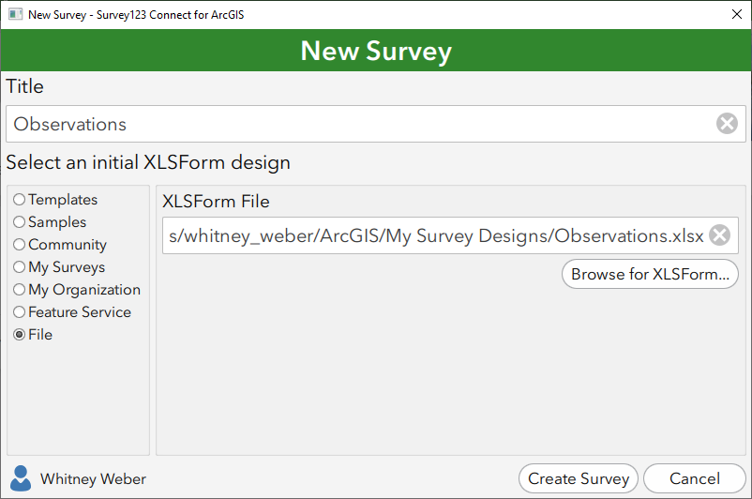
  - The Observations survey will open, as will the Observations.xlsx spreadsheet.

Configure the Survey Settings 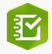
Regardless of whether NatureServe cloned the survey for you, you should review and probably configure the survey settings, according to the following instructions.
- Within the survey, use the various tabs at the bottom to configure the survey:
  - In the Details tab, click on the Thumbnail image to add a thumbnail.
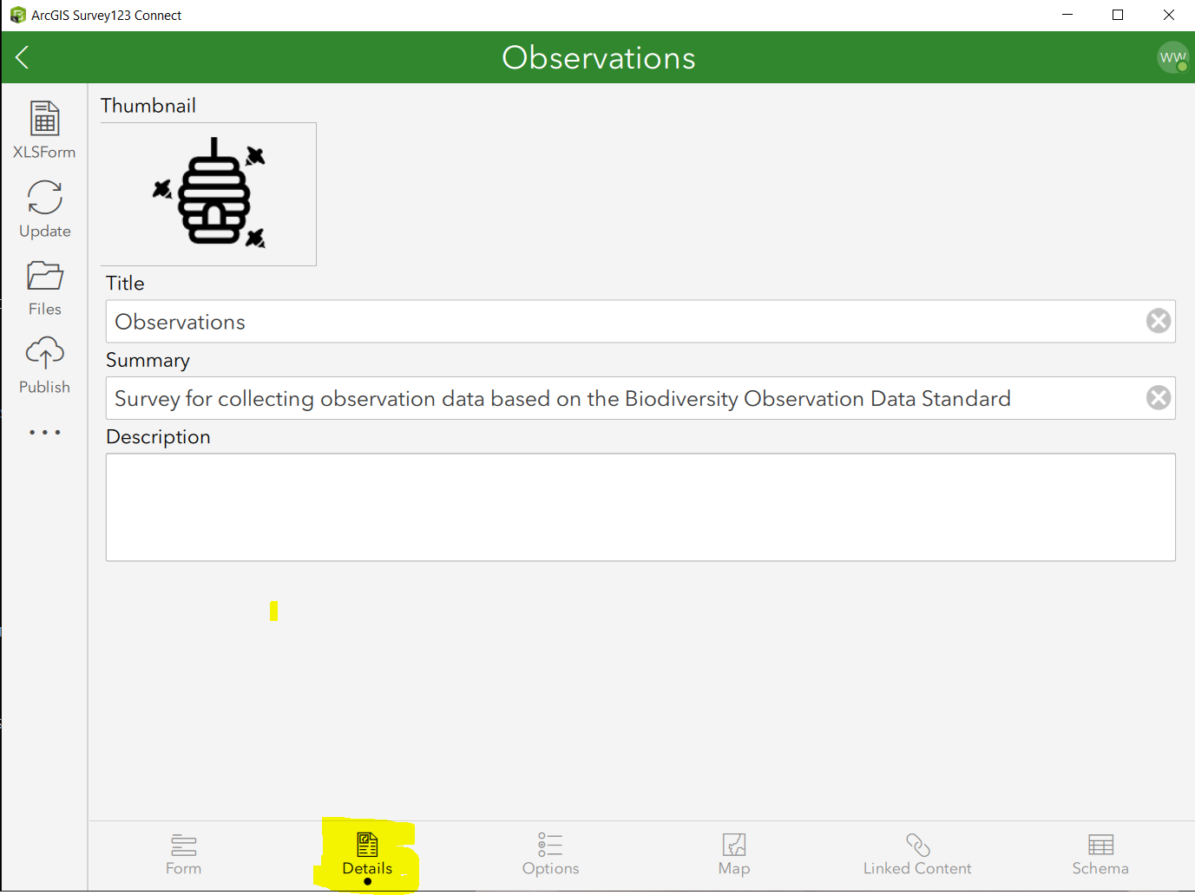
  - Navigate to the Map tab to configure the default map displayed, to your preference. 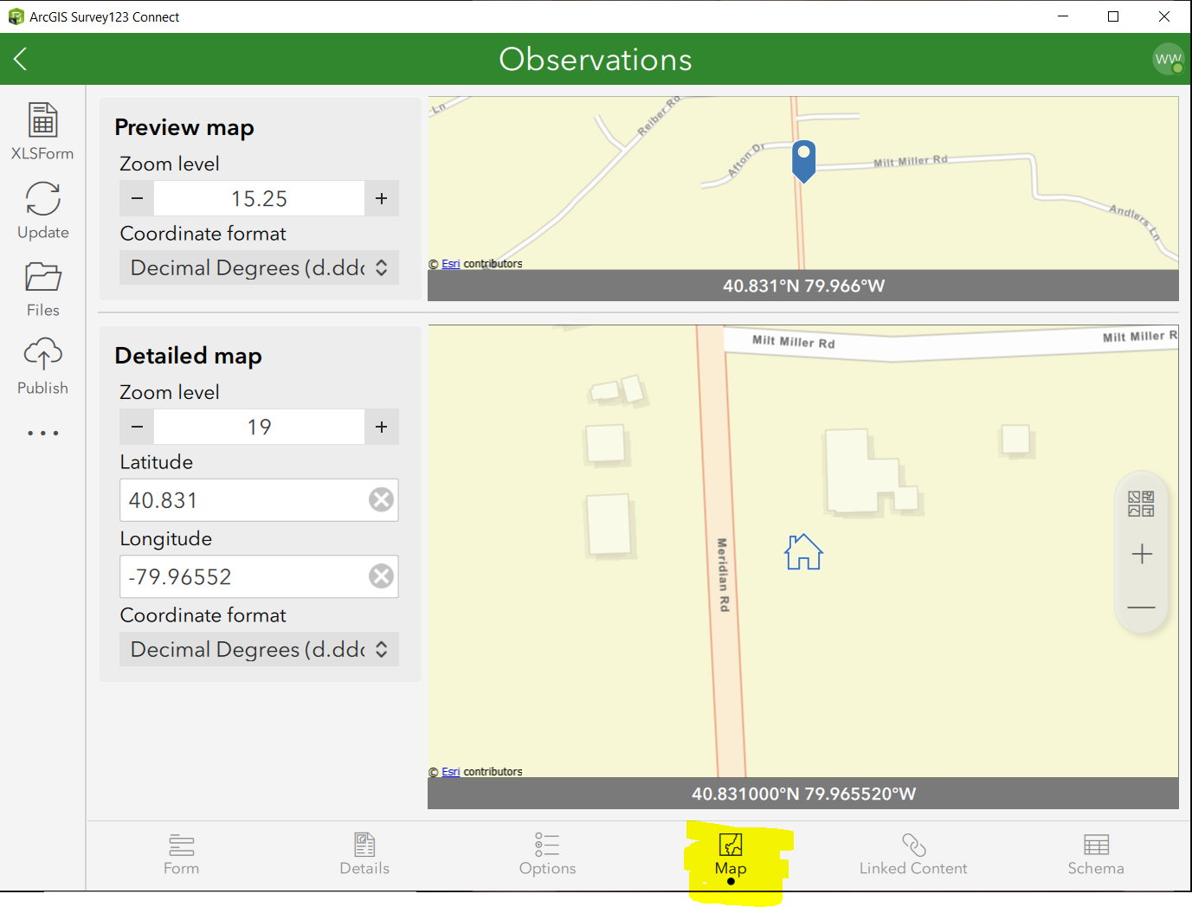
  - Navigate to the Options tab and set Inbox Mode to the desired setting. By default, you can edit any previously submitted surveys that exist in the Survey123 field app's Sent box. To edit existing survey data (for example, data collected on another day or by another user), you must specify your intent before publishing the survey by indicating to Enable Inbox folder.
NOTE: The inbox may appear to stop responding when too many features are returned by the query. Because of this, Esri recommends that implementing a WHERE clause that will limit this number. See the Prepare for editing existing survey data for additional details.
Enable Sent folder to store submitted surveys on the device, enabling users to edit and resend a survey, or copy the sent data to a new survey. If not enabled, submitted surveys will not be stored on the device, and will be deleted immediately on successful submission.
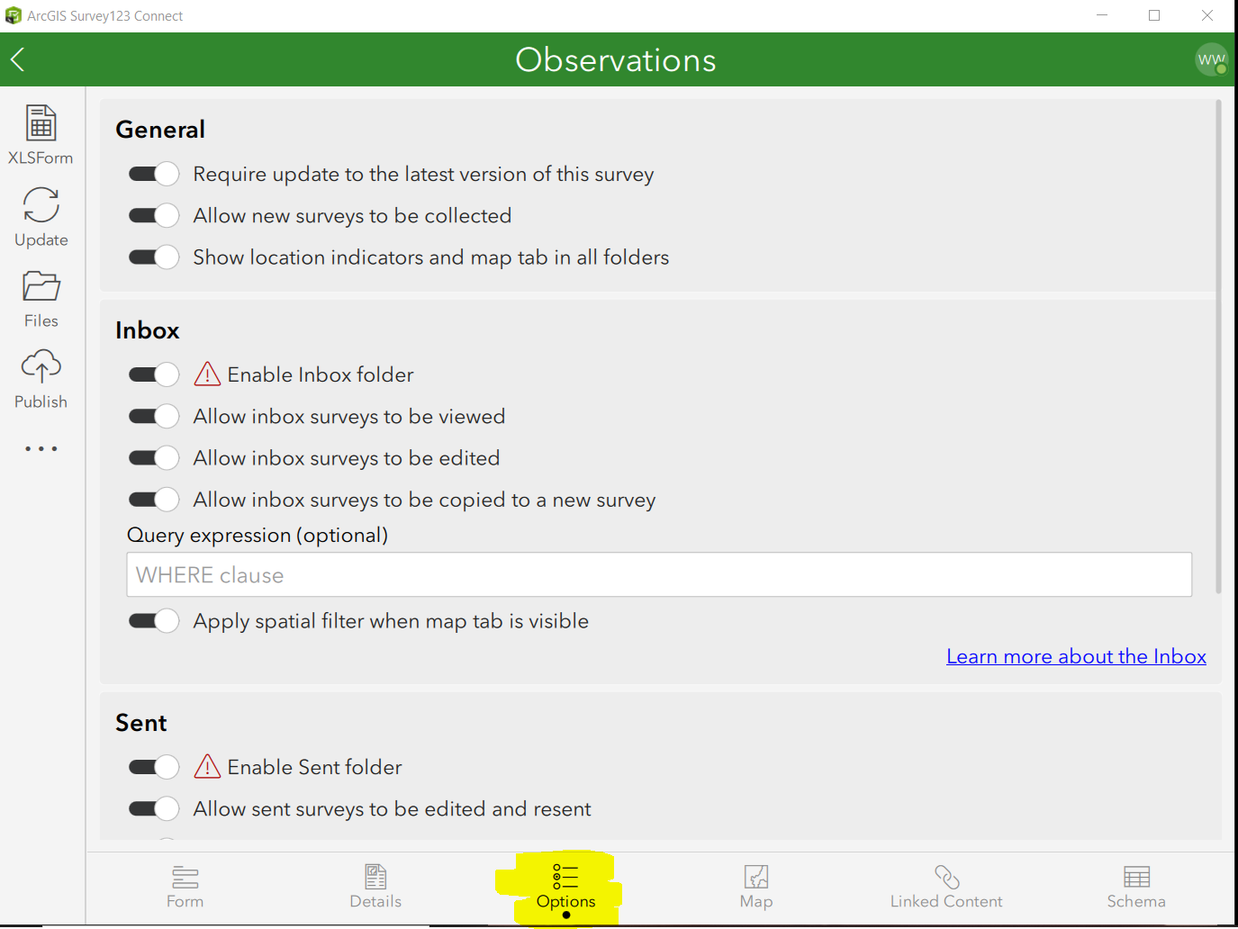
- If you would like an image displayed in the survey:
  - Rename your image file to logo.png and copy it to the survey’s media folder by clicking Files in the Table of Contents and opening the media subfolder.
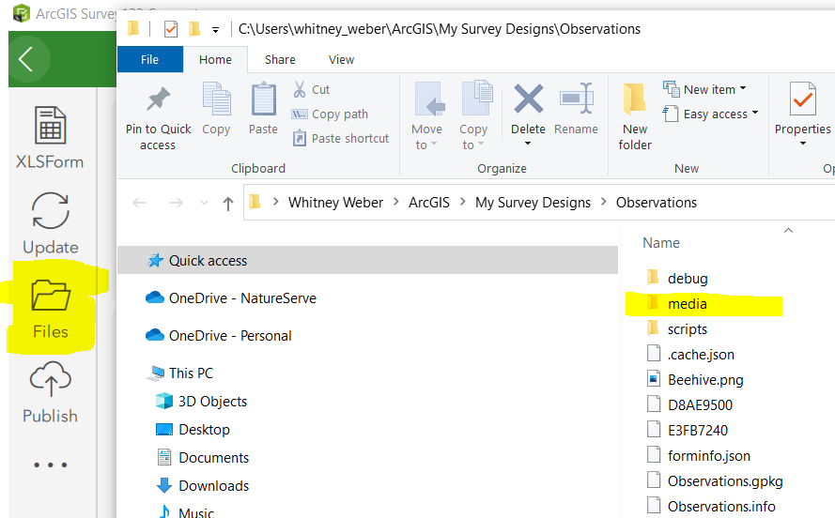
  - Move this row to the top of the spreadsheet if you prefer the image to be displayed at the beginning of the survey rather than the end.
  - Save changes to the Observations.xlsx spreadsheet, which will automatically update the Survey.
- Survey data collections have been configured to submit with a name using the element name and date to be able to distinguish one collection from the next. If you would like to reconfigure the name to include something else, this can be configured within the instance_name column of the settings tab within the Observations.xlsx spreadsheet.
- In Survey123 Connect for ArcGIS:
- From the Table of Contents, select Files to open survey content folder
- Copy and paste the species.csv, location_use_class.csv and higher_classification.csv files, created in the Customize the Observations.xlsx spreadsheet section, to the media folder.
NOTE: These files are used to populate the various dropdown values. Additionally, data within the species.csv file is used to autopopulate Common Name, SRank and Track Status, based on the element selected, so saving it to this location is required for that to work.
- Update the survey so that data from the csv files are recognized (i.e. verify that Location Use Class values appear for appropriate animals).
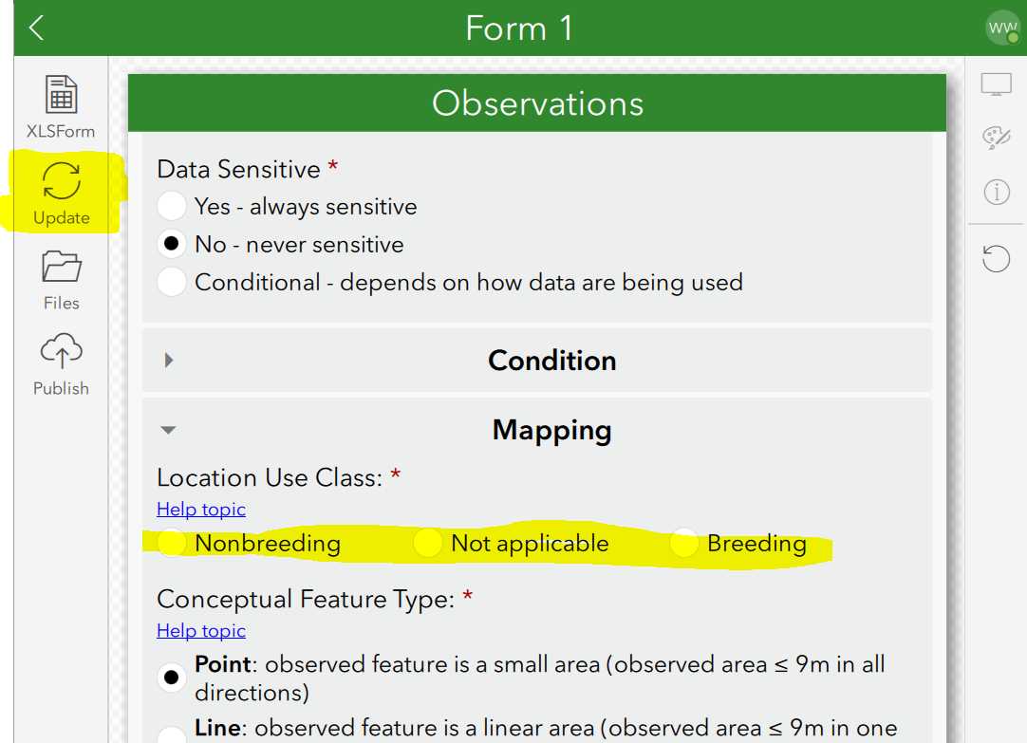
- In the Observations survey (Form Preview), enter data and Validate Input to verify that the survey is working correctly.
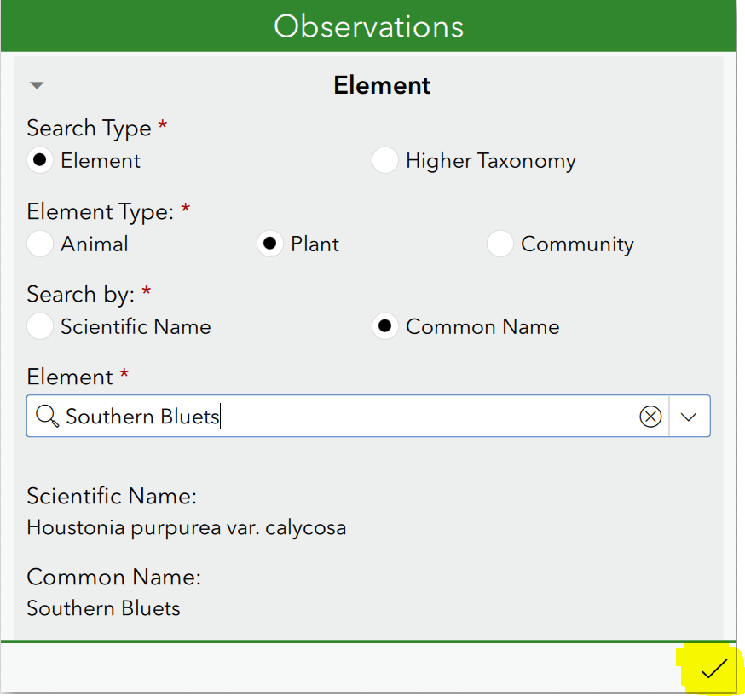

Publish the Survey
Regardless of whether NatureServe cloned the survey for you, the following steps are still required.
- Once the survey is to your liking, Publish the Observations survey.
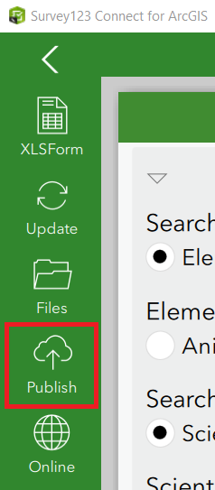
- In the Publish Observations dialog, click Options and disable Create coded value domains from choices and click OK. NOTE: This is CRITICAL because the correct values required for Biotics have already been configured.
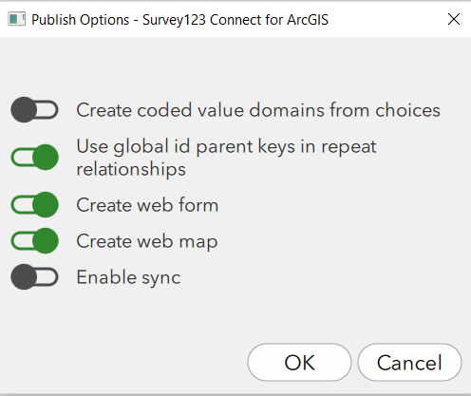
- Publish Survey and then click OK once complete. NOTE: The publishing screenshot may look a bit different.
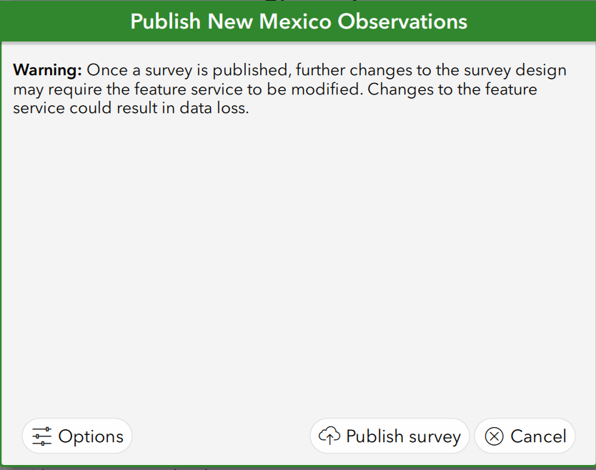
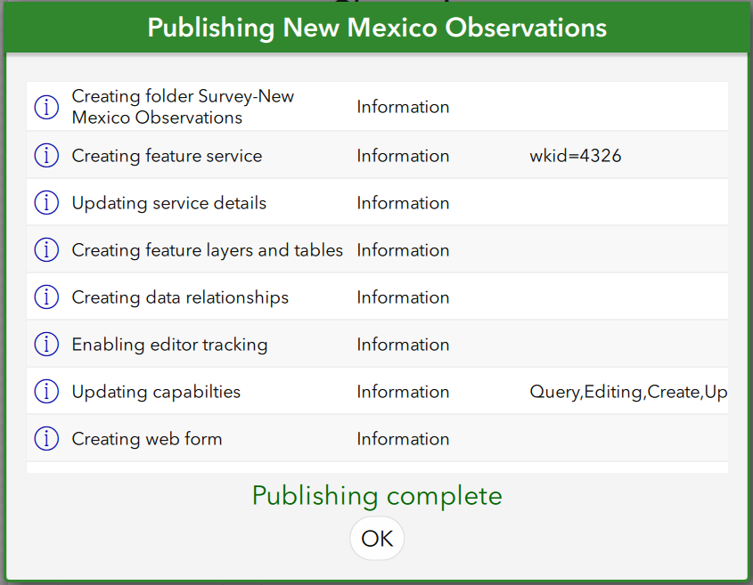

Add csv files to ArcGIS.com and link them to the survey
If NatureServe cloned the survey and related materials for you, the following steps would not be necessary.
This will add the species.csv, location_use_class.csv, and higher_classification.csv files to ArcGIS.com and link them to the survey, to allow for easy updates when changes are needed.
- Sign into ArcGIS.com and within Content, My Content, from the Folders section within the Table of Contents, navigate to the survey’s folder. This will automatically put the csv files within the survey’s folder.
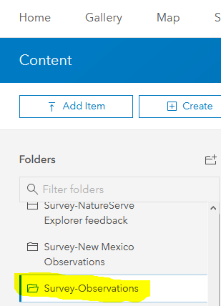
- Select Add Item, From your computer
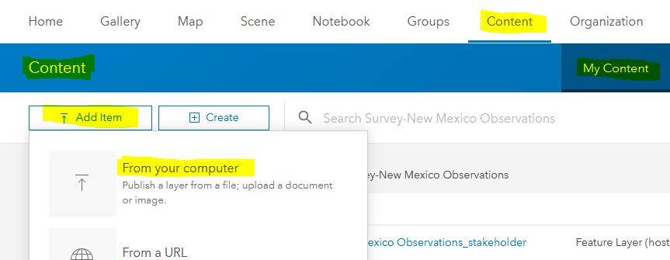
- Browse to the csv file found within the survey’s media folder (i.e. C:\Users\your_user_name\ArcGIS\My Survey Designs\Observations\media\species.csv).
- Uncheck Publish this file as a hosted layer and Add Item.
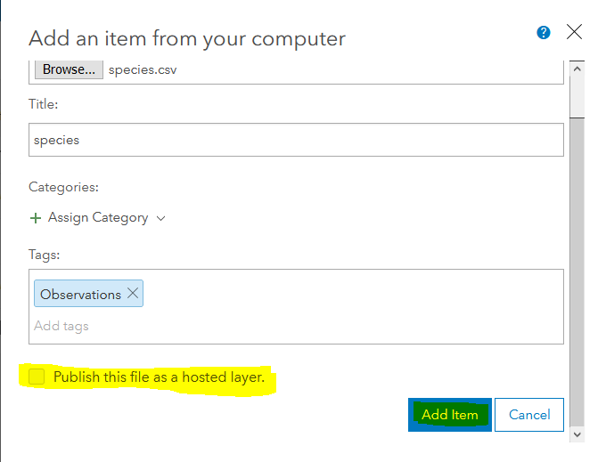
- Within the details page for the csv file, Share the file to the same group of people for which the survey has been shared.
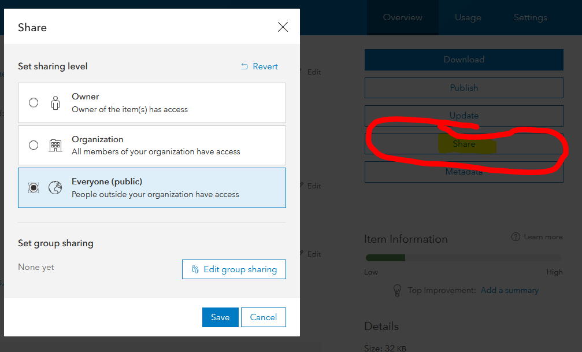
- Repeat Steps 2 – 5 to add the location_use_class.csv and higher_classification.csv files to ArcGIS.com.
- In Survey123 Connect, navigate to the Linked Content section and click Link content.
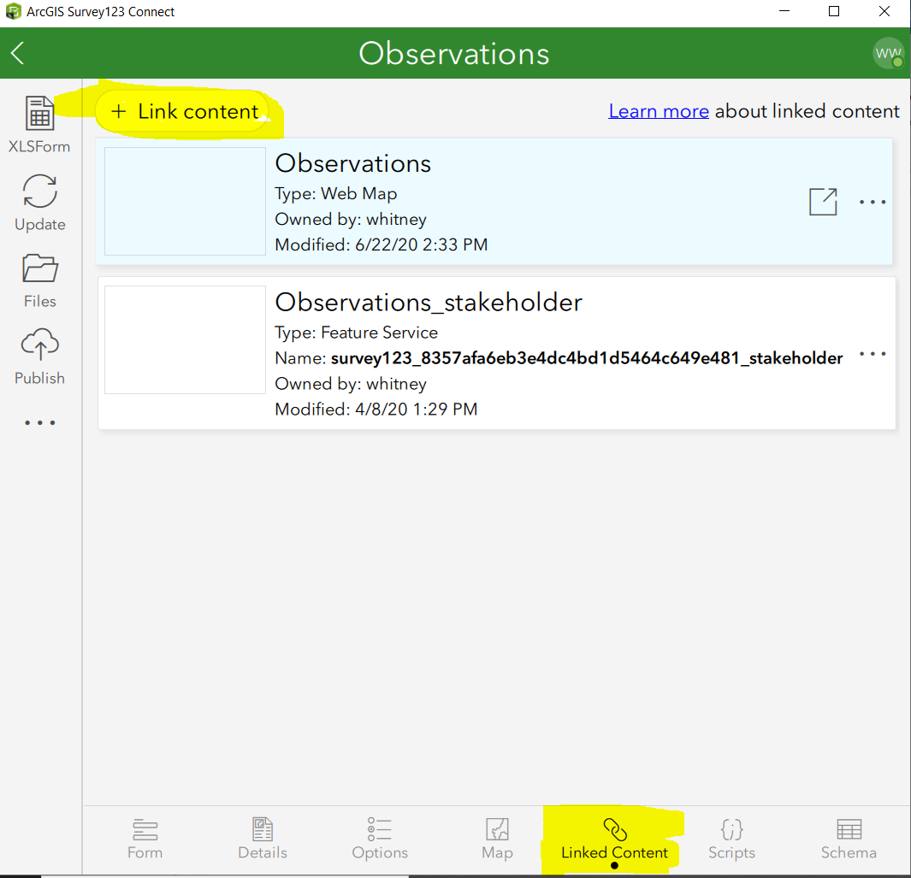
- Within the Link Content dialog, choose CSV.
- Within the Link CSV dialog, select the csv and click OK.
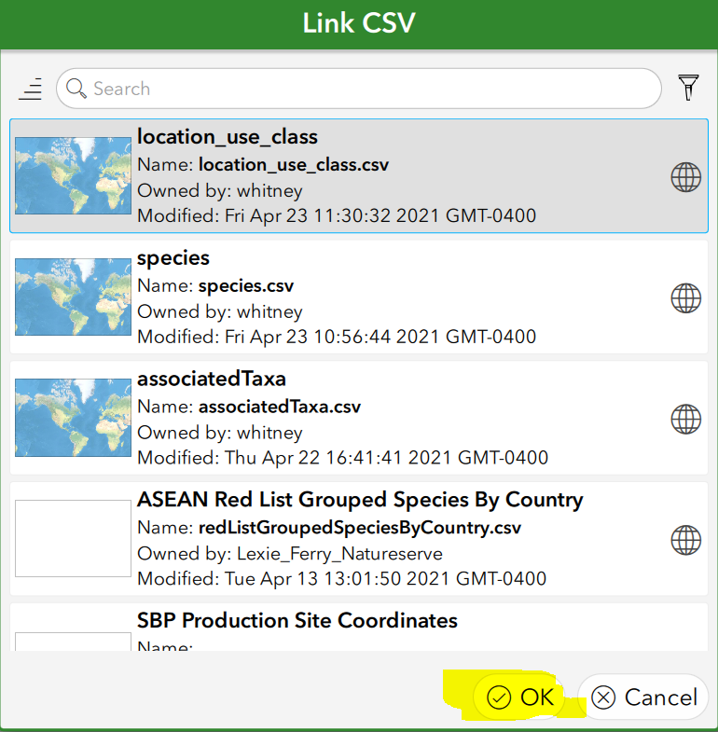
- Repeat until each of the 3 csvs have been added (species.csv, location_use_class.csv, higher_classification.csv)

Create Offline Basemaps
To create basemaps for offline use (aka, no internet connectivity), see this solution which combines multiple Esri online help topics, to hopefully facilitate this process!

Share the Survey for Data Collection
The following steps are required regardless of whether NatureServe cloned the survey and related materials for you.
- In Survey123 Connect for ArcGIS, after publishing the survey, from the Table of Contents, click the … icon and select Manage in Survey123 website.
NOTE: Alternatively, if you’re not in Survey 123 Connect for ArcGIS, log into the Survey123 for ArcGIS website. The Observations survey will be displayed.
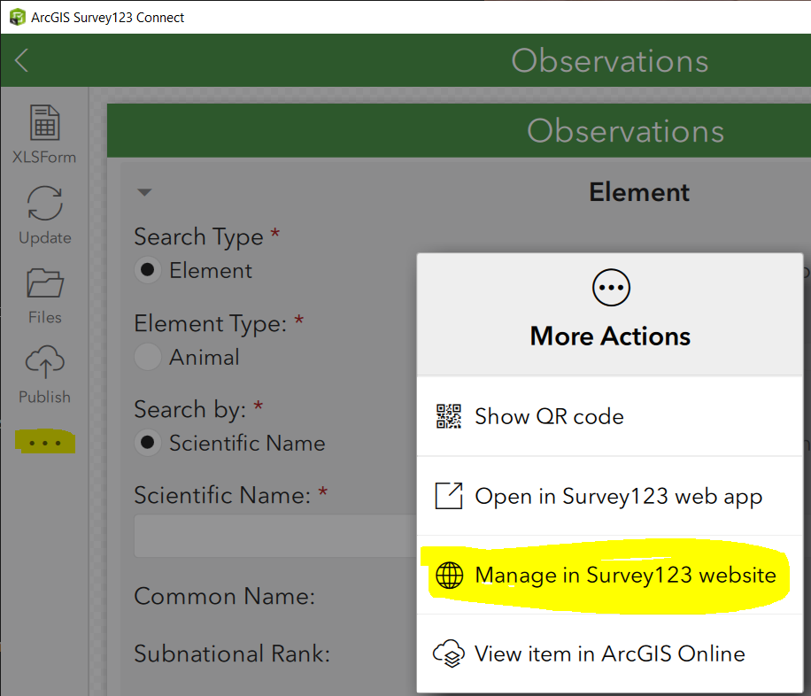
- Within the Observations survey on the Survey123 website, click on the Collaborate tab.
NOTE: Alternatively, if you went to the website rather than going through Connect, click on the lock icon on the Observations survey to go directly to the Collaborate tab. See the Share survey topic for additional details regarding any of the following options.
  - Within the Share survey section:
    - In the Link section, indicate to Ask the user how to open the survey, in browser or in the Survey123 field app. Provide the weblink or QR code to potential users of the survey so that they can easily access it.
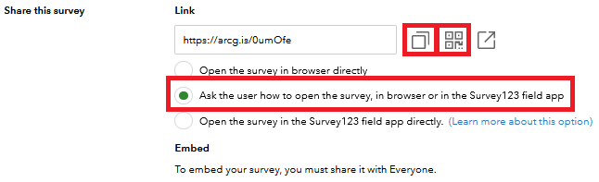
    - indicate who will be able to submit data – Everyone or certain members of your organization or specific groups
    - indicate which privileges those submitters will have.
    - whether to Enable draft mode
    - and whether to Allow multiple submissions.
    - Click Save.
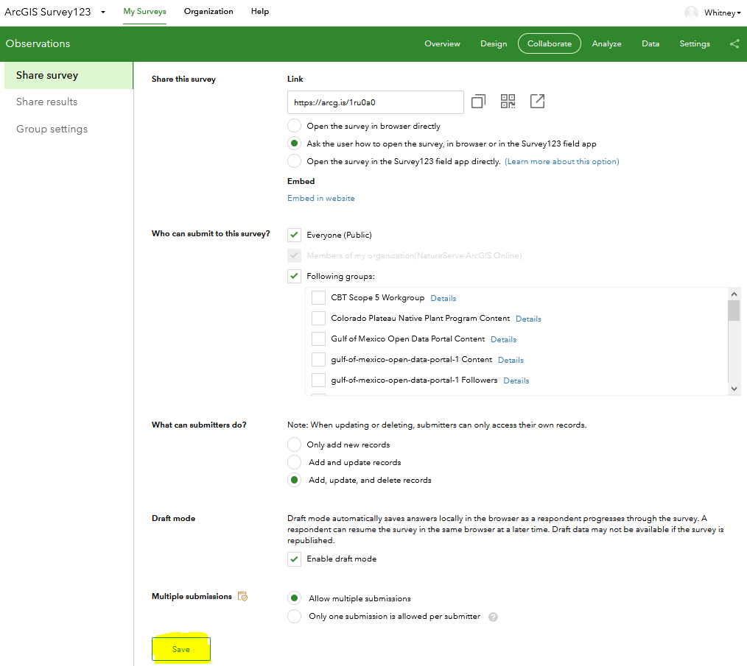
  - Within the Share results section:
    - Indicate who can view data within the survey
    - Indicate what data viewers can see
    - Indicate what viewers can do with the data
    - Click Save.
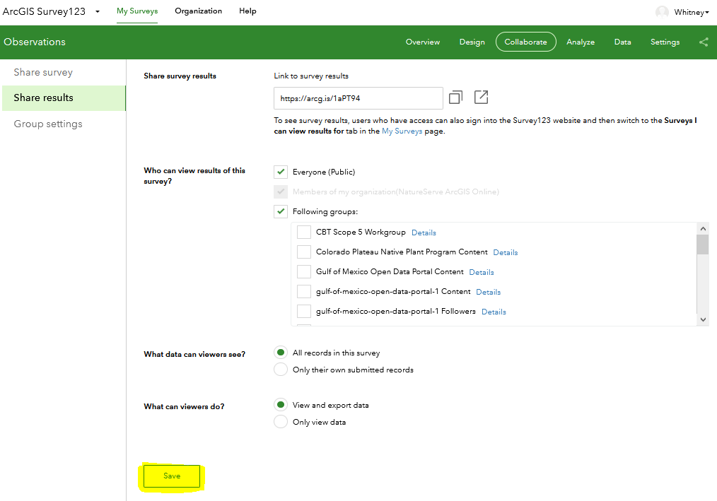
  - Within the Update survey section, indicate if members of a group should have privileges to update the survey design or settings. This is very useful, so that more than just the survey publisher has access!
  - If using groups to allow access to the survey, within the Group Settings section, follow the links to manage groups with appropriate people if that has not been previously done for your Organization.

Data Collection
Should you just want to share instructions on data collection via Survey123 with the data collectors, this portion can also be found in the Collect Data via Survey123.docx document and attached to the Solution titled: Collect Data via Survey123.

Install the Survey123 field app 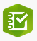
According to Esri documentation:
- Click the survey link or take a picture of the QR code, provided as instructed in the Share the survey for data collection section
- Follow the prompt to download and install the Survey123 field app.
- After installation, the Observation survey should open automatically.

Should you have an existing version of the Survey123 app, upgrade it to version 3.13.246 to ensure full functionality. If installing on a laptop, the newest version can be downloaded from the ArcGIS Survey123 Resources site. Scroll to the bottom of the page and select the appropriate version of the desktop app.
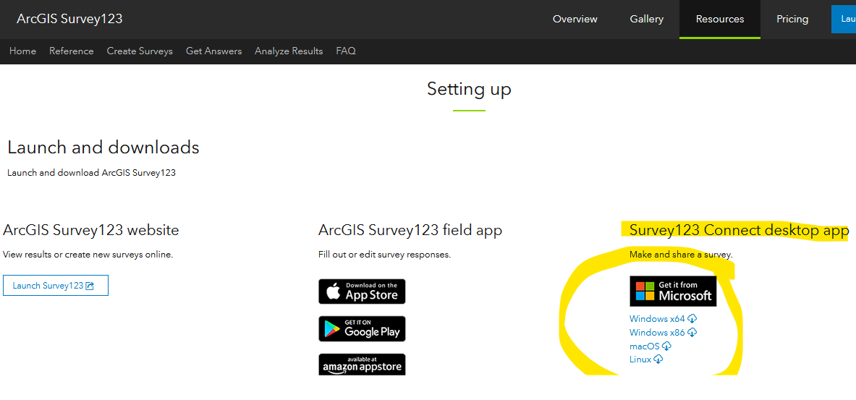Collect Data
Once the user follows the instructions above regarding installation, the Observations survey will automatically be listed within My Surveys in the Survey123 field app for subsequent use.
- Within the Survey123 for ArcGIS app, click the Observations survey.
- Within the Observations survey, click Collect to start entering data.
NOTE: Voice to text works within the Survey123 mobile app. Just click the microphone button (or appropriate for your device) and talk!
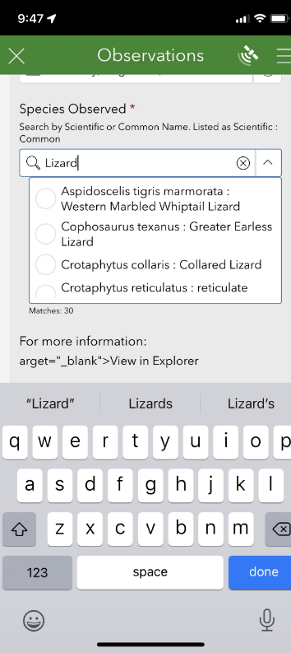

Location
Based on the Conceptual Feature Type and Locational Uncertainty Type entered, the Location of Element will either be defined by a Point, Line or Polygon, according to the Spatial Feature Development Summary.
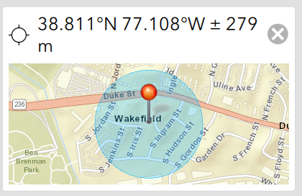
Line and polygon features have the option to draw the location via Sketch (free-form digitize) or Vertex.
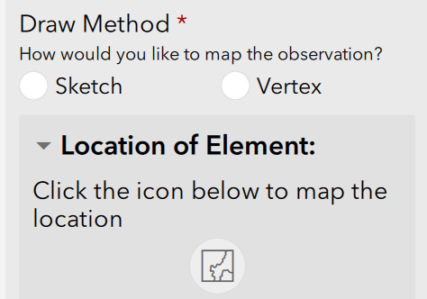

Sketch
The Sketch method is used to capture the geometry in a single motion, with the capture completing once the user has stopped drawing this single line. To begin capturing Sketch geometry, tap the Sketch button in the lower left of the map page and tap the map. When you have finished sketching the geometry, stop tapping the map. The geometry is then complete, with the geoshape connecting the beginning and end of the shape if necessary. The length of a geotrace, or the area and perimeter for a geoshape, is displayed below the map.
The Sketch method also provides a smart shape option, which attempts to simplify your sketched geometry into an ellipse, rectangle, or triangle. To use smart sketching, tap the Smart Shape button in the lower left corner of the map page, and tap the map to begin sketching. If your sketch is recognizable as an ellipse, rectangle, or triangle, the app automatically converts it. If your sketch doesn't resemble one of these shapes, no geometry is drawn.

Vertex
The Vertex method allows more precise geometric capture of a line or shape by placing vertices that connect together. To begin capturing Vertex geometry, tap the Vertex button in the lower left of the map page and tap the map to place your first vertex. More vertices can be placed by tapping the map again or tapping the Capture Vertex at Location button to place a vertex at your device's location (this enables you to map an area or transect as you walk). To move the map instead of placing vertices, tap the Pan and Zoom button to change map interactions to navigation mode. You can then capture a vertex at the map's central point with the Capture Vertex at Crosshair button . If at any point you place a vertex at the wrong position, tap the Undo button in the lower right to remove the last vertex placed, drag the point to move it to a new location, or drag the point to the Delete button that appears in the upper left of the map window. When you're done, you can tap the Confirm button to accept this geometry and move back to your survey.
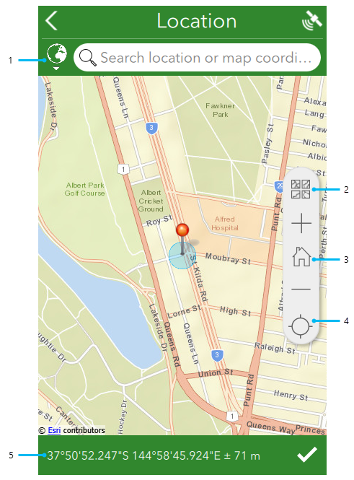
Smart shape
Sketch
Undo
Confirm
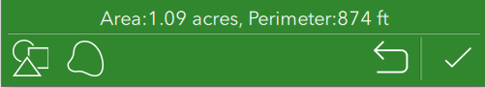

According to the Quick reference, callouts in the image above are detailed as follows:
- The geosearch bar allows you to locate an address or point of interest by searching for it, before snapping your geopoint and map to that location. The globe icon next to the search bar provides options to limit the extent of the geosearch capability, and to change the geocoder being used. For more information, see Geosearch and geocode.
- The Basemap button provides a number of alternative basemaps to the default, for a range of different purposes. This is also where any directly associated basemaps can be selected.
NOTE: Should you require basemaps for offline use, see the Create Offline Basemaps for use with Observations survey (Survey123) solution and the Use offline basemaps section below.
- Home returns the map marker to where the survey creator has defined a home location. If no home location has been defined, it instead returns the marker to the user's location.
- The Location icon is first displayed in black, indicating the location sensor is disabled. Select the button to switch to Navigation mode , enabling Location and tracking the device's current location. Moving the map marker from here, either directly on the map or by changing the coordinates, changes the location and coordinates of the answer, but the device's location remains visible as a pulsing blue dot while doing so. When this happens, the button switches to an Active Location icon ; select it to return to Navigation .
- The coordinates of your current location are listed here, using the coordinate format that has been set for that survey in Survey123 Connect. Pressing the area copies the location coordinates into the geosearch bar, allowing you to define a different location. Altitude is also included here if it has been enabled for the question. For more information, see Geopoints. In addition, pressing and holding these coordinates will perform a reverse geocode to give you the location, placed above the coordinates. As with the coordinates, pressing the location will copy it into the geosearch bar.

Use offline basemaps

Download a linked map package in the Survey123 field app
To download a shared map package, complete the following steps:
- Start the Survey123 field app and sign in with your ArcGIS organization account.
- Select the survey to which you associated a map package.
- Choose the menu and choose Offline Maps.
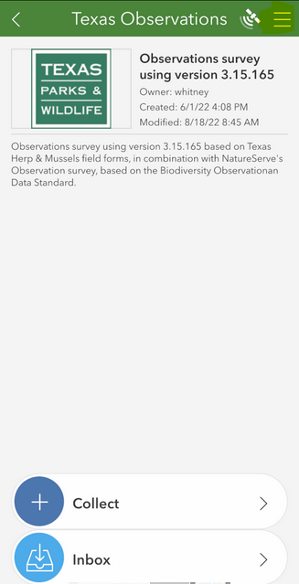
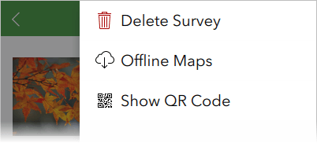
- Choose the map package from the list to download.
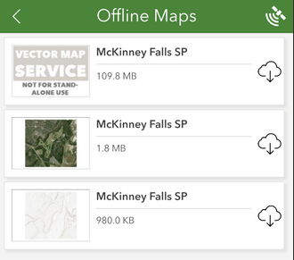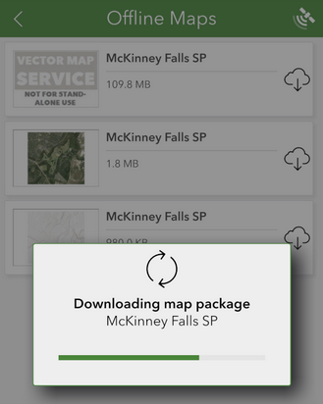
- Once it's successfully downloaded, you'll see the map package in the list of basemaps on the location page of your survey.

Use a map package in the Survey123 field app
You can use either manually copied map packages or downloaded, shared map packages in your survey.
To use a map package, complete the following steps:
- Start the Survey123 field app and sign in with your ArcGIS organization account.
- Select the survey to which you associated a map package.
- Choose Collect.
- Choose the map question and display the full-screen map.
- Select the Basemap button and select your map package.
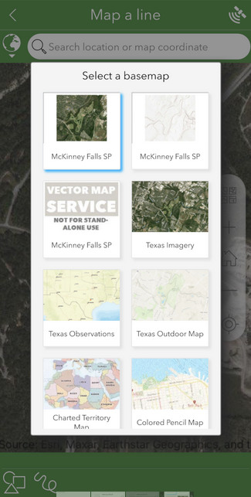

Copy a collection and edit it (if there are two elements in the same location):
There are two ways to copy data from a single collection to replicate it in subsequent collections, to minimize data entry.
- Copy (previously sent survey responses): includes locational data and all survey responses with the exception of Attachments.
- Favorite answers : do not include locational data; overwrites responses with default values, when default values are assigned. Do not include Attachments.

Copy
The following functionality is only feasible if, within Survey123 Connect, the Enable Sent folder option is indicated prior to publishing. NOTE: Unlike Favorite answers which do not include the location information and questions which have default values are overwritten by the default, copying previously Sent surveys copies all of the survey responses without overwriting or omitting any responses.
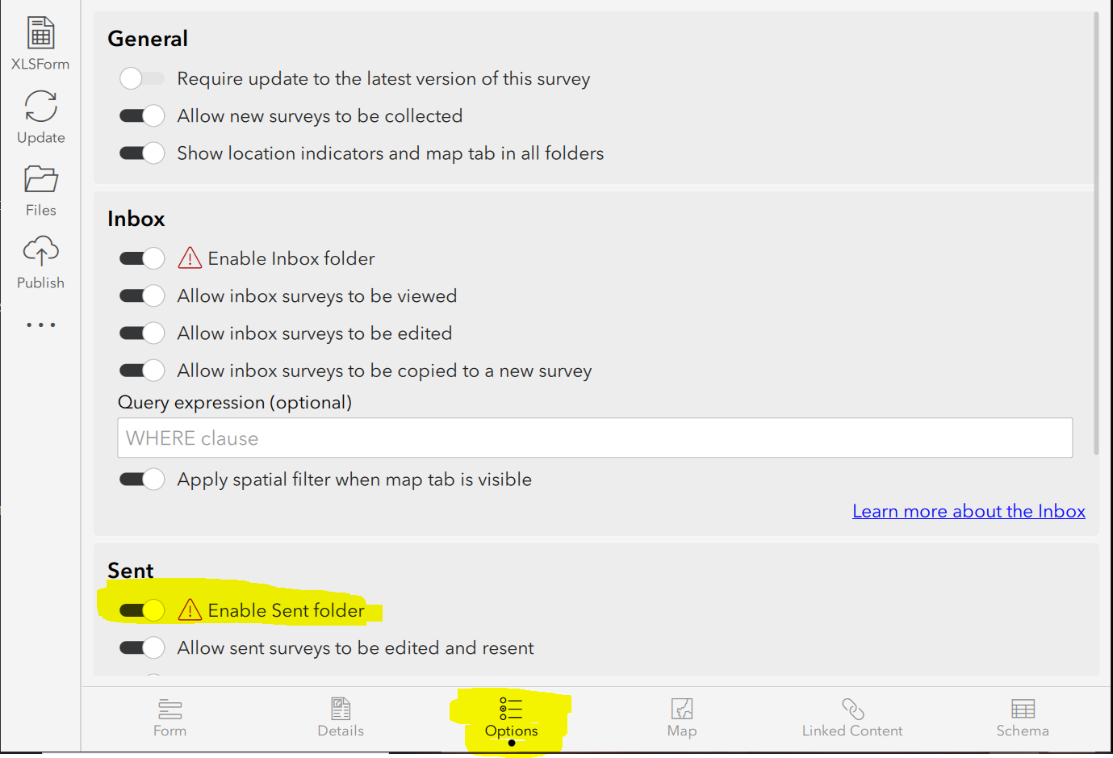
- After having sent in the original collection, go to the Sent section
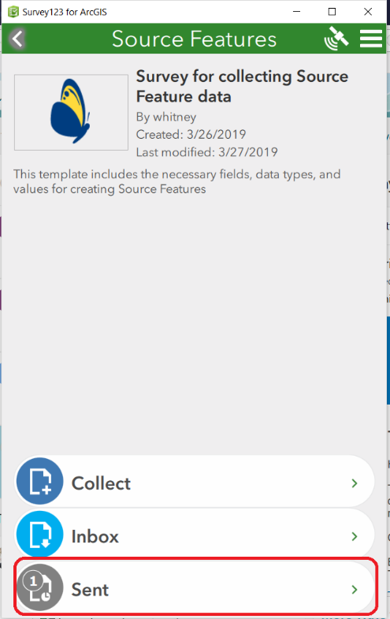
- Select the data collected via the List or Map and click Copy the sent data to a new survey.
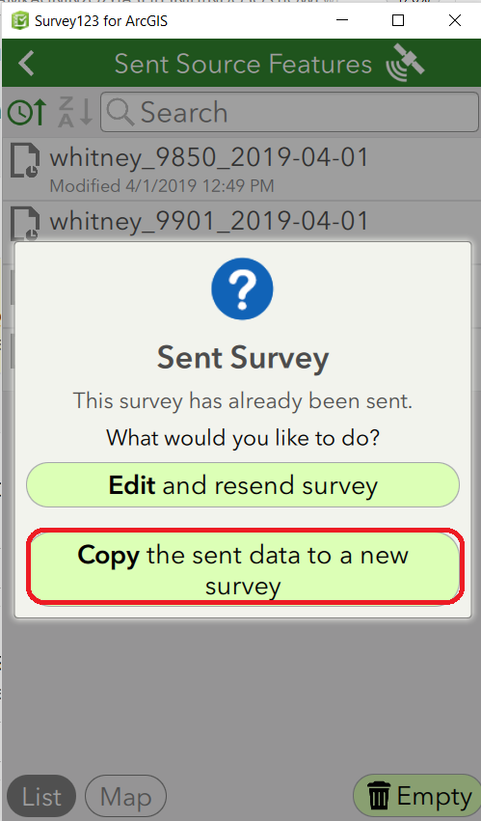
  - Edit the data for the second collection.
  - Repeat as necessary!

Favorite answers
Favorite answers facilitate entering repetitive information in subsequent surveys. NOTE: Favorite answers do not include the location information and questions which have default values are overwritten by the default.
- Complete a survey response with your preferred answers.
- Before submitting the response, using the menu in the upper right corner, choose Set as favorite answers to set the current state of your survey to act as your favorite answers. The saved survey is now marked with a star icon in the Sent list.
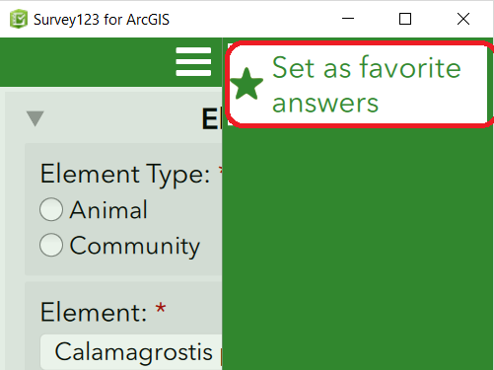
- Once you've set your favorite answers, the Paste answers from favorite menu becomes available. Select it to enter your favorite answers into your new survey.
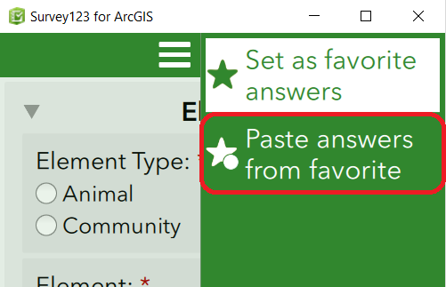
- To change your favorite answers, enter changes into your current survey and click Set as favorite answers.

Retrieve collections from a previous session
The following functionality is only feasible if, within Survey123 Connect, the Inbox mode setting is set to Enabled – The Inbox folder will be available for this survey, prior to publishing. The data available within the Inbox (for example, data collected on another day or by another user) is defined by the Where, if specified.
- From the Inbox
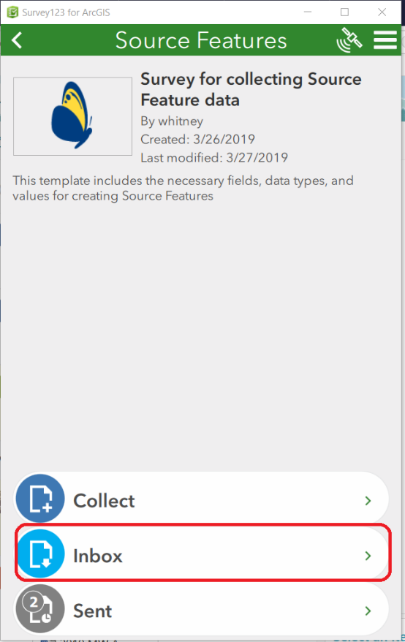
  - Click Refresh
  - Select the desired collection via the List or Map view
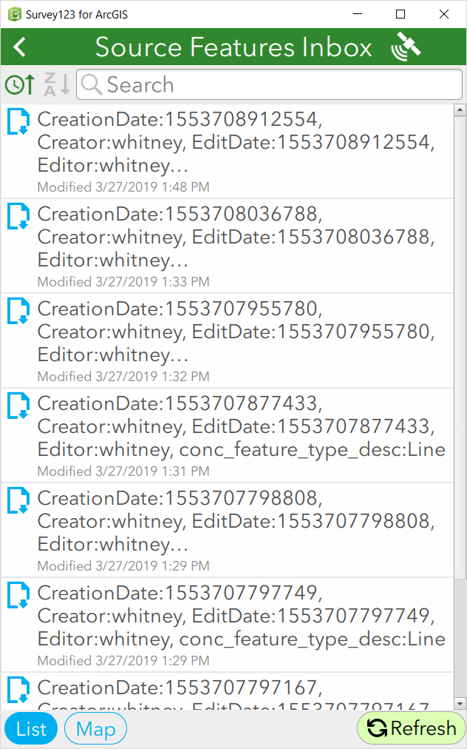
  - Edit as desired.

Edit existing data
Again, whether data within the Sent and Inbox are available are determined by the Settings defined in the Inbox and Sent Surveys settings in Survey123 Connect.
- Select Outbox (if not Sent), Sent (if already Sent), as shown below, or Inbox (if sent in a previous session):
- Select the data collected, via the List or Map, and click Edit and resend survey.
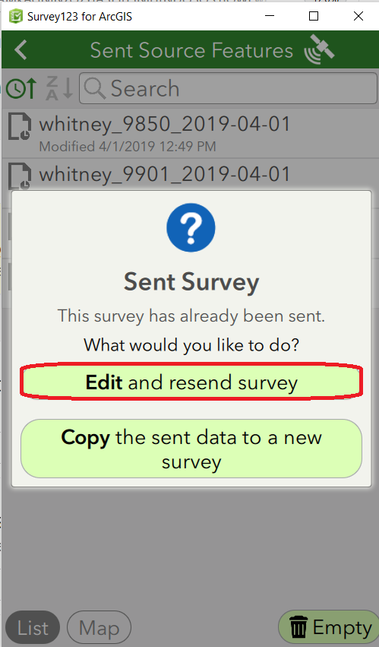
- Edit the data as desired.

Update Survey and Republish
NOTE: Once a survey is published, implementing certain types of changes can result in all existing survey results being deleted (you will receive a warning). Therefore, it is very important that you test the survey and hopefully finalize it before beginning to collect production data.
There are two types of changes, which are treated differently and hence separated here:
- Changes to the species.csv, location_use_class.csv, and associatedTaxa.csv, which alter the dropdown values
- Changes to survey questions

Changes to the species.csv, location_use_class.csv, and associatedTaxa.csv to alter dropdown values:

If updating the data within the species.csv, location_use_class.csv, and associatedTaxa.csv with data from Biotics:
- Re-run the original queries (found within the zip file) in Query Builder
- Save the results as a CSV file with the same file names. Skip to the Update the files in ArcGIS Online section.

If manually updating one or more of the species.csv, location_use_class.csv, and associatedTaxa.csv files:
- Within Survey123 Connect, navigate to the Linked Content section and download the file to update.
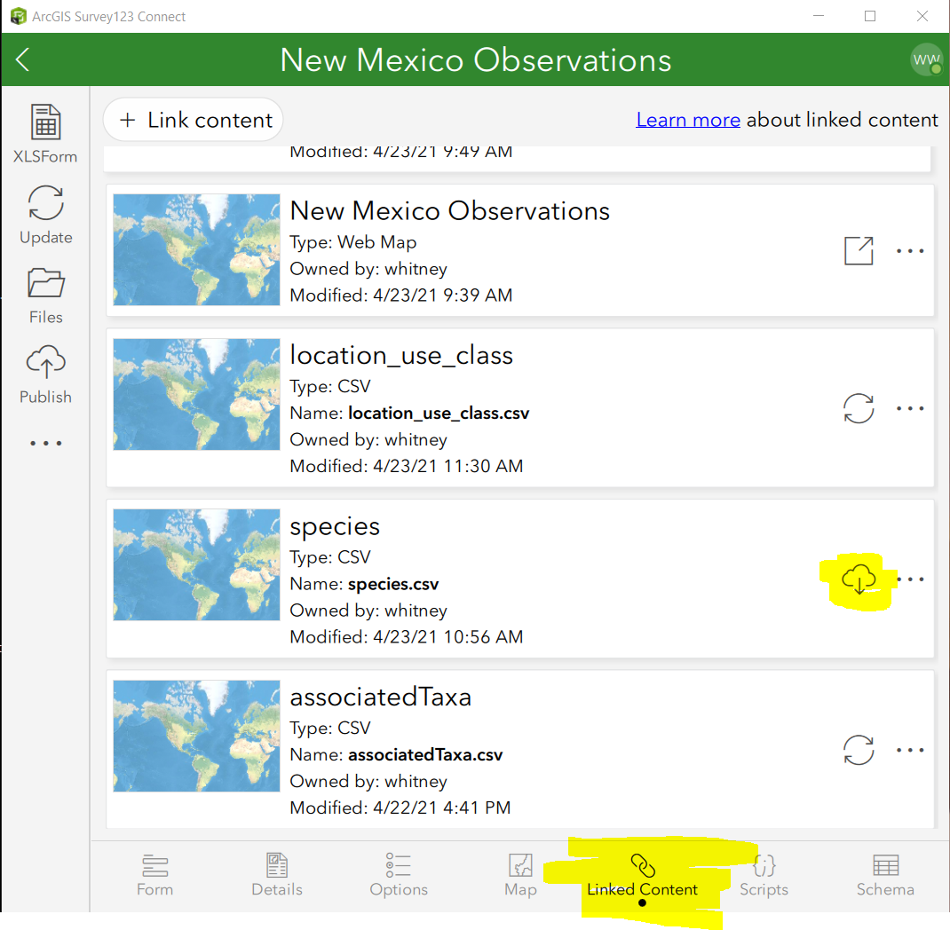
- From the Table of Contents, choose Files and navigate to the media folder.
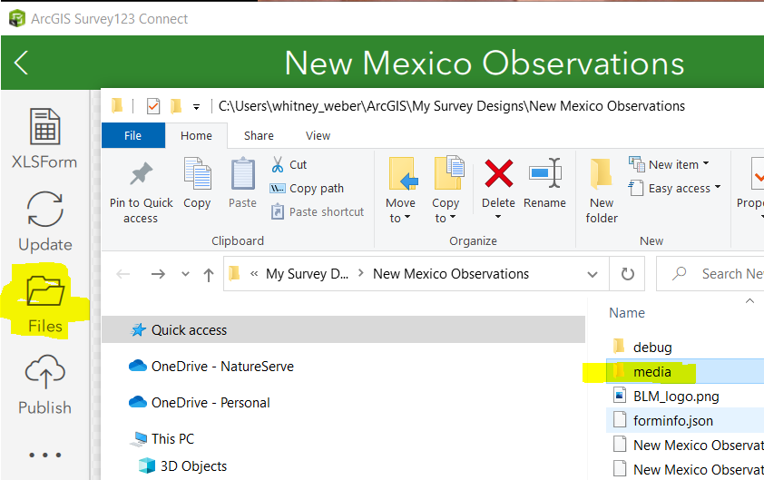
- Open the csv file to update (i.e. species.csv).
- Update the data within the csv file, as appropriate, making sure NOT to change the column headings or file name.
- Save the changes to the updated csv file.

Update the files in ArcGIS Online
- In ArcGIS.com, within Content, My Content, from the Folders section within the Table of Contents, navigate to the survey folder.
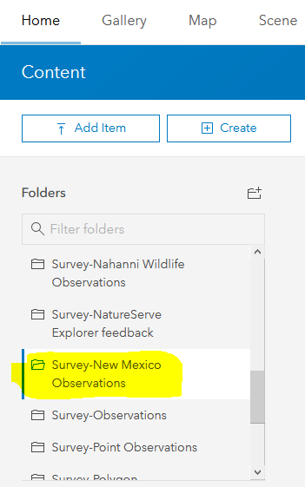
- Select the updated csv to open its Details page.
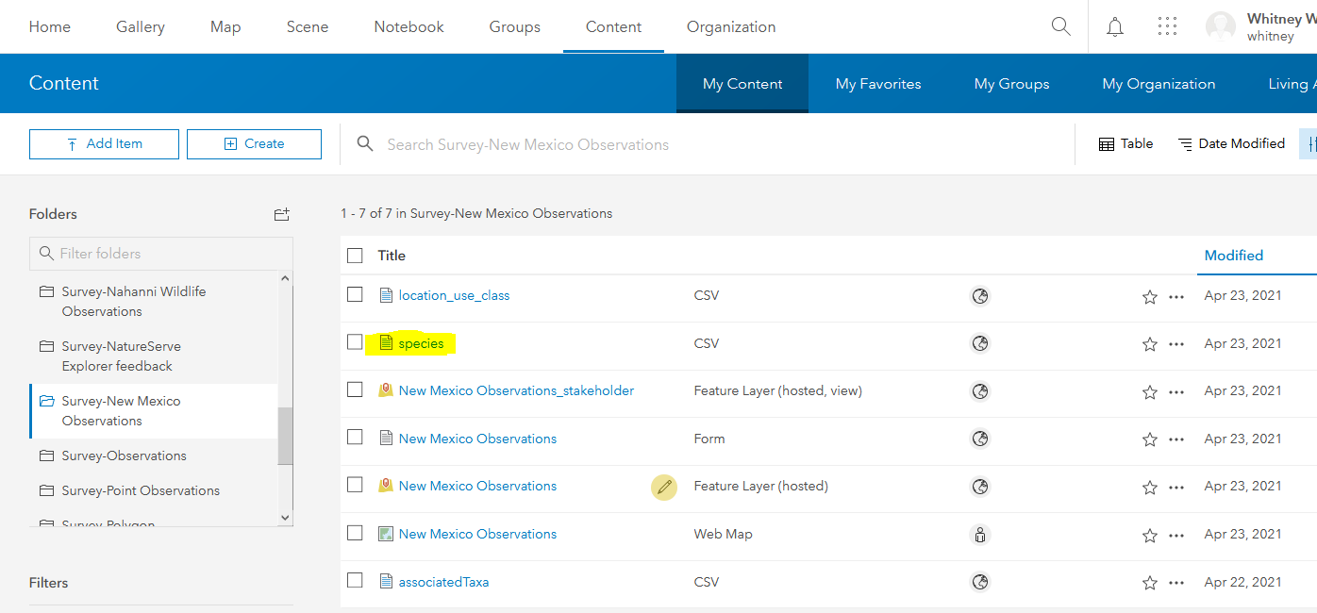
- Browse to the updated csv file found within the survey’s media folder (i.e. C:\Users\your_user_name\ArcGIS\My Survey Designs\New Mexico Observations\media) and click Update Item.
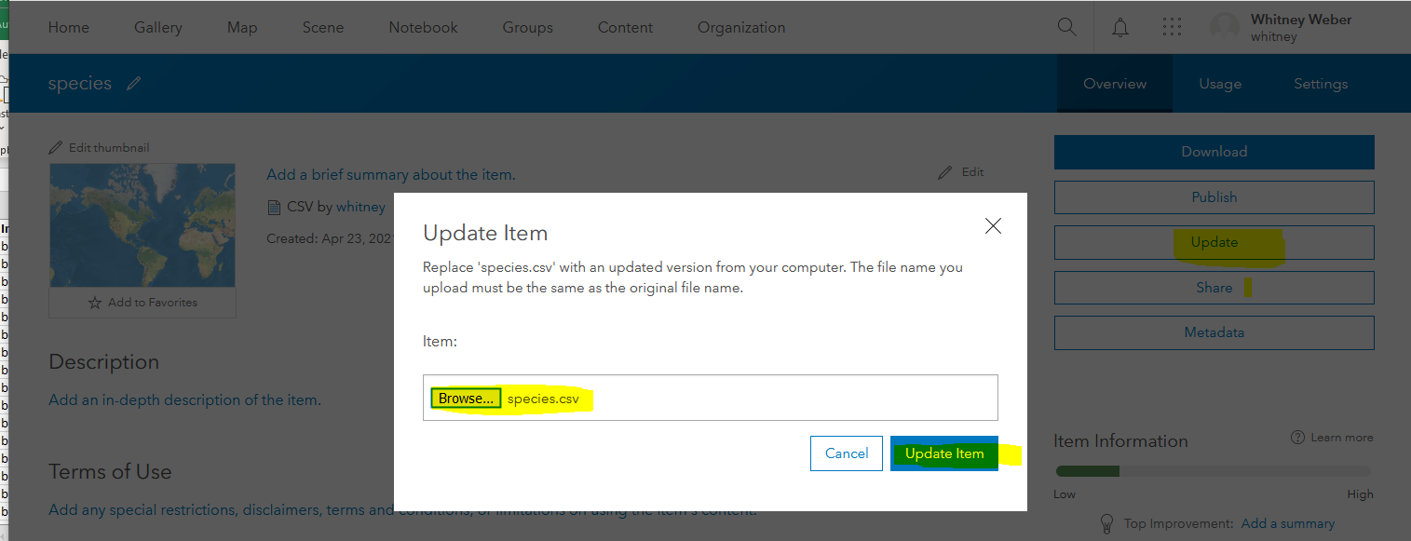
- The updated data will be reflected automatically in the survey.

Changes to survey questions
If after collecting data, you realize that changes need to be made to the survey, first, export the existing survey results to a geodatabase (see instructions within the following section: Viewing, Downloading & Using data collected in Survey for Bulk Create in Biotics) to ensure that if data is deleted from the survey (you will receive a warning) that you have a backup.
For details regarding what changes can/cannot be made to a survey, see the Update surveys section within the Publish your survey topic.
- If NatureServe cloned the survey to your organization’s ArcGIS Online account, log into ArcGIS Online and navigate to the Survey-Observations_v1.4 folder.
- From the menu options associated with the Observations_v1.4 Form, select Edit in Survey123 Connect.
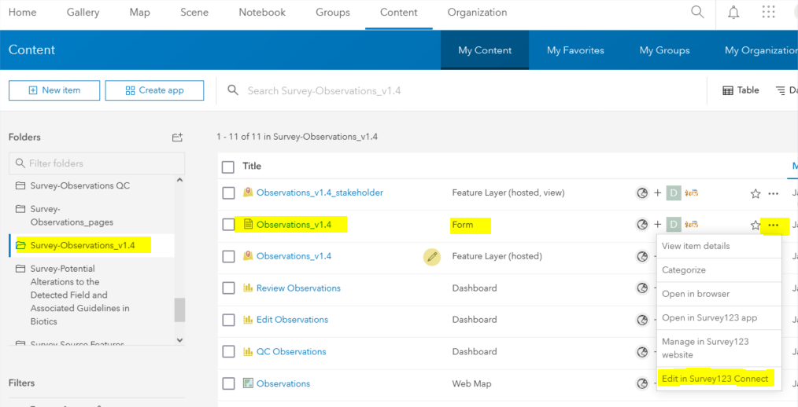
The steps forward apply whether you created and published the survey yourself or NatureServe cloned it for you.
- Within Survey123 Connect for ArcGIS, open the Observations survey and click XLSForm to edit the spreadsheet and make the desired changes.
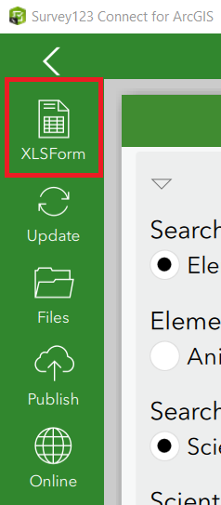
- Once the changes have been tested and verified, Publish the changes:
  - Remember, In the Publish Observations dialog, click Options and disable Create coded value domains from choices and click OK., This is important because the correct values required for Bulk Create in Biotics have already been configured.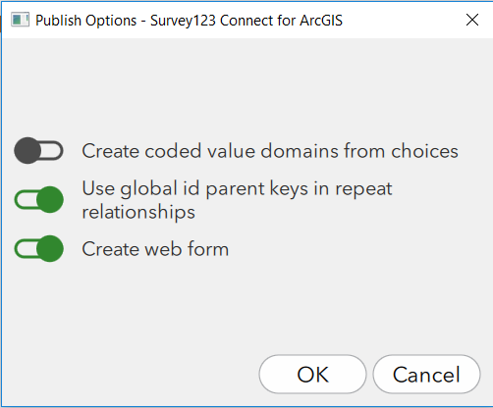
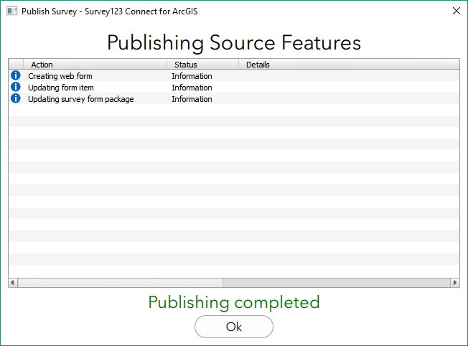
- If using Survey123 version 3.9 or higher, users of the survey will be notified that an update has been made and prompted to update the survey. If users are potentially using an earlier version, encourage them to update as bugs have been fixed and functionality added which may be incompatible with older versions! Otherwise, you will need to advise any user who has previously downloaded the survey to refresh the survey, to realize the changes.
  - Within the main menu of Survey123 for ArcGIS, click Updates available (if in version 3.9 or higher) or select Download Surveys from the menu.
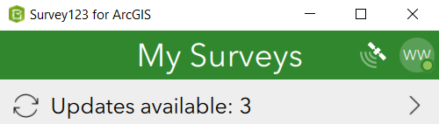
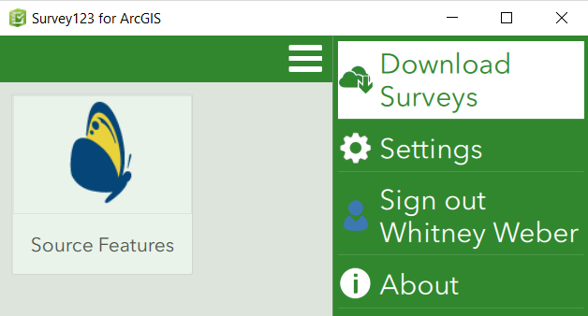
  - Select the Observations survey and click it to get the updates to the survey.
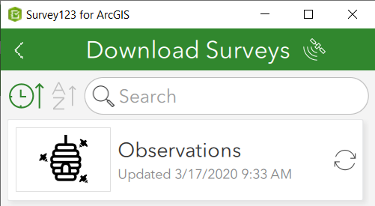

Creating the Dashboard*
Avoid this work (and a lot of effort) by requesting that NatureServe clone the survey and related materials (Maps, Dashboards, Apps) to your ArcGIS Online account! See the What's involved: NatureServe cloning data from NS AGOL to member AGOL solution for details.
The dashboard can be used for reviewing, editing, or QCing the data. Consider making 3 copies of the dashboard and giving different groups of users access to the different dashboard, based on their role. Following are examples:
- Data collector: full edit capability to extrapolate on the data collected in the field (i.e. mode=edit)
- Quality Control staff: provide a second survey which limits editable fields to just QC fields and
- Management/researchers: provide read-only access to the survey results (i.e. mode=view)

Determine the id of the Survey Form*
The following steps are only necessary if NatureServe has not cloned the survey, and related materials, for you.
This can be done in one of two ways – in ArcGIS Online or ArcGIS Survey123.

In ArcGIS Online
- Log into ArcGIS Online and from the Content section, My Content, select the Survey-Observations folder within the Table of Contents.
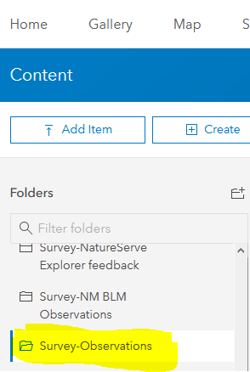
- Click the Observations Form.
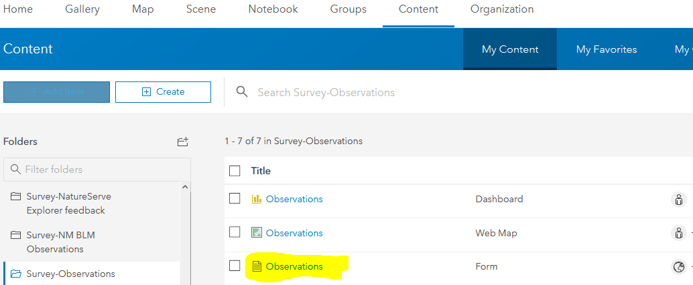
- Within the Observations details page, click the URL and copy everything after id= , as shown in blue below.
- Paste this survey form ID somewhere to access it in a later step, to add the survey to the dashboard.

In ArcGIS Survey123
- Log into ArcGIS Survey123 and select the Observations survey.
- Within the Observations survey, click the URL and copy everything after survey/ and before /… , as shown in blue below.
- Paste this survey form ID somewhere to access it in a later step, to add the survey to the dashboard.

Edit the Observations Web Map*
The following steps are only necessary if NatureServe has not cloned the survey, and related materials, for you.
When the survey was published, an Observations web map was automatically created, but it will only include the Observations (Point Layer) which reflects the (tabular) survey data. The spatial data is actually contained within the point, poly, and line Layers which need to be added to the Observations Map, for use in the Dashboard.
- Log into ArcGIS Online and from the Content section, My Content, select the Survey-Observations folder within the Table of Contents.
- Click the menu associated with the Observations Web Map and select Open in Map Viewer.
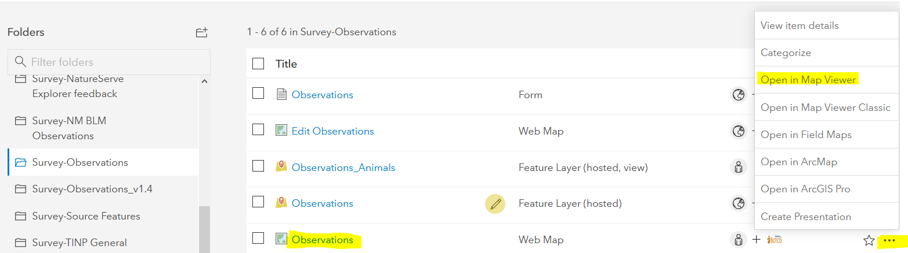
- Within the Observations web map, choose Add layer.
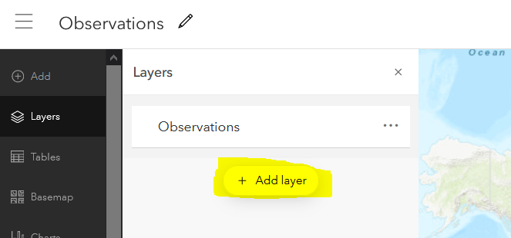
- Within Add layer, navigate to the Observations layer and click the icon to add all the layers within the survey to the map.
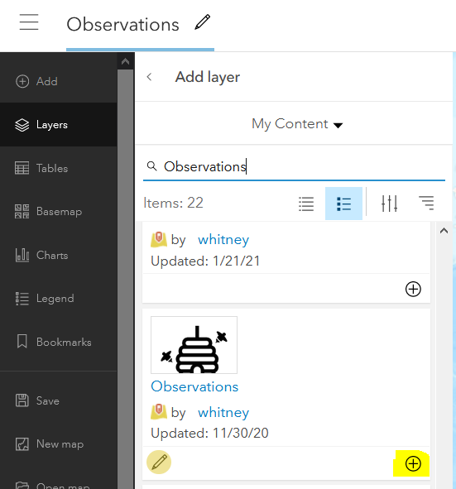
- Change the Properties for the Line, Point, and Polygon layers, as desired. Navigate between the layers using the dropdown at the top.
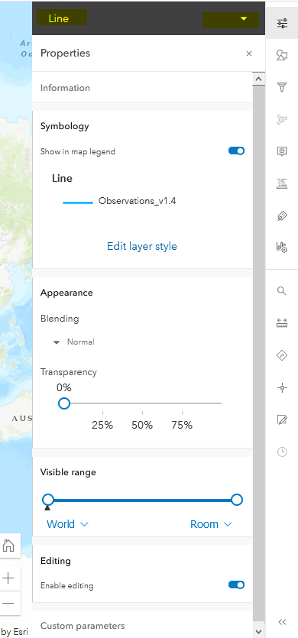
- Should you want other layers visible within the map to use within the dashboard, add them now. Otherwise, click the icon next to Add layer to stop adding layers.
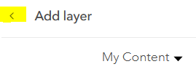
- Click the menu icon to the right of the Observations layer at the top and choose Remove, as it duplicates the existing Observations layer in the Map.
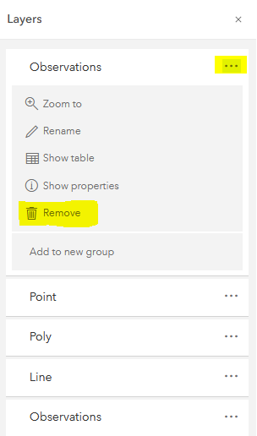
- Hover next to the menu icon associated with the Observations layer at the bottom and click the icon to turn off the layer’s visibility. The actual point locations are reflected in the Point layer, hence turning off the layer’s visibility. The layer is still necessary within the map for the tabular data, so DO NOT remove it.
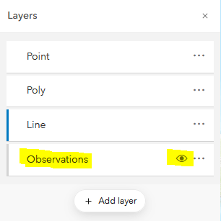
- If desired, use the menu icon to Rename the layers (i.e. Point observations,…) and click OK.
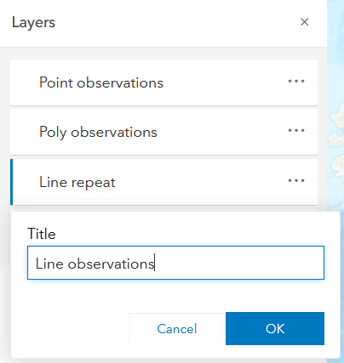
- Save the map .
- Click the Create app icon and choose Dashboards.
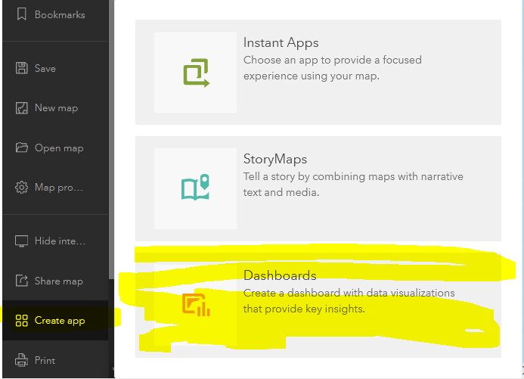

Create the Dashboard*
The following steps are only necessary if NatureServe has not cloned the survey, and related materials, for you.
- Within Create new dashboard, enter the appropriate data and click Create dashboard.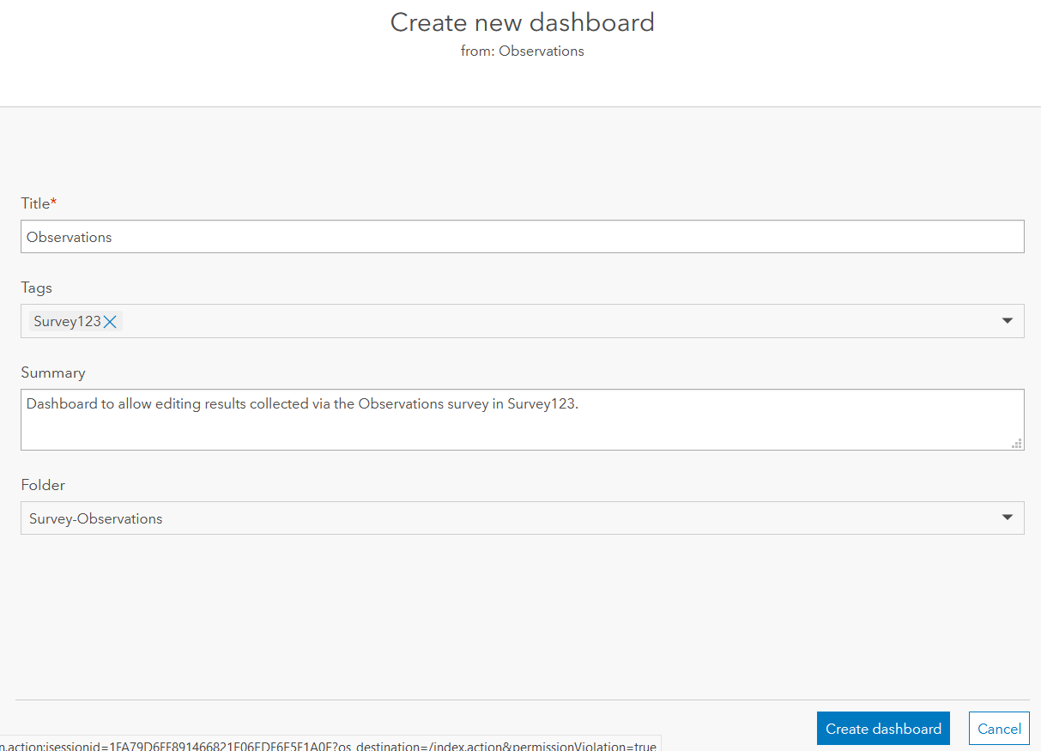
- Within the newly created dashboard, hover over the Map and expand the menu, displayed in the top left corner. Click the Configure icon.
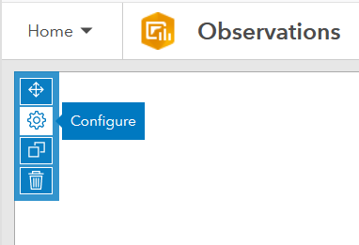
- Within the Settings section, indicate the tools to be available via the Map and click Done.
NOTE: Given that the Point, Line, and Polygon observations layers contain no data, I recommend disabling the pop-ups to prevent confusion. This data will be displayed in both a summary of the data as well as the survey response itself.
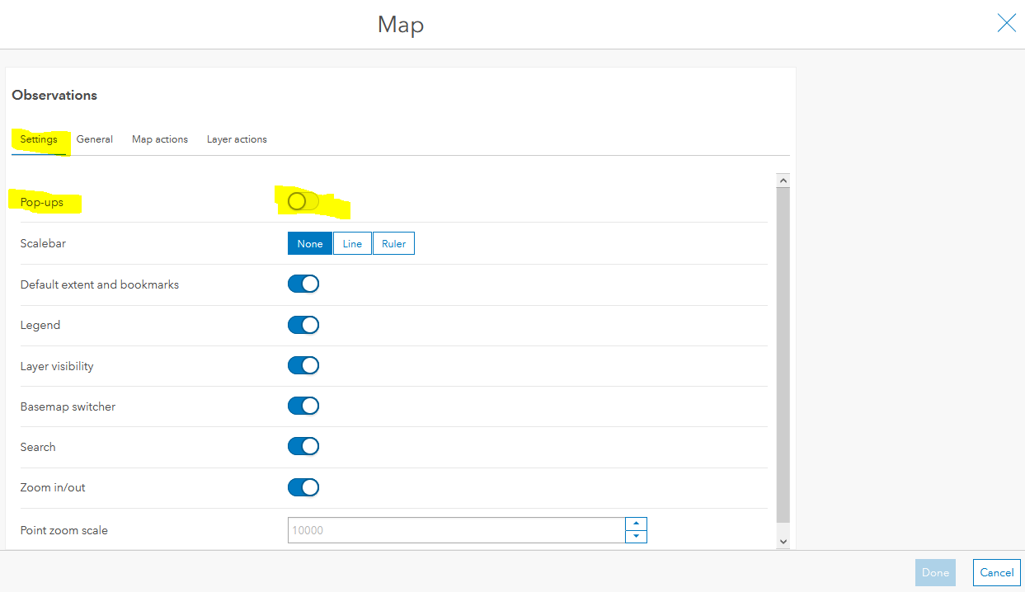
- Navigate to the Layer actions section.
- Click the Add action 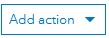 dropdown menu corresponding to the Point observations and select Zoom.
- Within the Zoom section, from the Add target dropdown, choose the Map icon. This will result in the Map zooming to the selected records.
- Repeat Steps 5 & 6 to configure the Zoom action for both the Line observations and Polygon observations layers.
- Click Done to save the configuration changes to the Map.
- Save the changes to the Dashboard.

Create a List of Observations*
- From the Add elements 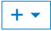 dropdown menu, choose List.
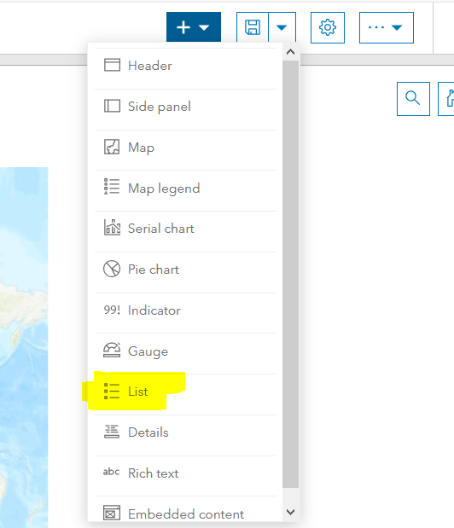
- Within List, select the Observations layer, as it contains all of the survey data.
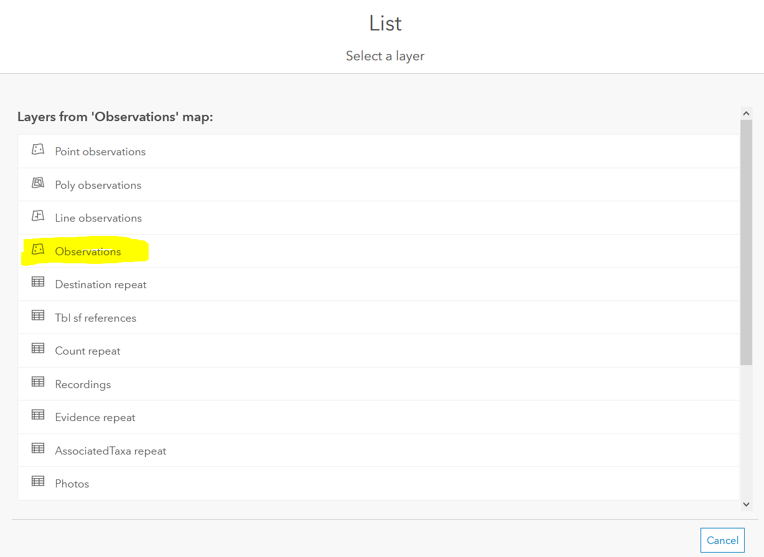
- Within the List settings, navigate to the List section.
  - Populate the Line item template with the desired data. Click the attribute 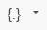 icon to include data from fields. Following is a formatted example which can be copied.
Scientific Name: {scientific_name}
Common Name: {common_name}
Higher Taxonomy: {higher_class_unit_name}
Visited By: {v_by}
Visit Date: {v_date}
Element Type: {element_type}
Pre-SF Type: {pre_sf_type}
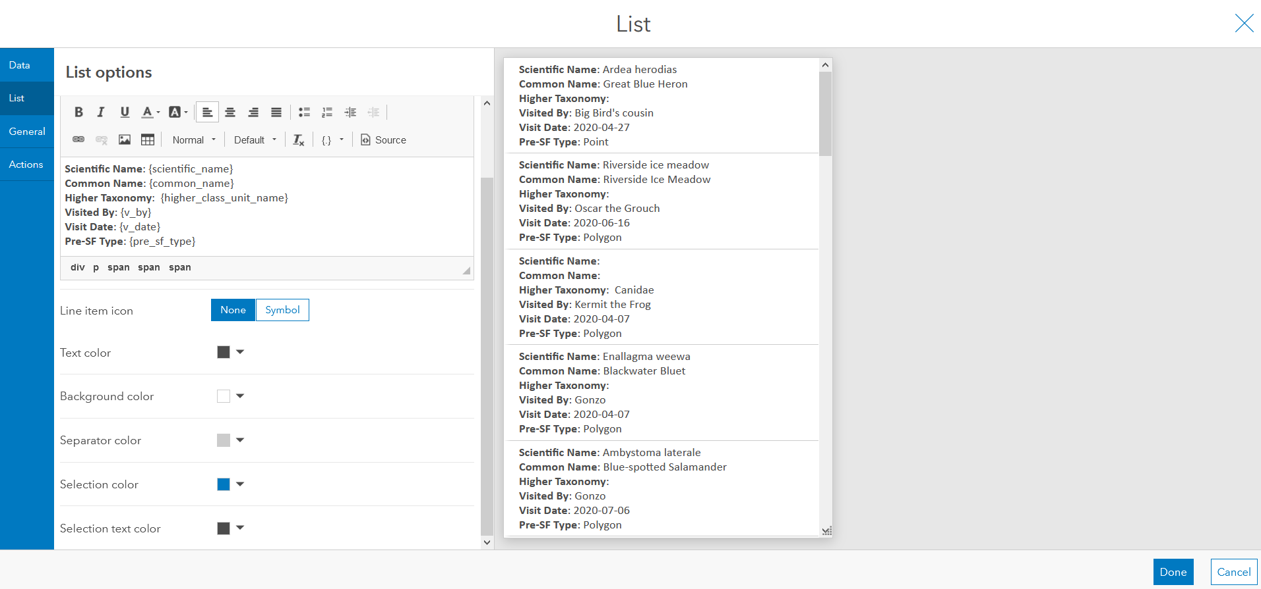
- Navigate to the General section and provide a Name, such as Survey summary.
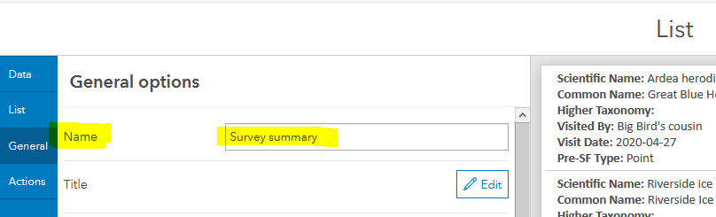
- Navigate to the Actions section, click the Add action dropdown to select Filter.
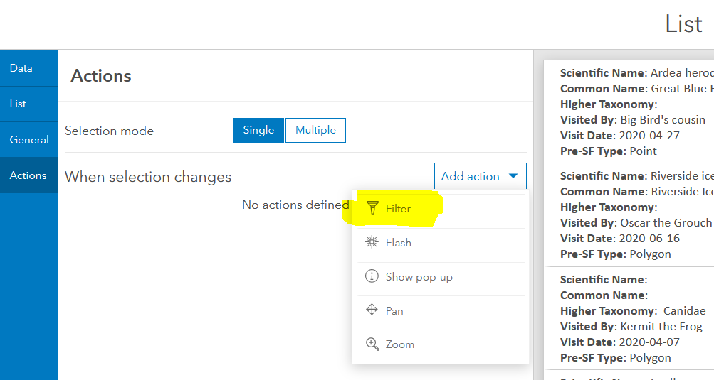
  - Within Filter, click the Add target dropdown to select the Observations layer. This will filter the layer within the Map based on the record selected in the List.
  - Again, click the Add target dropdown to select the Point observations layer (or Point repeat if not renamed).
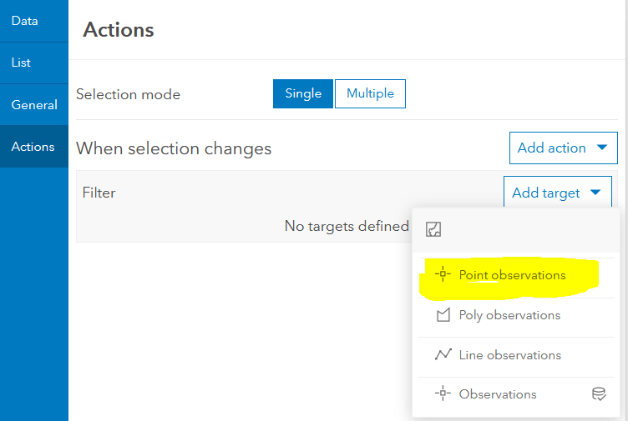
    - For the Point observations, choose GlobalID as the Source field and ParentGlobalID as the Target field. The Source field refers to the Observations layer on which the List is configured (see Step 16). The Target field refers to the corresponding data record within the Point observations layer, which we chose as the target layer in the previous step.
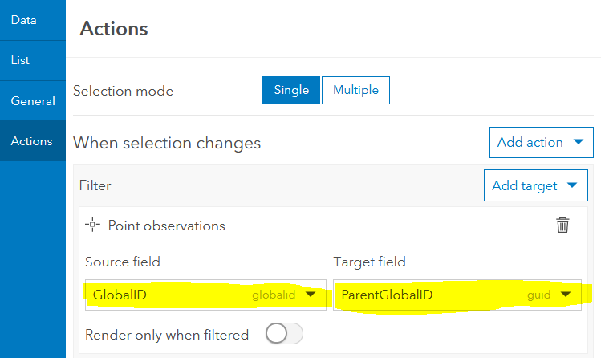
    - Repeat the previous two steps to add the Poly observations and Line Observations as additional Filter targets.
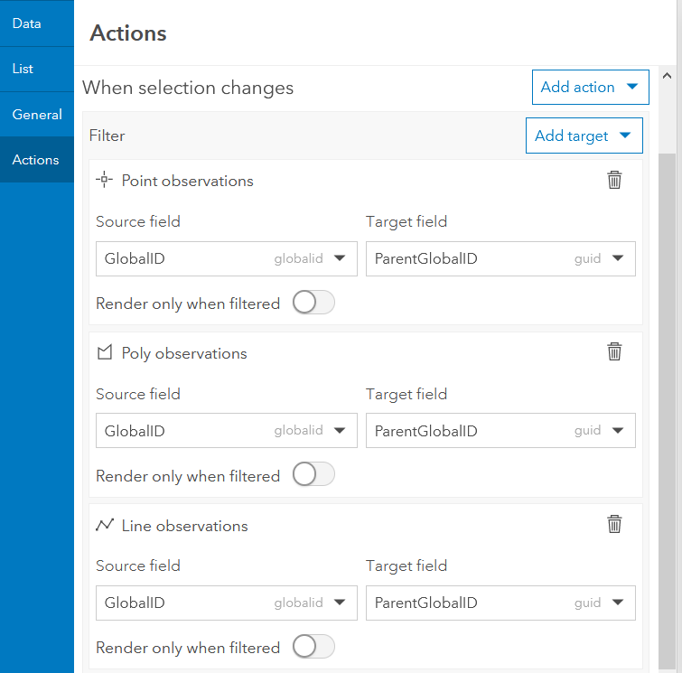
- Click Done to save the configuration changes to the List.
- Save the changes to the Dashboard.

Add the Photos/Audio Recordings*
NOTE: This section does not apply if you used the standard Observations_v1.4 survey, as the Photos are no longer in a repeat section but as an image with a multiline appearance setting. This does apply for the audio recordings which are within a repeat section.
- Within the dashboard, from the Add elements dropdown menu, choose Details.
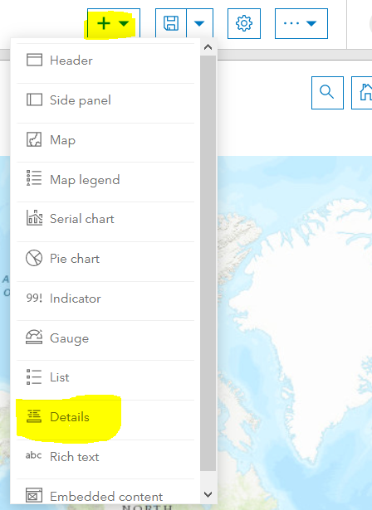
- Within Details, select the Photos table.
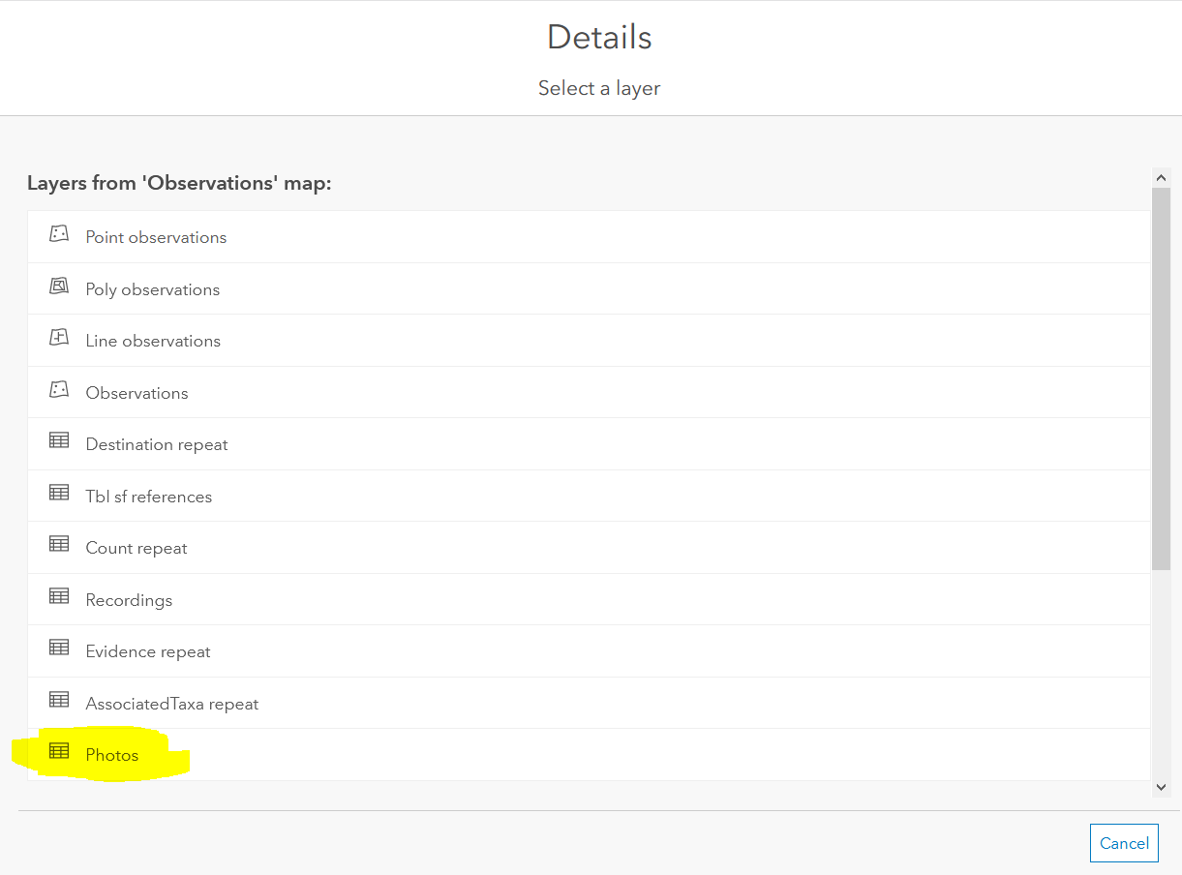
- Within the General section, change the Name to Photos and toggle Last update text.
- Click Done to save the configuration changes to the Photo Details.
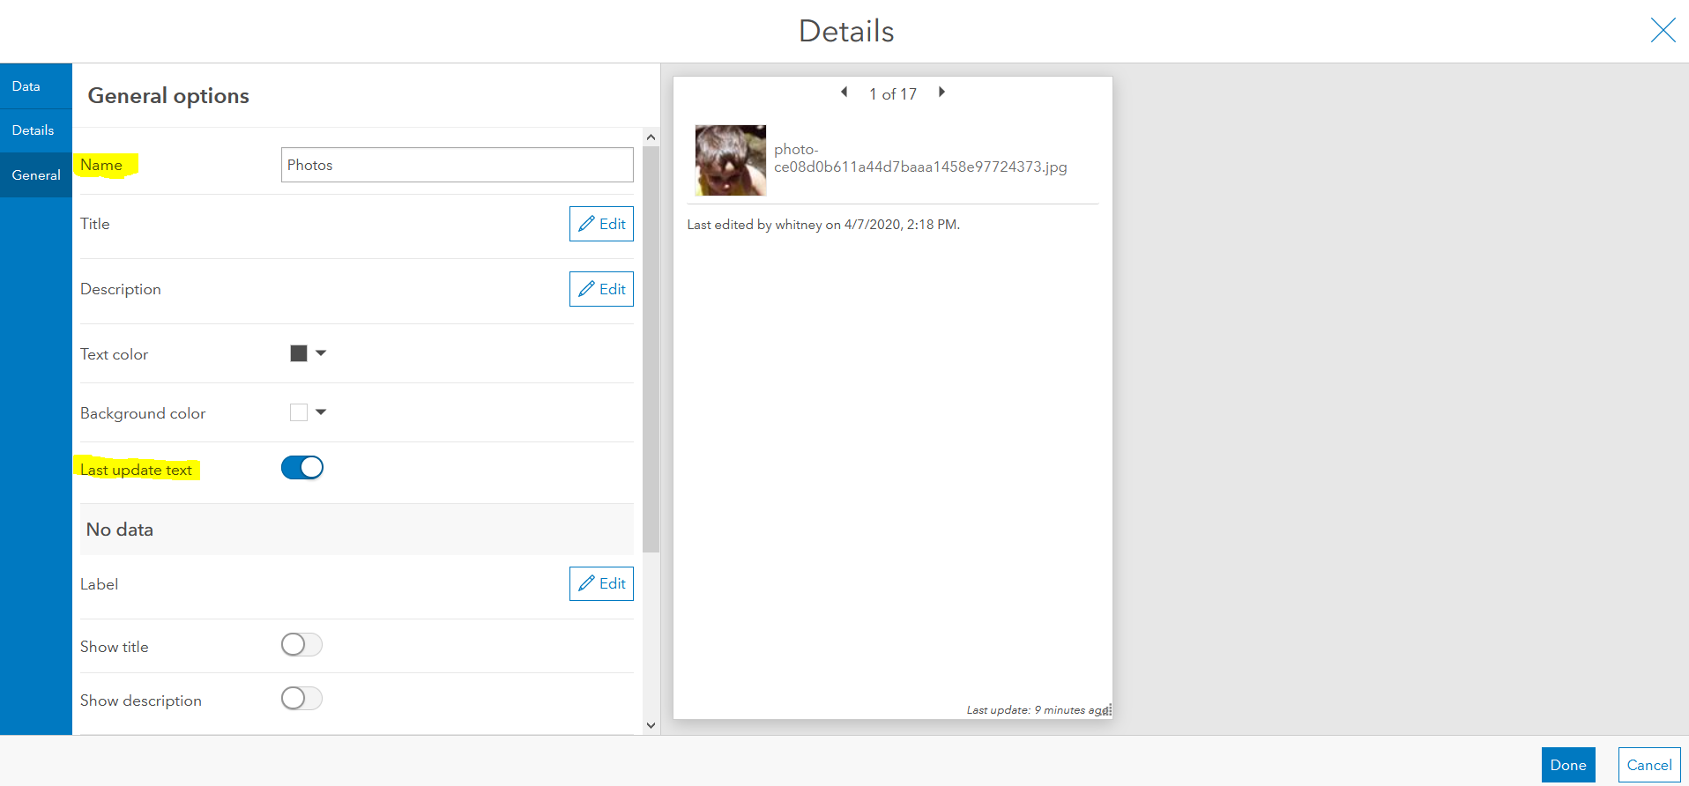
- Hover over the Photos and expand the menu, displayed in the top left corner.
- Click the Drag item 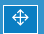 icon and drag the Photos onto the middle box on the Map to Stack the items.
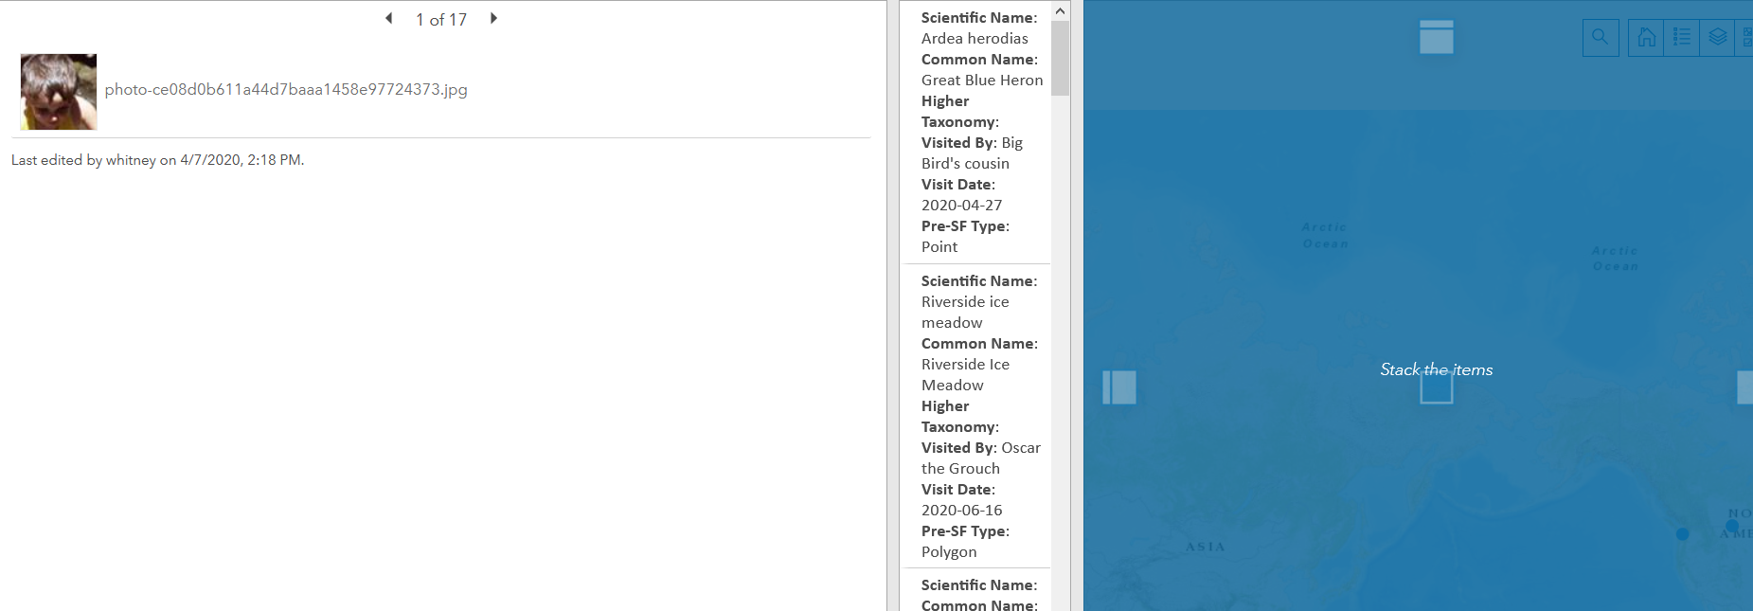
- Click the pencil icon next to Details to rename the tab Photos.
- Save the changes to the Dashboard.

Add the Survey*
- From the Add elements dropdown menu, choose Embedded Content.
- Within Embedded Content, select Features as the Type.
- Select the Observations layer.
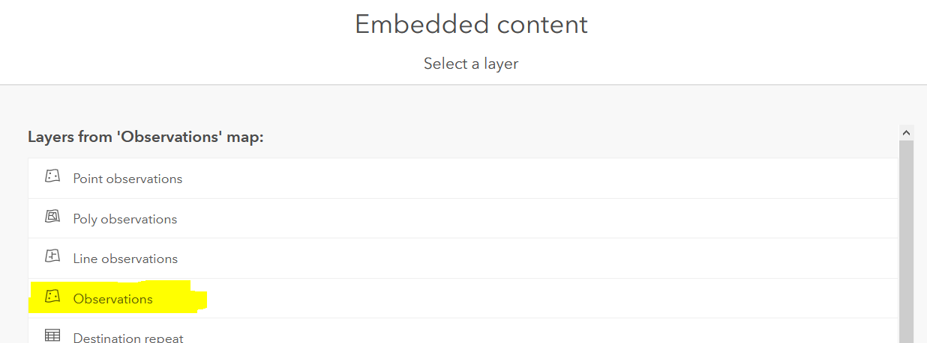
- Within the URL, enter the following, replacing xxxx with the id of the survey form, identified in Determine the id of the Survey Form:
https://survey123.arcgis.com/share/xxxx?mode=edit&globalId={globalid}&hide=navbar,footer&version=latest
  - mode=edit: the survey will be editable
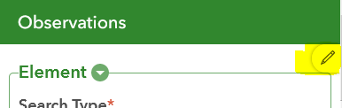
NOTE: to only allow the survey to be viewed, use mode=view
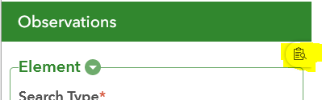
  - hide=navbar,footer: hides the navigation bar and footer
  - version=latest: uses the most recent version of Survey123
NOTE: See this blog article for more information on Web form URL parameters.
- To minimize wait time for survey results to load, decrease the Maximum features displayed.
- Within the General section, change the Name to Survey.
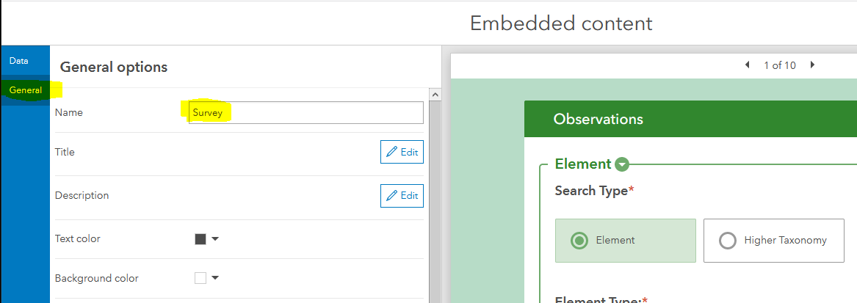
- Click Done.
- Click the Drag item icon and drag the survey onto the right box on the Map/Photos to Dock as a column.
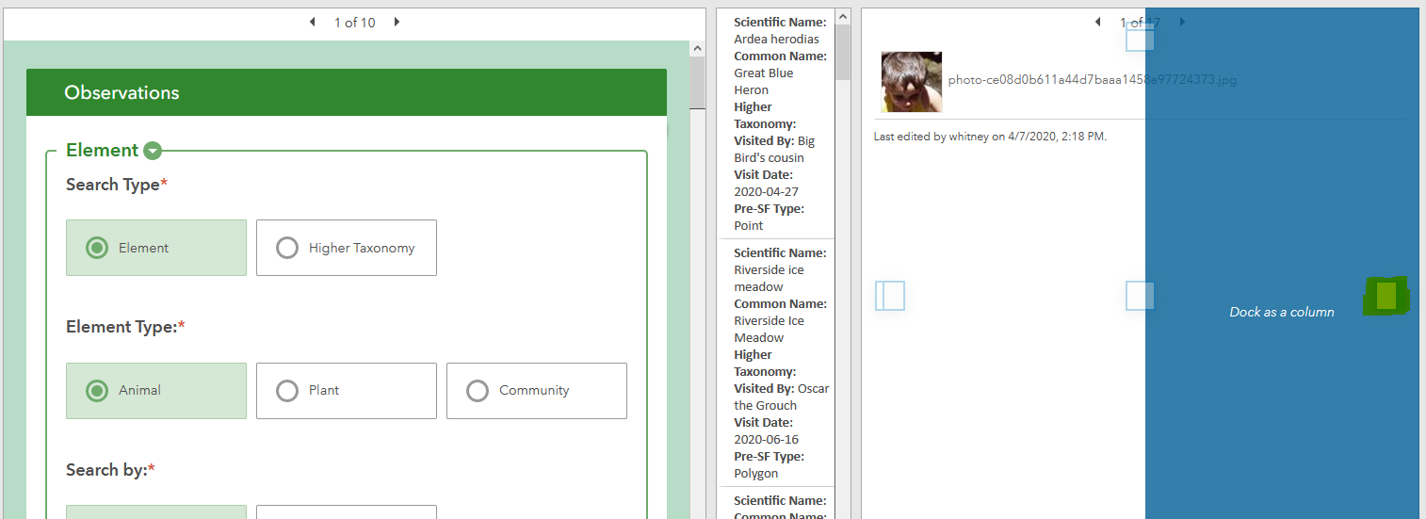
- The survey is repositioned to the right of the Map/Photos stack.
- Save the changes to the dashboard.

Add a Header*
- From the Add elements dropdown menu, choose Header.
- Within the Header panel, click Done unless you want to further customize the header.
- Save the changes to the dashboard.

Add Filters
Limit the data displayed within the Survey summary list by adding filters to the Header.
NOTE: Filters can also be added to a Side panel, should you not want to clutter the Header or have too many filters to fit well.
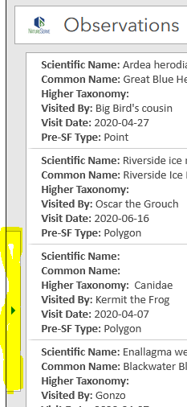 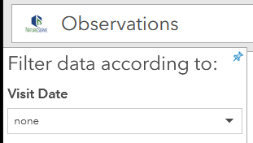
- Hover over the newly created Header, to expand the menu. Select the Add category selector icon.
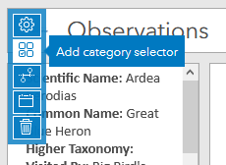
- Within the Category selector, select Grouped values from the Categories from option.
- Select the Observations layer, as it contains all the data.
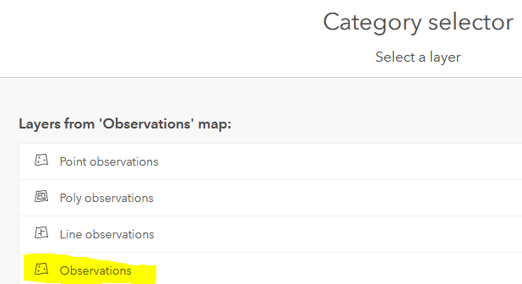
- From the Category field dropdown, select the field on which to base the filter (i.e. Scientific Name).
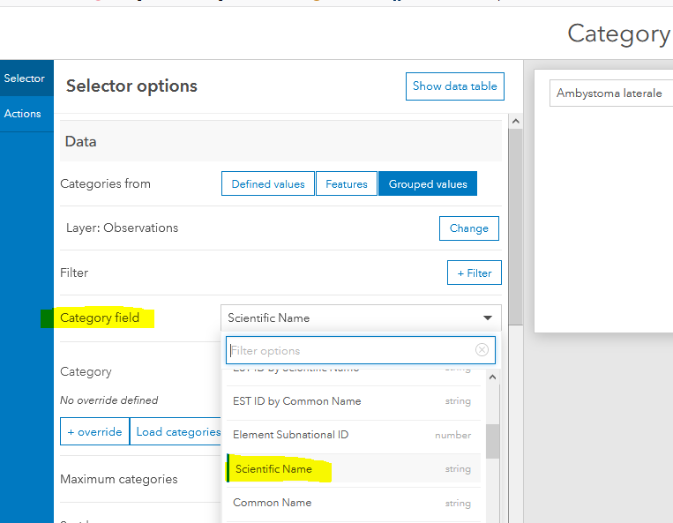
- In the Selector tab, allow for Multiple Selections.
- Toggle the None option and within Label for none, enter Filter by Scientific Name. NOTE: Including this here rather than as a Label, saves space to allow for additional filters.
- Name the selector Filter by Scientific Name.
- Within the Actions section, click Add action 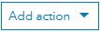 corresponding to When selection changes and select Filter.
- From the Add target 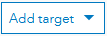 dropdown, select Survey summary.
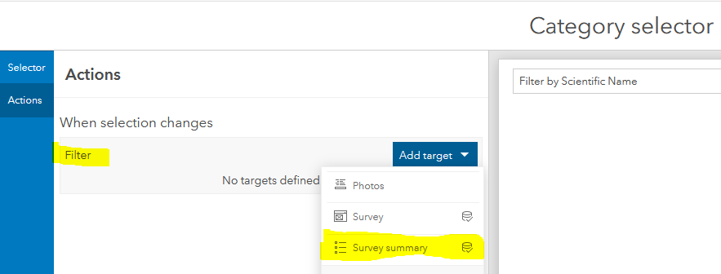
- Should you want the filter applied to the other elements, repeat step 9 for the Survey.
- Click Done and Save the changes to the dashboard.
- The filter appears in the Header.
- Repeat to create as many filters as would be helpful (i.e. Common Name, Visitor, Visit Date, Taxonomy).

Configure Actions of Survey summary list to include new elements*
The following configures the Survey summary list to filter the Photos & Survey results, based on the selected records. Additionally, the Map will zoom to the selected records.
- Hover over the Survey summary list and expand the menu, displayed in the top left corner. Click the Configure icon.
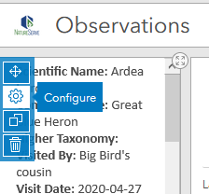
- Navigate to the Actions section, and within Filter, click the Add target dropdown to select Photos (or Recordings). This will filter the Photos (or Recordings) based on the record selected in the List. 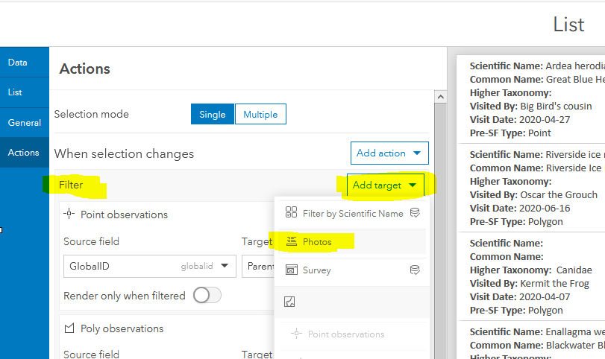
- Again, within Filter, click the Add target dropdown to select the Survey. This will filter the survey results based on the record selected in the List.
- Within When selection changes, click the Add action dropdown to select Zoom to the Map.
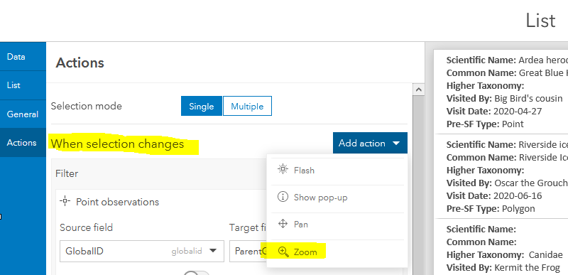
- Click Done and Save the changes to the dashboard.

Configure Actions of Map to Filter new elements*
The following will result in the Photos, Survey, and Survey summary records being filtered according to the selection within the Map. This gives the option of a spatial filter, rather than the attribute filters developed within the Add Filters section.
- Hover over the Map and expand the menu, displayed in the top left corner. Click the Configure icon.
- Within the Map configuration, navigate to the Layer actions section.
- Click the Add action dropdown menu corresponding to the Point observations and select Filter.
- Within the Filter section, click the Add target dropdown and choose Survey summary.
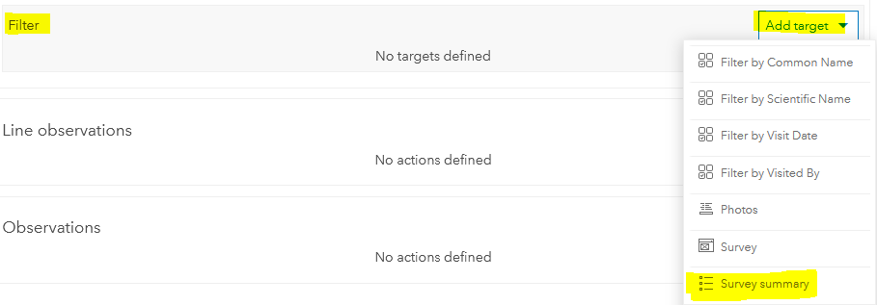
- Within the Survey summary section, choose ParentGlobalID as the Source field and GlobalID as the Target field. The Source field refers to the field within the Point observations layer on which the Action is configured. The Target field refers to the corresponding data record within the Observations layer on which the Survey summary list is based (see Step 2 within Create a List of Observations).
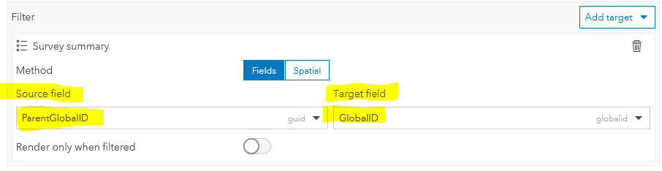
- Repeat Steps 4 & 5 to Filter the Survey and Photos/Recordings, as well.
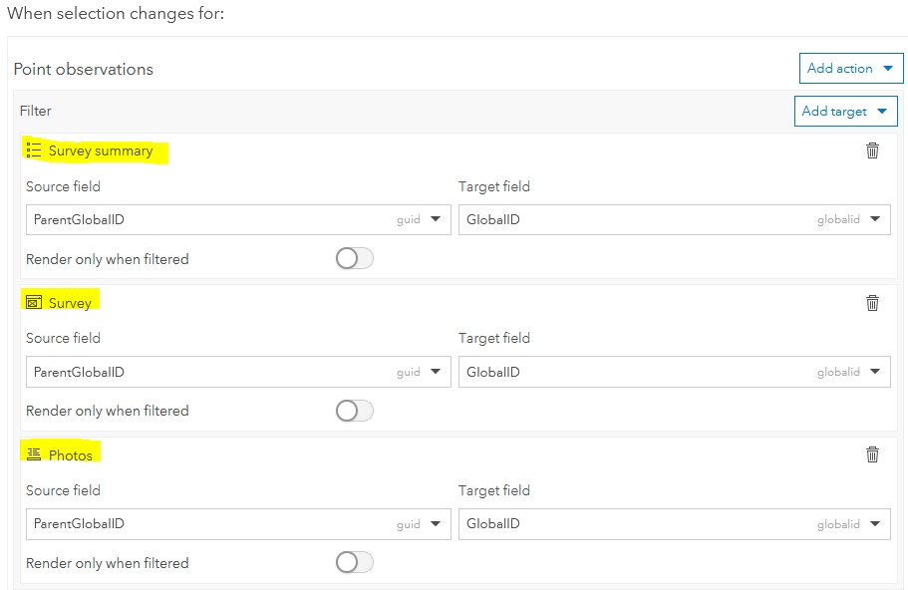
- Repeat Steps 3 through 6 to Filter the Line and Polygon observations
- Click Done and Save the changes to the dashboard.

Configure the dashboard*
- Click the Configure icon at the top of the dashboard.
- Within Dashboard settings, navigate to the General section and toggle Allow element re-size and click Done. This will allow the Dashboard to resize according to the size of the viewing device.
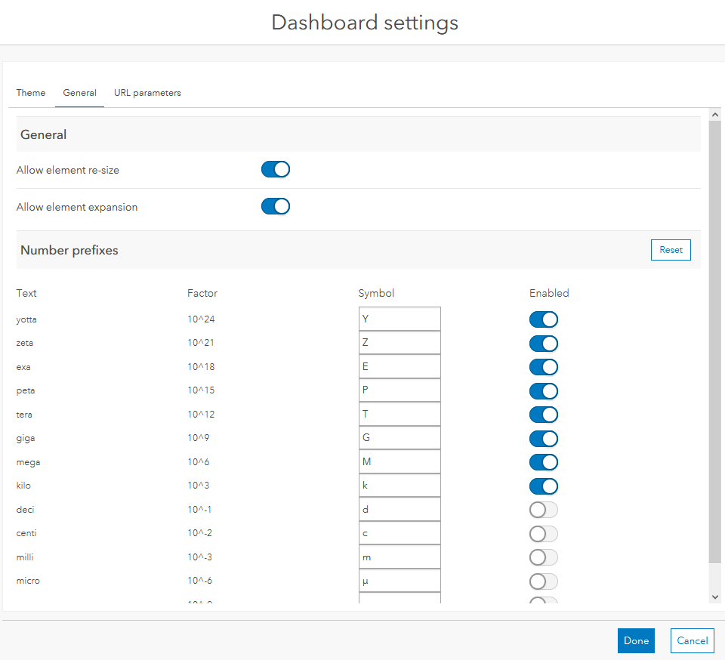
- Resize the elements within the dashboard to your preference.
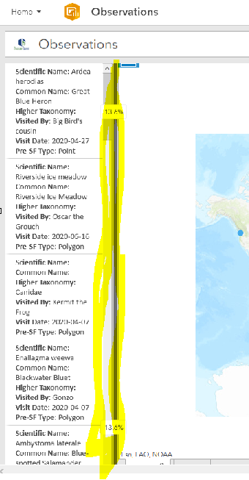
- Save the changes to the dashboard.
- To create additional versions of the dashboard (i.e. view only or only edit certain fields [i.e. QC fields]), from the Save menu, choose Save as and give it a new name (i.e. Review or QC Observations).
- From the Home menu, choose Dashboard item details.
- Within the Dashboard details page, Edit thumbnail to include the same icon used for the survey.
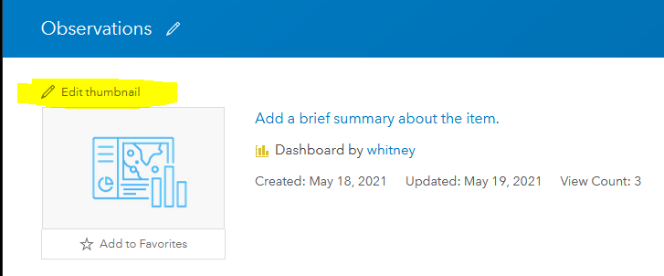
  - Within Create Thumbnail, Browse to the Beehive.png or icon of your choice.
  - Adjust the Zoom scale to include the entire icon and click OK.
- Share the dashboard with the appropriate audience and Save the changes.
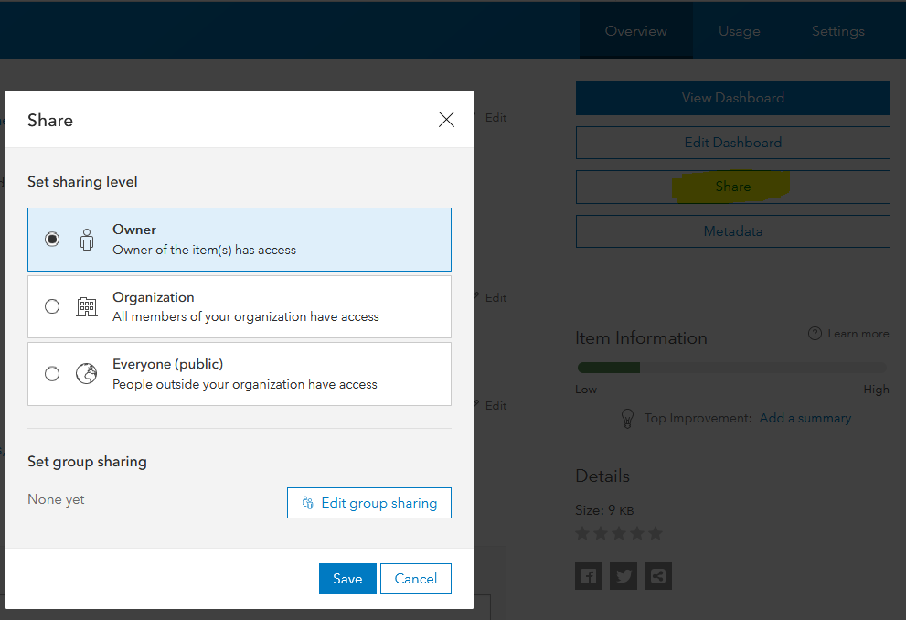
- View Dashboard to determine if further changes are desired.
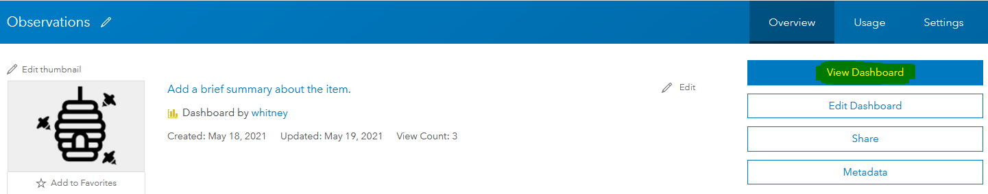

Create additional versions of the Dashboard for QC or Review only purposes (OPTIONAL)*
The following steps are only necessary if NatureServe has not cloned the survey, and related materials, for you.
It may be useful to have additional versions of the Dashboard for sharing to different user groups, based on their roles and use of the data. The initial dashboard allows editing of all the survey responses. Additional versions may include:
- Only QC fields are editable
- Review of survey responses only – no edits allowed
- Survey responses limited to animal/plant data

Create a view only version of the dashboard (OPTIONAL)*
The following example provides information for duplicating the original dashboard to build a version for view only (i.e. no edits allowed), utilizing the survey created in the previous section: Create a version of the survey which only allows specific fields to be editable (i.e. QC fields)
- Edit the original dashboard, created in the Create the Dashboard section.
- Finalize all changes as the dashboard will be duplicated.
- From the Save dropdown list, select Save as.
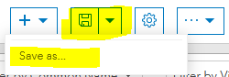
- Name the new dashboard appropriately and maintain it in the same folder, to easily find all dashboards associated with the survey (i.e. Review Observations).
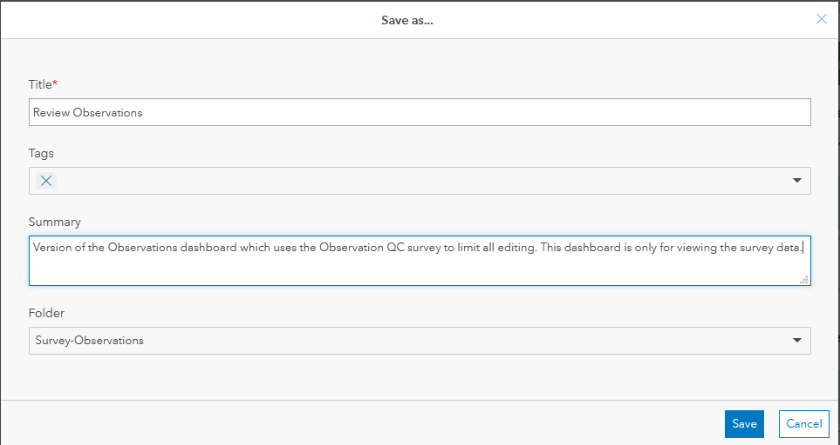
- Hover over the survey portion of the dashboard and select Configure.
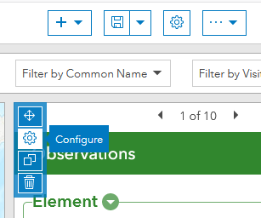
- Within Embedded content, edit the URL to change the mode from edit to view.
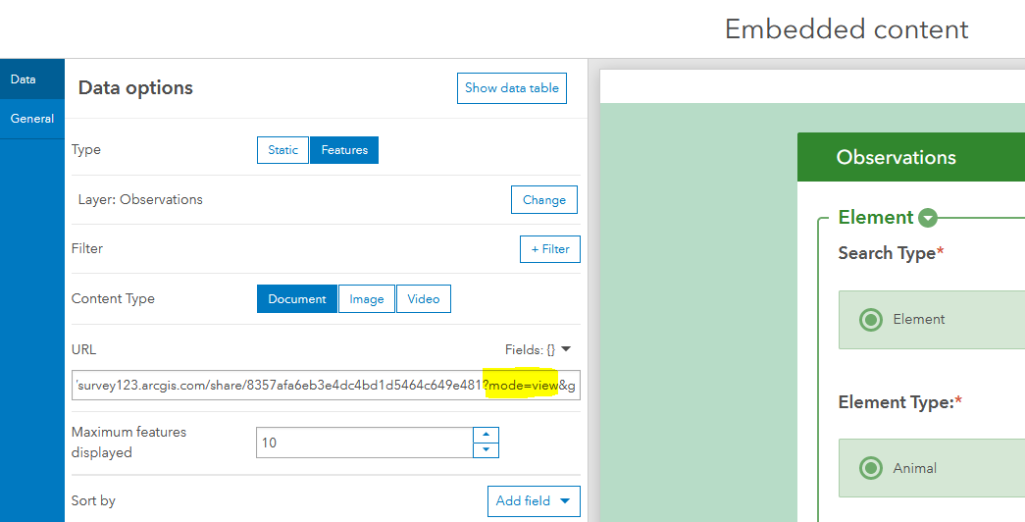
- To improve performance of the dashboard opening and the surveys displaying, consider limiting the Maximum features displayed to 10, or another value.
- Click Done to save the changes to the survey configuration.
- Save 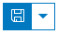 the changes to the Review dashboard.

Create a QC version of the dashboard (OPTIONAL)*
The following example provides information for duplicating the original dashboard to build a version used only to edit the QC fields. Doing so requires a new survey be created, which limits all fields to readonly, except for those which should be editable – the QC fields, in this case.

Create a version of the survey which only allows specific fields to be editable (i.e. QC fields)* (OPTIONAL)
The instructions below apply, should another version of the Dashboard be desired, such as one which only allows the QC fields to be editable, for those users only responsible for QCing data.
- Create a new survey called Observations QC by choosing the Observations survey in My surveys, created when the original survey was published.
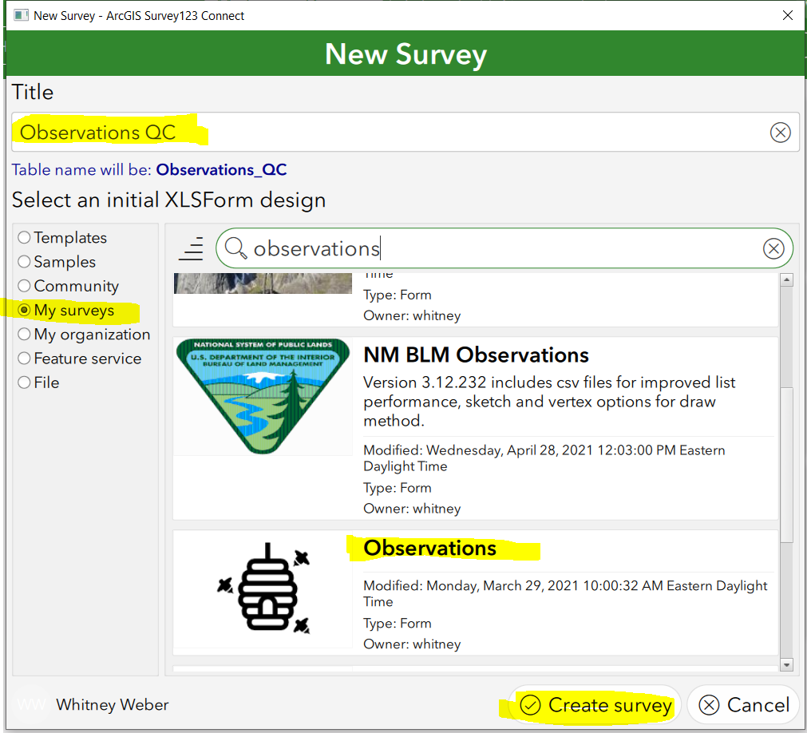
- Within the newly created survey, click the XLSForm icon to open the spreadsheet.
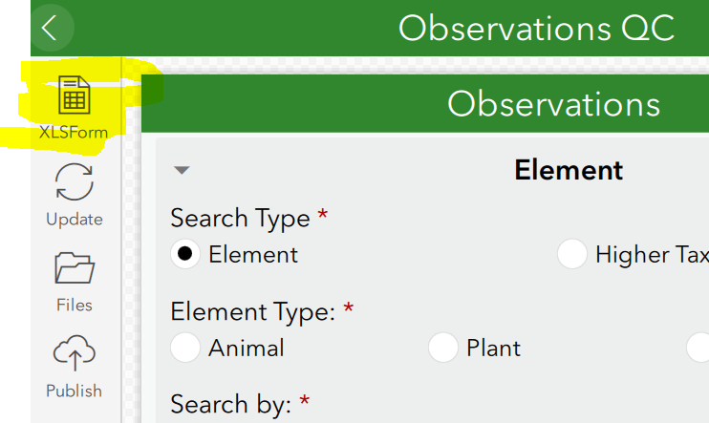
- Within the survey tab,
  - set the value to yes within the readonly column for all rows before the Quality Control section.
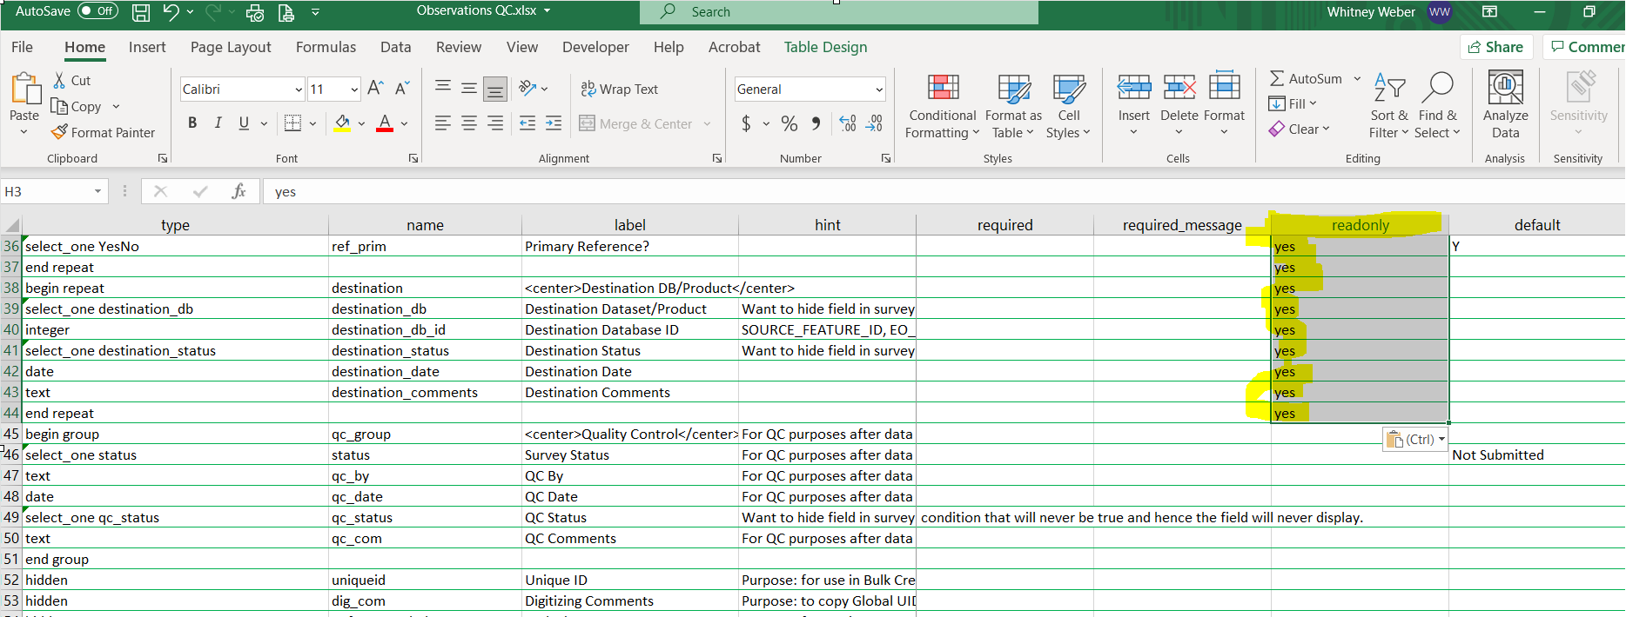
  - Remove compact from the appearance column for the row with name = qc_group
- Navigate to the settings tab.
  - form_title: Change the form_title (i.e. QC Observations) to differentiate it from the original, fully editable survey
  - form_id: Enter the name of the layer in the feature layer that is used by the survey. (Observations).
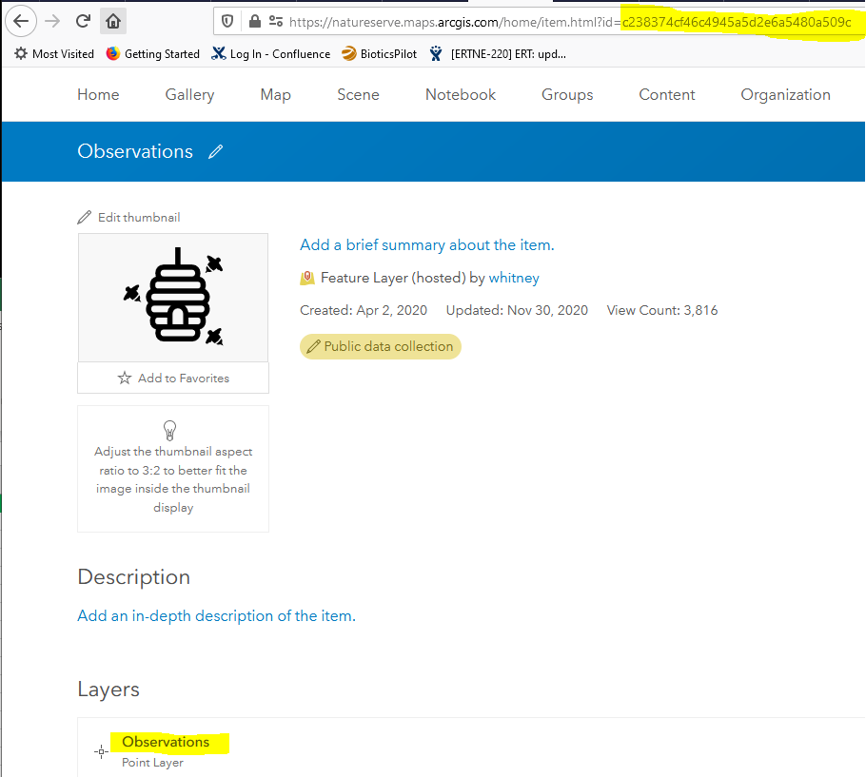
  - submission_url: To create this URL, concatenate the Item ID of the Observations Feature Layer with the following, if referencing an ArcGIS Online item:
https://www.arcgis.com/sharing/rest/content/items/id
https://www.arcgis.com/sharing/rest/content/items/c238374cf46c4945a5d2e6a5480a509c
If using a layer within a portal, rather than ArcGIS Online, the URL would be:
https://<host>:<port>/arcgis/sharing/rest/content/items/id
See this help topic for additional information.
- Save the changes to the spreadsheet and view the survey. The Quality Control section should be expanded and only fields within that section should be editable.
- Navigate to the Options section of the survey to Enable Inbox folder and Allow inbox surveys to be edited.
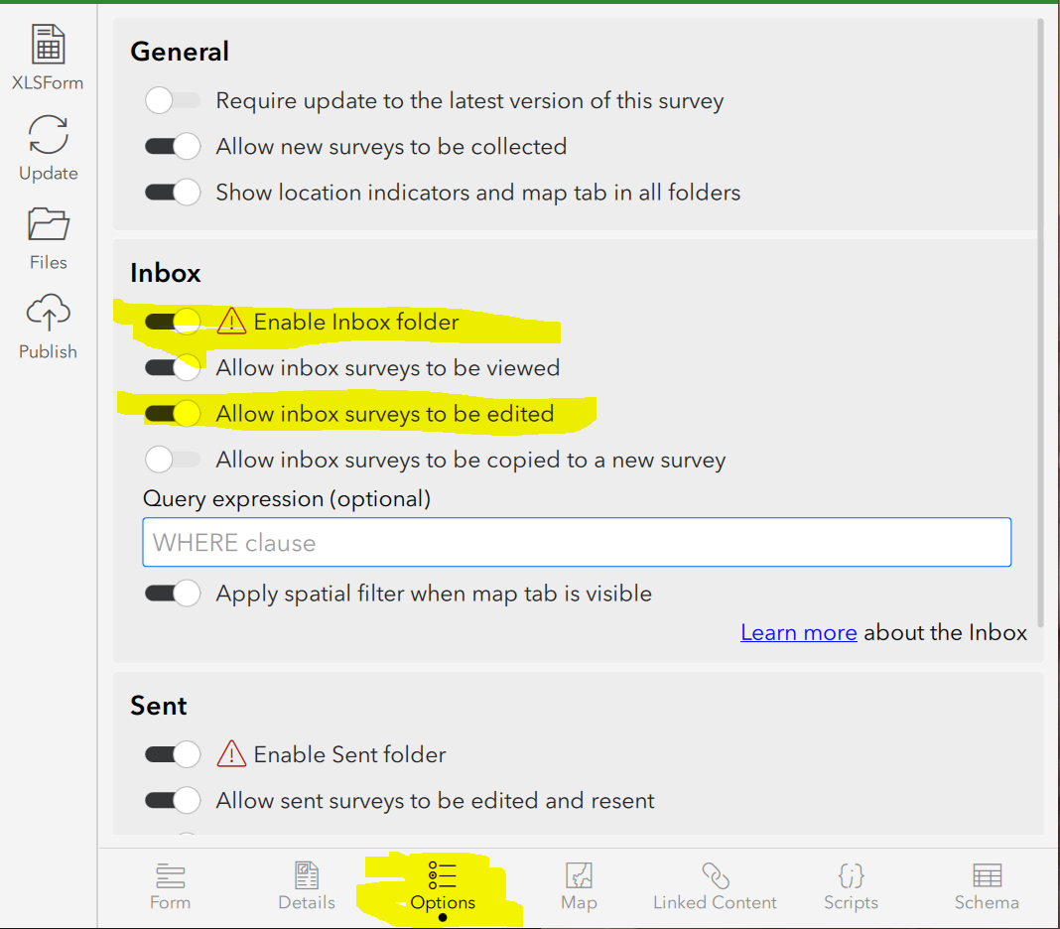
- Publish the Observations QC survey.
  - In the Publish Observations dialog, click Options and disable Create coded value domains from choices and click OK. NOTE: This is CRITICAL because the correct values required for Biotics have already been configured.
  - Publish Survey and then click OK once complete.
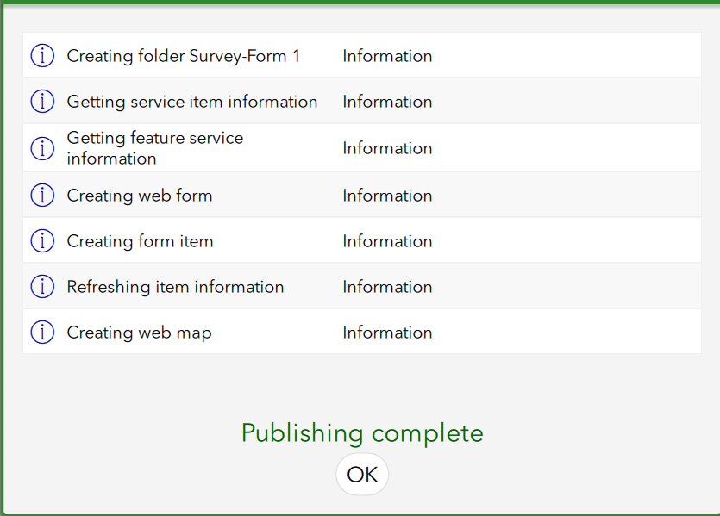
- From the Table of Contents, click the … icon and select Manage in Survey123 website.
NOTE: Alternatively, if you’re not in Survey 123 Connect for ArcGIS, log into the Survey123 for ArcGIS website. The survey will be displayed.
- Within the Observations survey on the Survey123 website, click the URL and copy everything after survey/ and before /… , as shown in blue below.
- Paste this survey form ID somewhere to access it in a later step, to add the QC survey to a QC dashboard.
- Click on the Collaborate tab.
NOTE: Alternatively, if you went to the website rather than going through Connect, click on the lock icon on the Observations survey to go directly to the Collaborate tab. See the Share survey topic for additional details regarding any of the following options.
  - Within the Share survey section:
    - In the Link section, indicate to Ask the user how to open the survey, in browser or in the Survey123 field app. Provide the weblink or QR code to potential users of the survey so that they can easily access it.
    - indicate who will be able to submit data – Everyone or certain members of your organization or specific groups. Given that these users will only be able to edit the specific fields, the group of users will likely differ from those granted permission to edit the full survey.
    - indicate which privileges those submitters will have.
    - whether to Enable draft mode
    - and whether to Allow multiple submissions.
    - Click Save.
  - Within the Share results section:
    - Indicate who can view data within the survey
    - Indicate what data viewers can see
    - Indicate what viewers can do with the data
    - Click Save.
  - Within the Update survey section, indicate if members of a group should have privileges to update the survey design or settings. This is very useful, so that more than just the survey publisher has access!
  - If using groups to allow access to the survey, within the Group Settings section, follow the links to manage groups with appropriate people if that has not been previously done for your Organization.

Create the QC Only Dashboard*
The following instructions indicate how to create a dashboard which only allow specific fields within the survey to be edited, such as the QC fields. This dashboard requires the survey developed in the previous section, which set all other fields to readonly.
- Edit the original dashboard, created in the Create the Dashboard section.
- Finalize all changes as the dashboard will be duplicated.
- From the Save dropdown list, select Save as.
- Name the new dashboard appropriately and maintain it in the same folder, to easily find all dashboards associated with the survey (i.e. QC Observations).
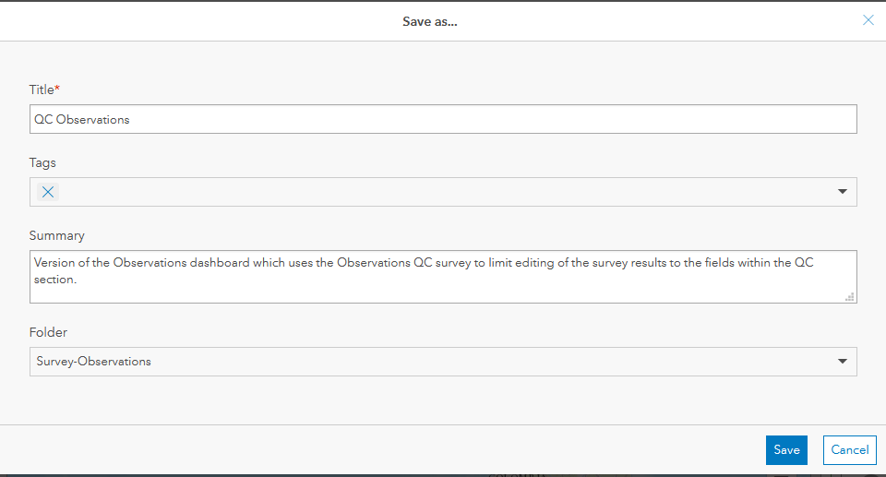
- Hover over the survey portion of the dashboard and select Configure.
- Within Embedded content, change the id within the URL section to reflect the survey form id of the QC survey, as determined in Step 10 of Create a version of the survey which only allows specific fields to be editable (i.e. QC fields), rather than the Observations survey.
  - Edit the URL, to replace the existing survey id, with that for the QC Observations survey, starts after share/ and before ?.
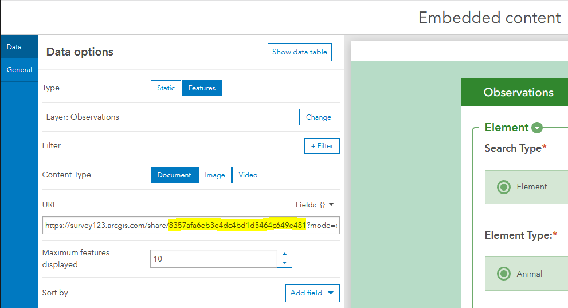
- To improve performance of the dashboard opening and the surveys displaying, consider limiting the Maximum features displayed to 10, or another value.
- Click Done to save the changes to the survey configuration.

Add an additional Category Selector to Filter by the Survey Status value*
This filter will identify surveys which have not been qc’d as indicated by Survey Status value being set to Not Submitted, rather than Submitted. The QC fields are only displayed when Survey Status = Submitted.
- Repeat the steps within the Add Filters section for Category field = Survey Status.
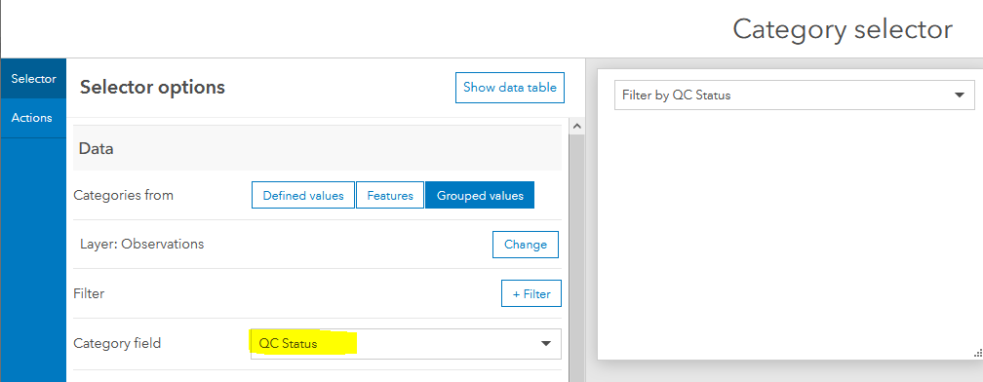
- Click Done to save the newly created Category selector.
- Hover over the newly created filter and click the left arrow icon to move the filter to the leftmost location, as it is the filter most likely to be used in this dashboard.
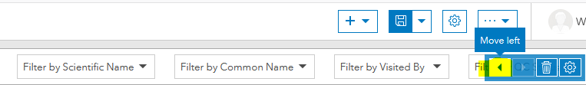
- Save the changes to the QC dashboard.

Include Batch Edit tool in Dashboard* (OPTIONAL)
It may be more efficient to batch edit attributes rather than edit the survey responses individually. An example of this would be to batch edit the QC fields. Following are instructions for building the necessary web app and embedding the web app in the QC dashboard.

Create a Web App to allow for batch editing of survey responses*
- Log into ArcGIS Online and from the Content section, My Content, select the Survey-Observations folder within the Table of Contents.
- Click the menu associated with the Observations Web Map and select View item details.
- From the Create Web App dropdown, select Web AppBuilder.
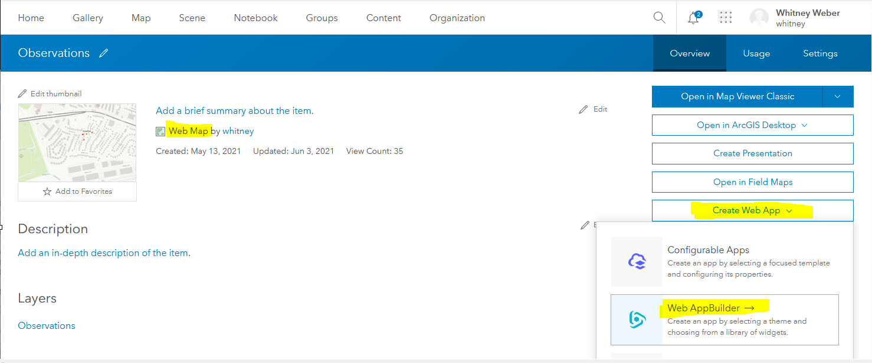
- Give the web app an appropriate Title and Summary (Optional).
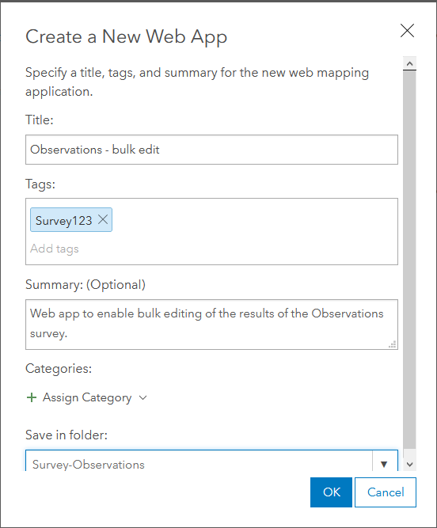
- Within ArcGIS Web AppBuilder, select the desired Theme. (Given that this will be embedded within the Dashboard, I would recommend a minimal theme, such as the Billboard Theme).
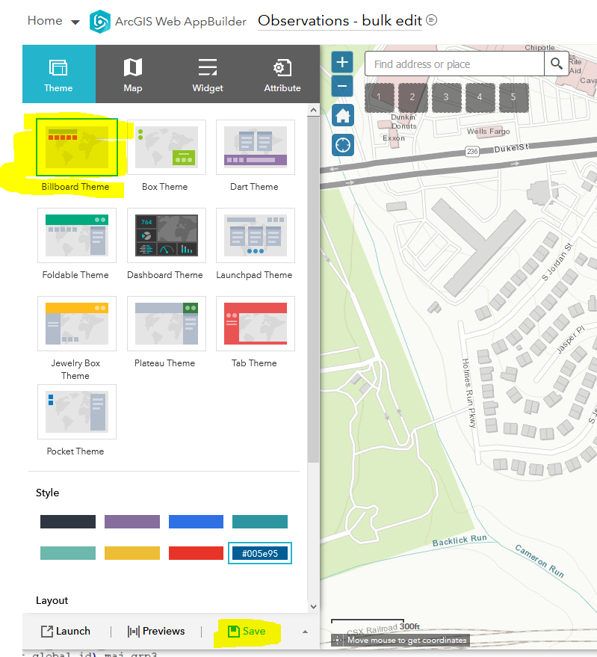
- Save the changes and move to the Widget tab.
- Within the Widget tab, click the 1 Widget.
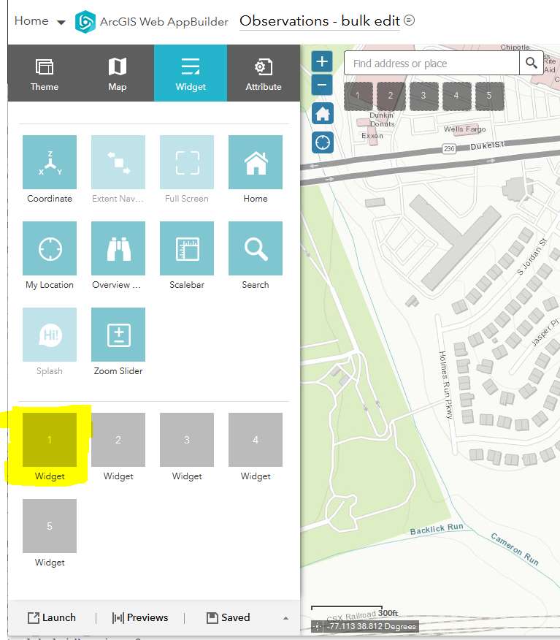
- Within the Choose Widget window, type edit to filter the options and select the Batch Attrib… widget and click OK.
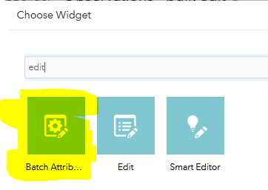
- Within the Configure Batch Attribute Editor window, navigate to the Define Layer(s) to Update section and select Observations.
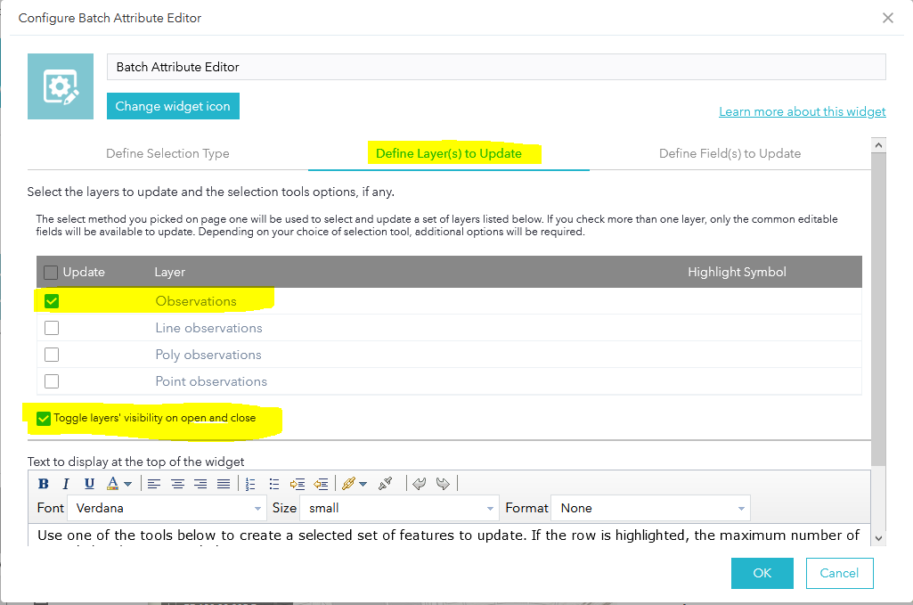
- Navigate to the Define Field(s) to Update section and select the fields that should be editable either individually or via the Editable checkbox, to indicate all fields. NOTE: Allowing all fields to be editable will significantly impact the tools performance. Consider only including the necessary fields for editing, such as the QC fields.
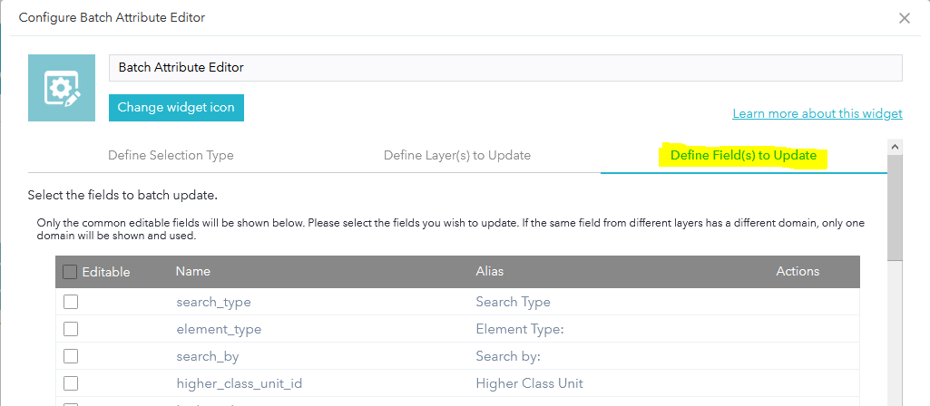
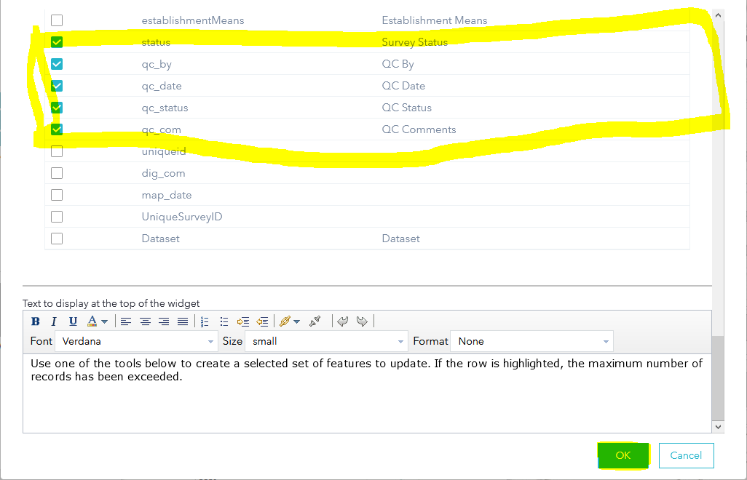
- Click OK to save the configuration settings to the Batch Attribute Editor.
- Should you wish to add additional widgets, do so now, then Save the changes.
- Navigate to the Attribute tab and click the logo icon to add the logo being used for the Observations survey and dashboard (i.e. Beehive.png).
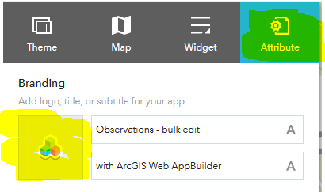
- Click Upload and navigate to the desired logo, then click OK.
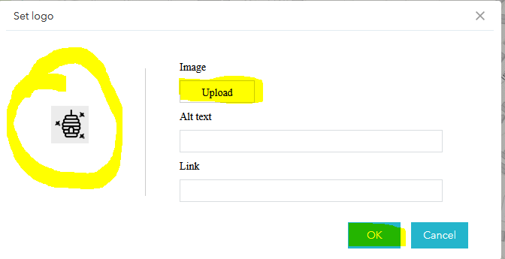
- Save the changes and Launch the newly created app.
- Within ArcGIS Online, click the newly created Observations – bulk edit Web Mapping Application to View item details.
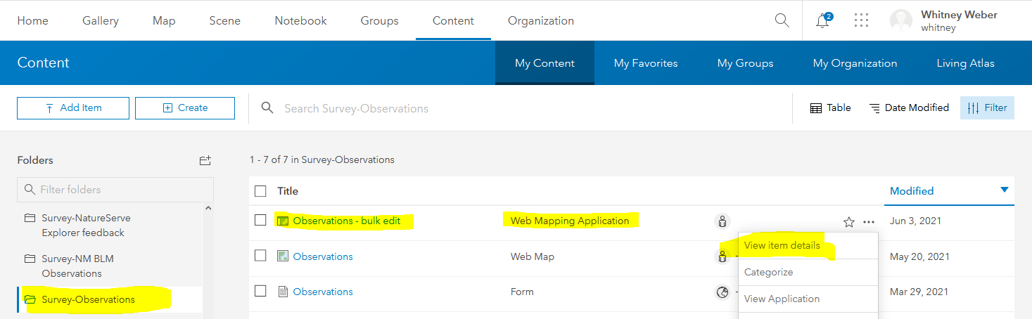
- Share the Web Mapping Application to the same group of people as the Dashboard in which it will be embedded.
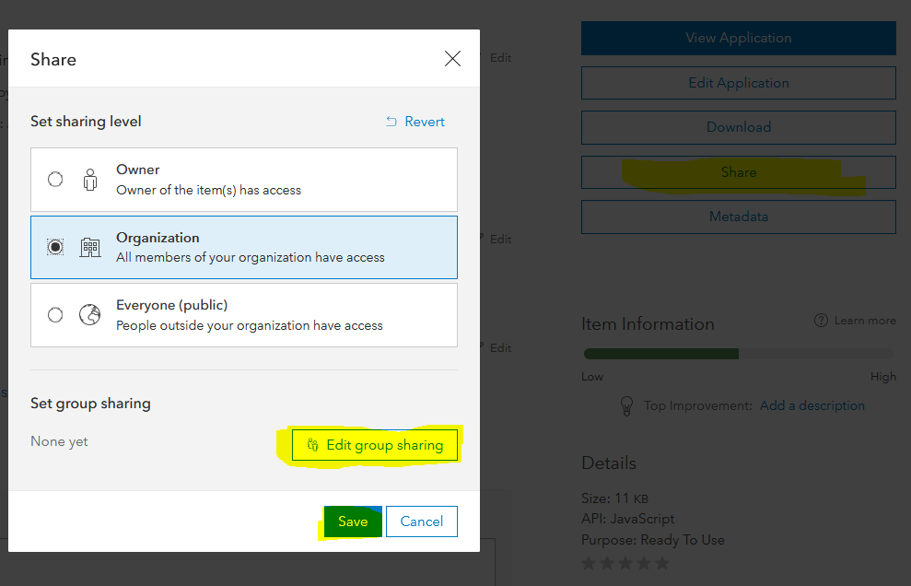
- Scroll to the bottom of the page to copy the app’s URL
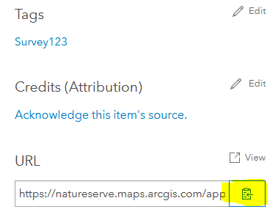

Embed the Web Mapping Application in the Dashboard*
- Return to the appropriate dashboard (QC Dashboard) and from the Add elements dropdown menu, choose Embedded Content.
- Within Embedded Content, select Static as the Type and paste the app’s URL into the text box.
- Navigate to the General tab and give a logical name such as Batch Attribute Editing app and click Done.
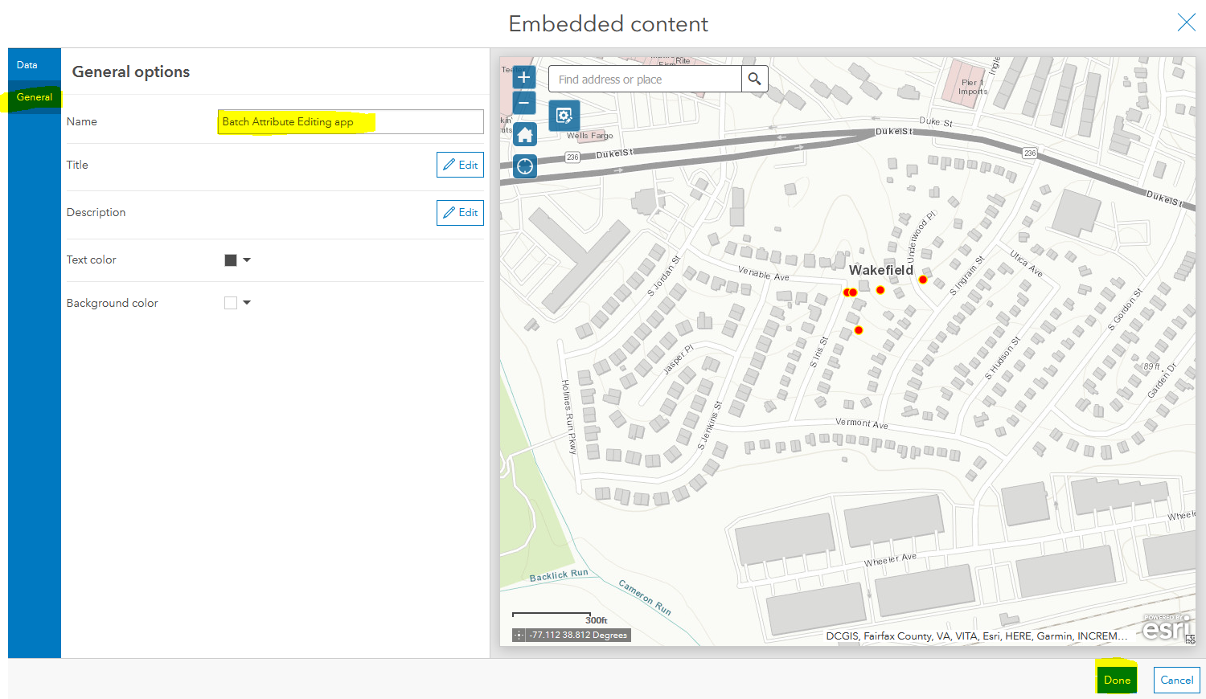
- Hover over the web app and expand the menu, displayed in the top left corner.
- Click the Drag item icon and drag the web app onto the middle box on the Map to Stack the items.
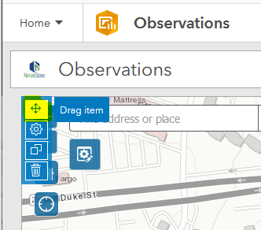
- Click the pencil icon next to Embedded content to rename the tab Batch edit.
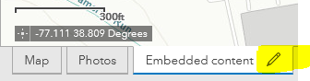
- Save the changes to the Dashboard.

Create dropdown List for QC fields*
Create dropdown lists for the Survey Status and QC Status fields to reflect those defined in the survey, to populate the lists within the Batch (Attribute) Edit tool. Unless each of these values already exist within the data set, they will not be displayed, allowing for free-form typing/values. Creating the lists will prevent data inconsistencies and allow for easier filtering/searching.
- Log into ArcGIS Online and from the Content section, My Content, select the Survey-Observations folder within the Table of Contents.
- Click the menu associated with the Observations Feature Layer (hosted) and select View item details.
- Within the Observations feature layer details page, navigate to the Data tab.
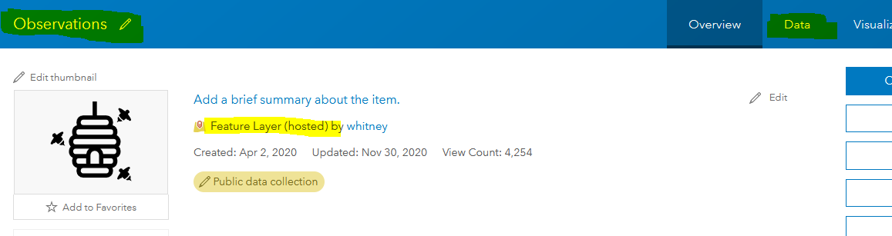
- Within the Data tab, select Fields.
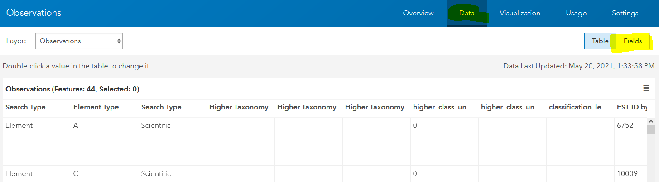
- Scroll down through the list of fields until you reach Survey Status and click on the link to see the field details.
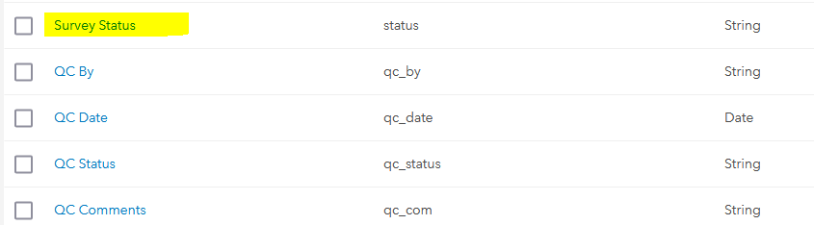
- Click Create List.
- Enter the following values for both the Label & Code, as defined within the Observations.xlsx (survey) spreadsheet: Not Submitted, Submitted.
- Save the changes.
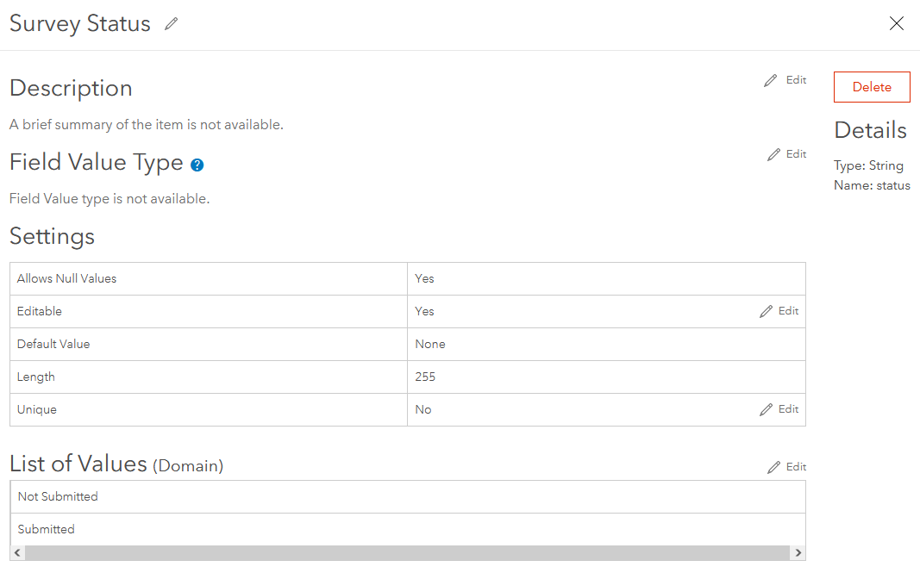
- Repeat Steps 5 – 8 for the QC Status field, entering the following values for both the Label & Code, as defined within the Observations.xlsx (survey) spreadsheet: Incomplete, Passed, Failed.
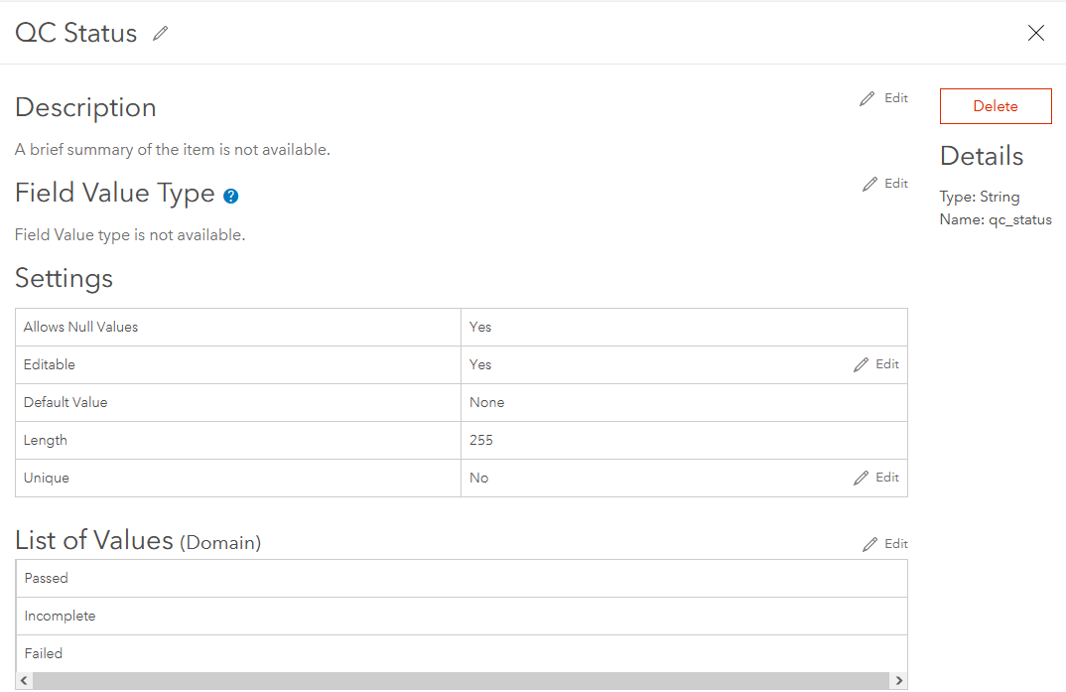

Using the dashboard
Welcome to the dashboard(s), which will allow users to view/edit/qc the results of the survey, collected in the field, via Survey123.
Filter the data displayed within the Survey summary (list) by applying one or more filters. By default, all data is displayed.
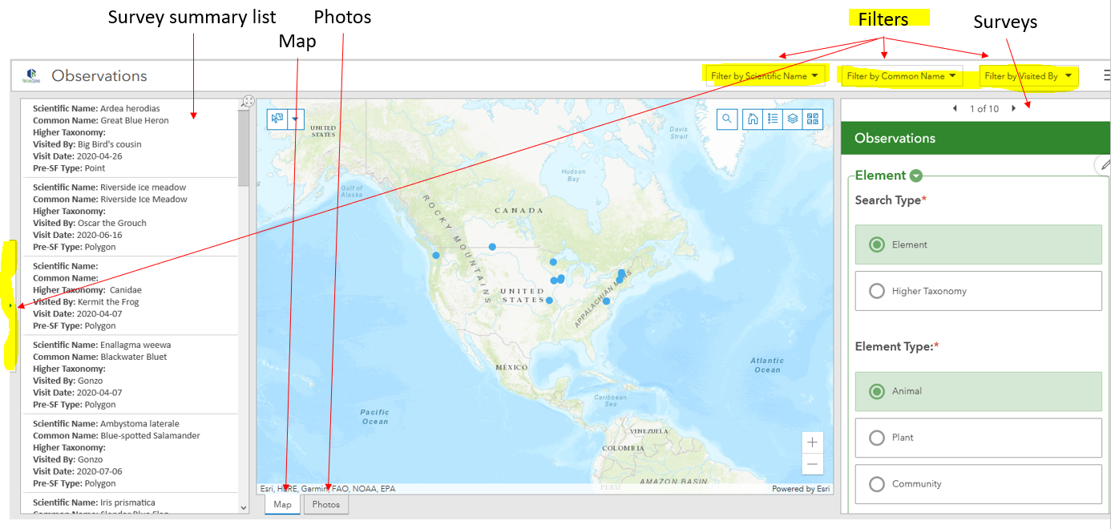
Select a record within the Survey summary list to view the Survey result, zoom to the record within the Map and display any Photos associated with the survey record.
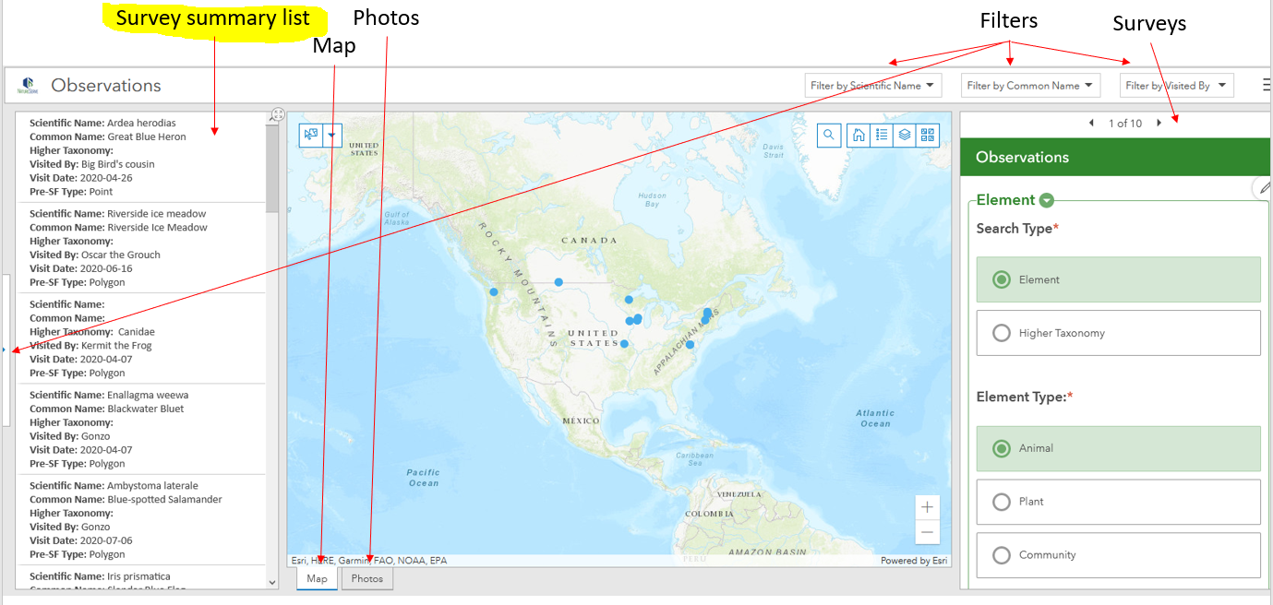
Use the various Map tools to:
- Find address or place
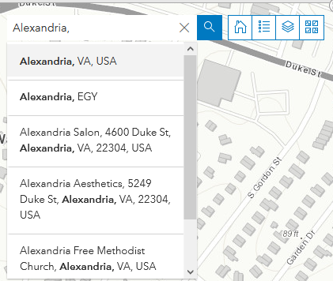
- Return to the original extent of the Map 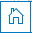
- View the legend 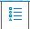
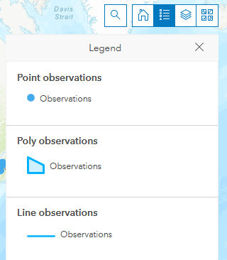
- Turn on /off layer visibility
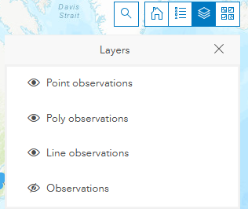
- Change the basemap
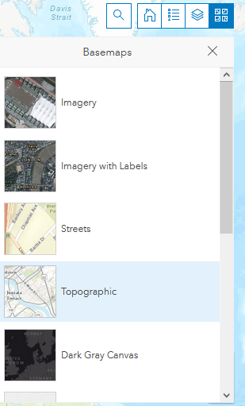
- Select records 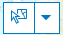 to zoom to the record’s location in the Map and filter the data within the Survey summary list to the selected record(s).
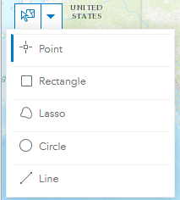
- Edit the survey 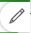 and then click Submit 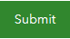 at the bottom of the survey.
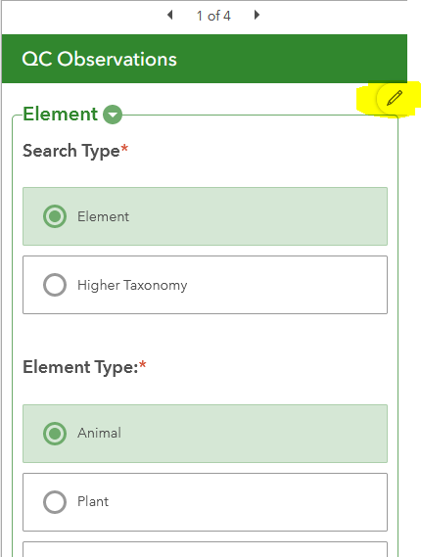
Within the QC dashboard, from the Batch edit tab, click the Batch Attribute Editor 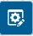 icon and the preferred selection tool. Select the records to edit and enter the desired values. Click Save to update the values for the selected features.
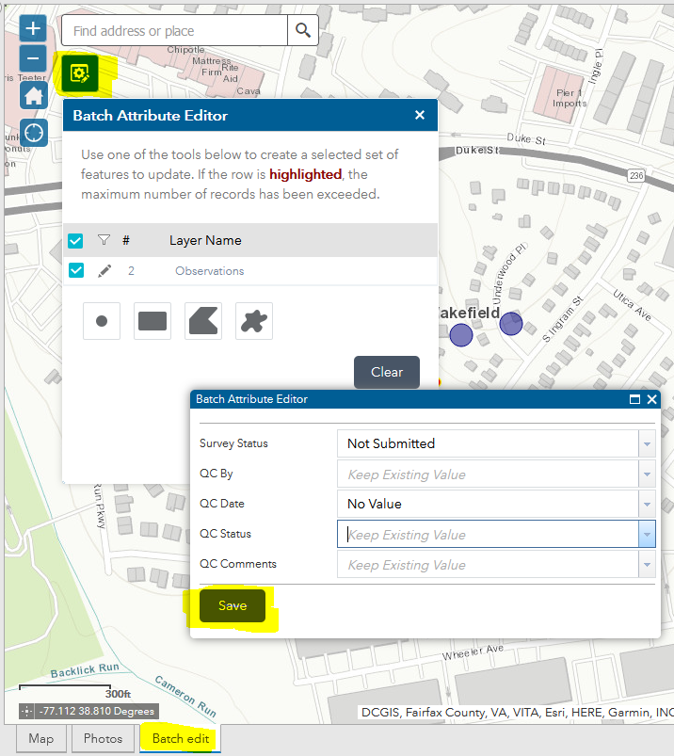

Viewing, Downloading & Using data collected via Survey (OPTIONAL)
The following is all optional, should you wish to do so.

View & Download data in ArcGIS Survey123
NOTE: If using the Observations for Non-Biotics.atbx (in ArcGIS Pro), it is not necessary to download the data from ArcGIS Survey123 as the tool (Create GDB and Files) will do so for you, if the credentials of an ArcGIS Online user with the necessary permissions to download the data are provided to the toolbox.
- Log into the Survey123 website which is also accessible via the Online dropdown menu in Survey123 Connect.
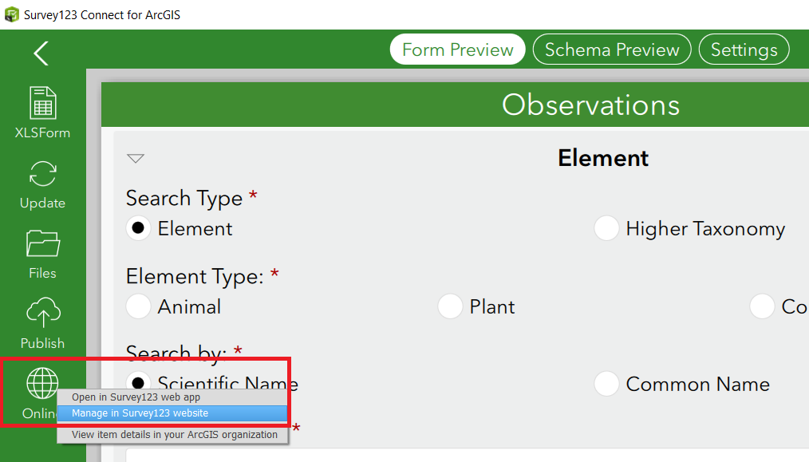
- The Observations survey will be displayed with the number of responses collected.
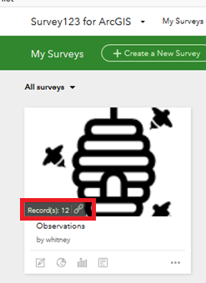
- Click the 4th icon to view the Data collected. Alternatively, if you have already entered the survey, select the Data menu.
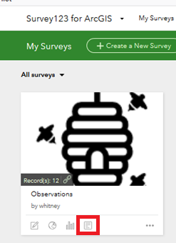
- From the Export dropdown, select File Geodatabase (NOTE: to include all related records for the Bulk Create).
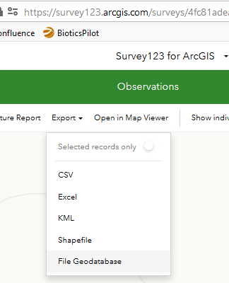

If you get the following error when trying to export to File Geodatabase, see the Troubleshooting Guide.
- To avoid duplicating data in Biotics of subsequent data downloads, filter data according to EditDate is after (the date you last downloaded data, so as not to duplicate data in Biotics) and EditDate is before prior to exporting the data.
NOTE: To avoid missing data collected later the same day, we recommend setting the before date to yesterday, rather than today’s date. Then start with today’s date as the next after date. To remember this date, I suggest (later in the instructions) appending the after date to the BulkCreate.gdb.zip file.
NOTE: EditDate and CreationDate are equal unless the record has been edited following creation, so filtering by EditDate will get all records created or edited as of the chosen date.
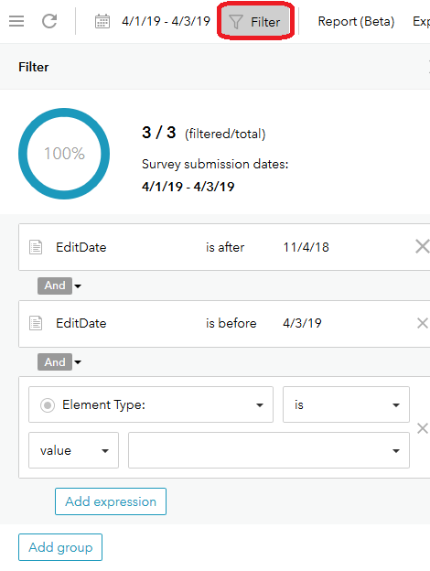

Publish the Observations survey results as a web map (OPTIONAL)*
A web map of the survey results is cloned by NatureServe, so this step is not necessary unless the data was not cloned for your organization, or should you just want another version of the web map.
- Still within the Data section of the, select Open in Map Viewer.
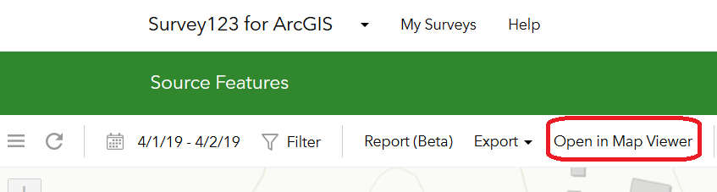
- Configure the web map as desired, then Save.
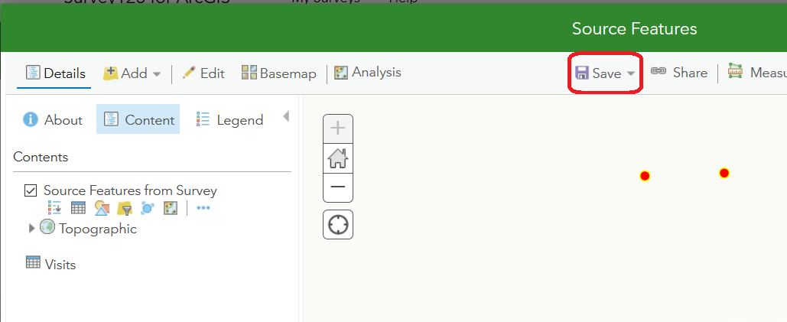
- Share the Map, as appropriate.
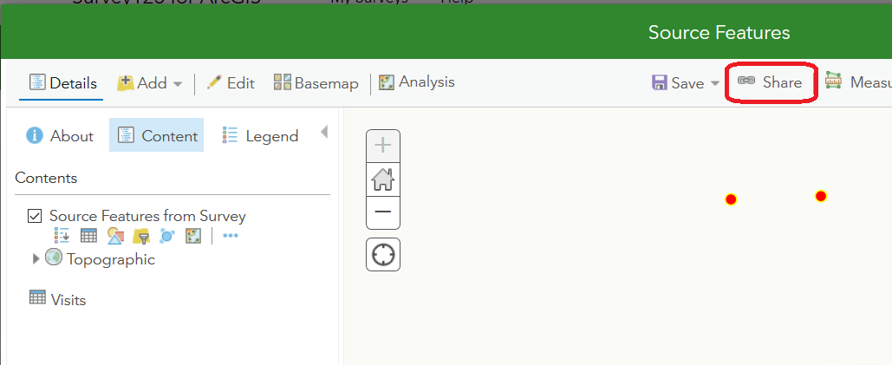

Save a (single) photo or audio attachment from an Observation record (OPTIONAL)
Script 3 within the Observations.tbx will download all photo and audio attachments within the geodatabase downloaded from Survey123, but should you just want to download a single photo/audio file, see the Save an attachment instructions within the ArcGISPro article titled: Add or remove file attachments.

Install and Run the Observations for Non-Biotics toolbox
Download the Observations toolbox for Non-Biotics use which automates downloading the survey data and attachments (photos, audio recordings, files) and creates a file to auto-generate specimen labels.

Troubleshooting Guide
If you run into errors with Survey123, check out the Survey123 Troubleshooting Guide. If the problems are while configuring the survey spreadsheet and publishing it is useful to log your errors and then review the log file.
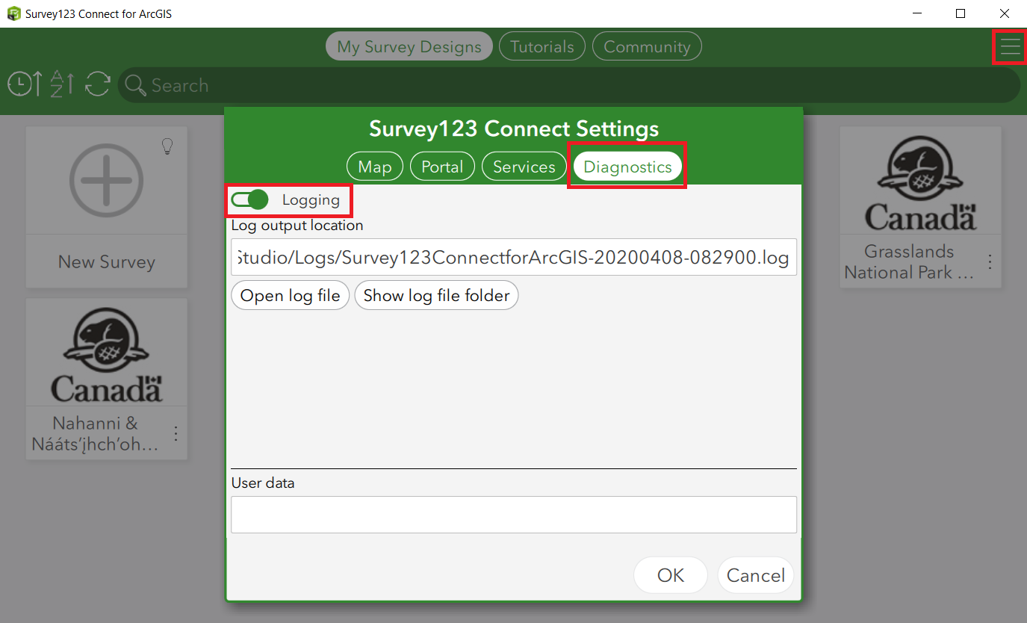
If you get the following error when trying to export to File Geodatabase
- In arcgis.com, navigate to the Survey-Observations folder and select the Observations Feature Layer (hosted).
- Within the details of the Observations feature layer, choose Export Data, Export to FGDB.
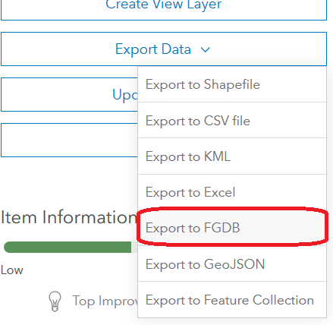
- Name the export and choose to Save in folder: Survey-Observations.
NOTE: If, despite the Title you give the file, it refuses to export, do so with the python script as explained in this solution.
- Go to the Content tab and select the Survey-Observations Folder. The saved File Geodatabase should be listed.
- Select the saved File Geodatabase and in the details page, Download the file.

