Create spatial View containing only Observations with QC Status = ‘Passed’
You may wish to only expose certain Observations, such as those which have already passed QC. Following are instructions for doing so, using this specific example, but can be applied to any tabular or spatial criteria.
- In ArcGIS Online, navigate to the Observations Feature Layer (hosted) and choose Create View Layer.
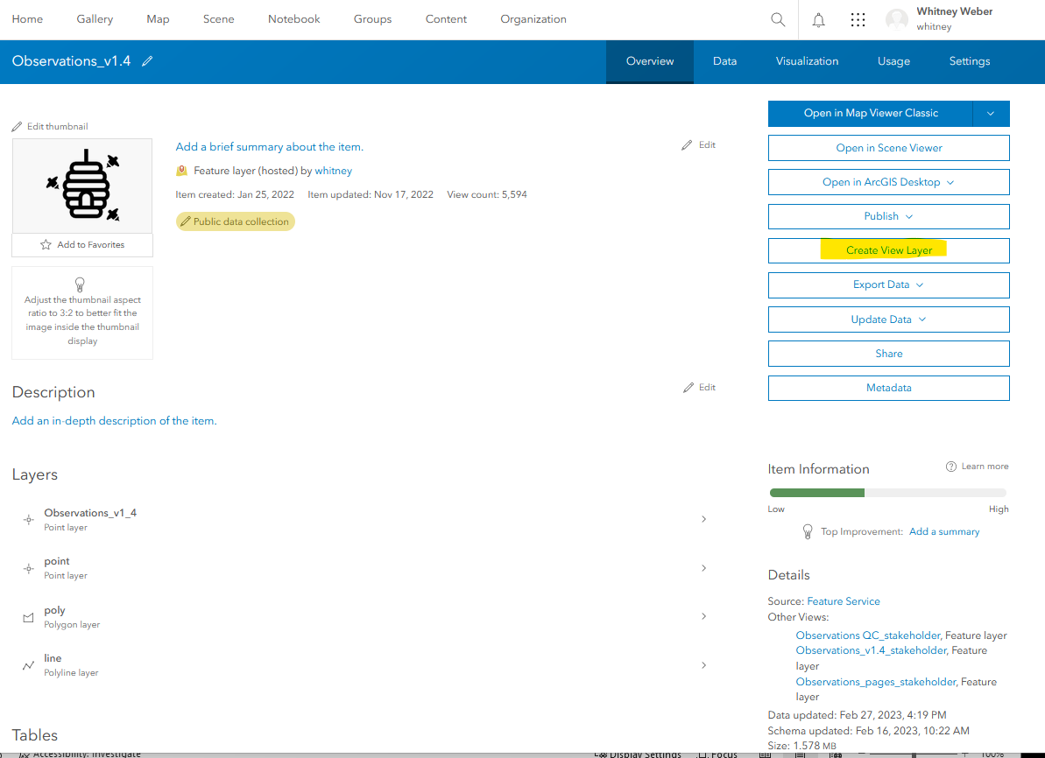
- Within Create View Layer, step 1. Choose layers, click Next (all Layers are selected by default and should be).
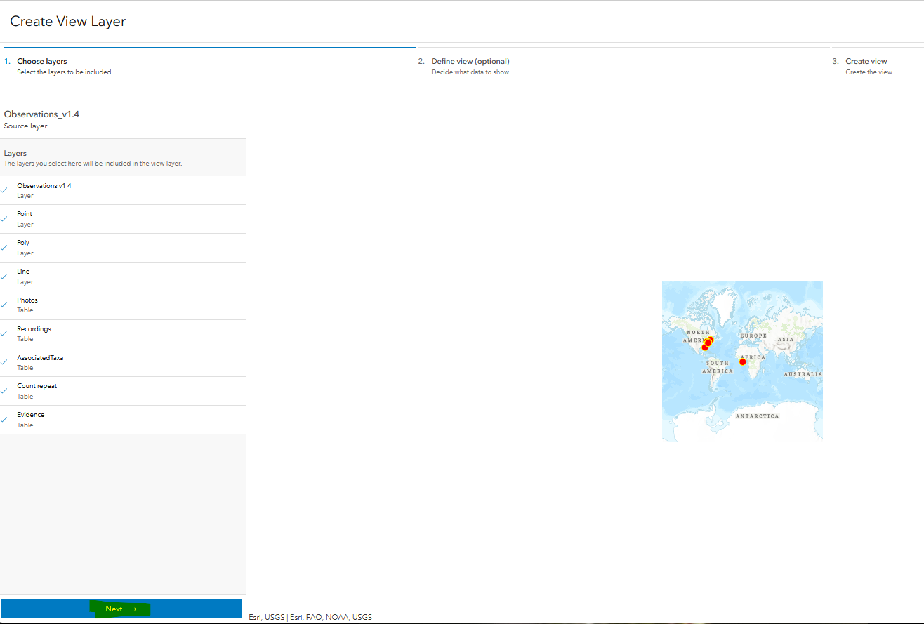
- In step 2. Define view (optional), select the Observations layer
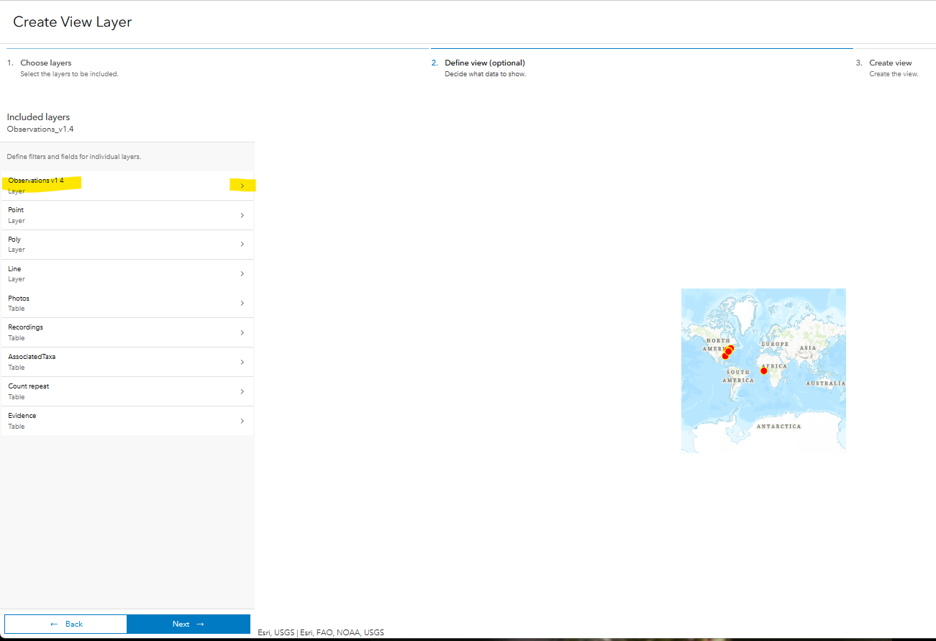
- Within the Layer definitions for the Observations layer, Add filter.
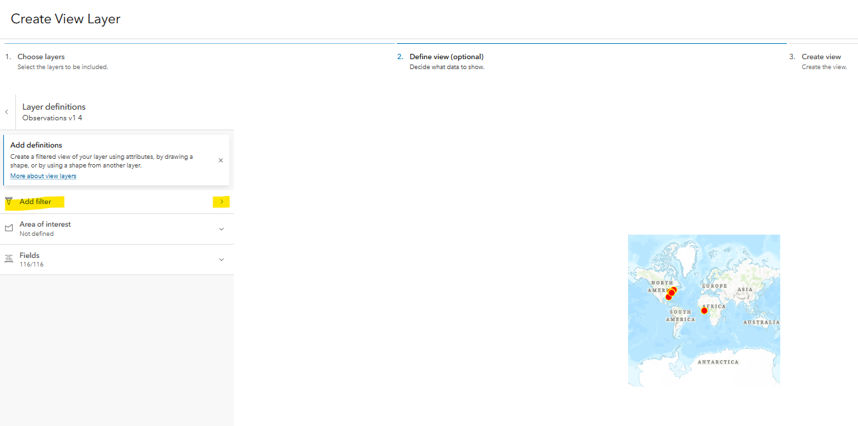
- Within the Filter for the Observations layer, click Add expression.
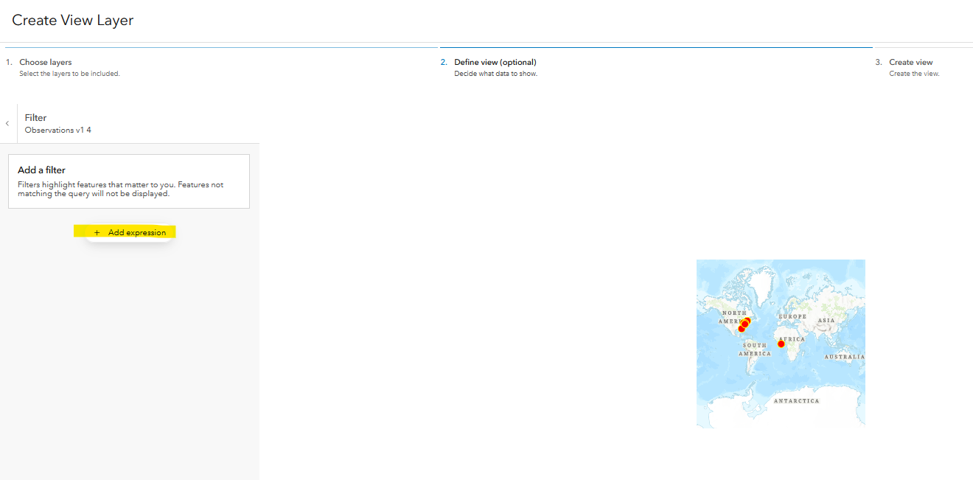
- Define the expression, as desired (i.e. QC Status is Passed) and click the arrow next to Filter to return to the Layer definitions.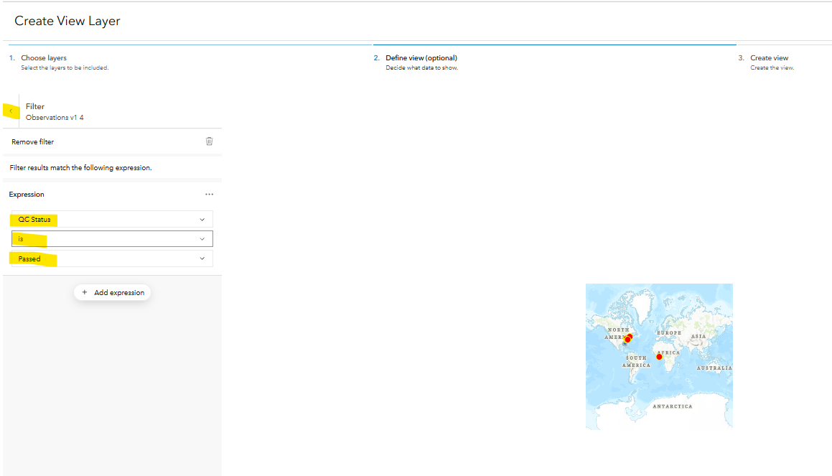
- Click the arrow next to Layer definitions to return to the Included layers.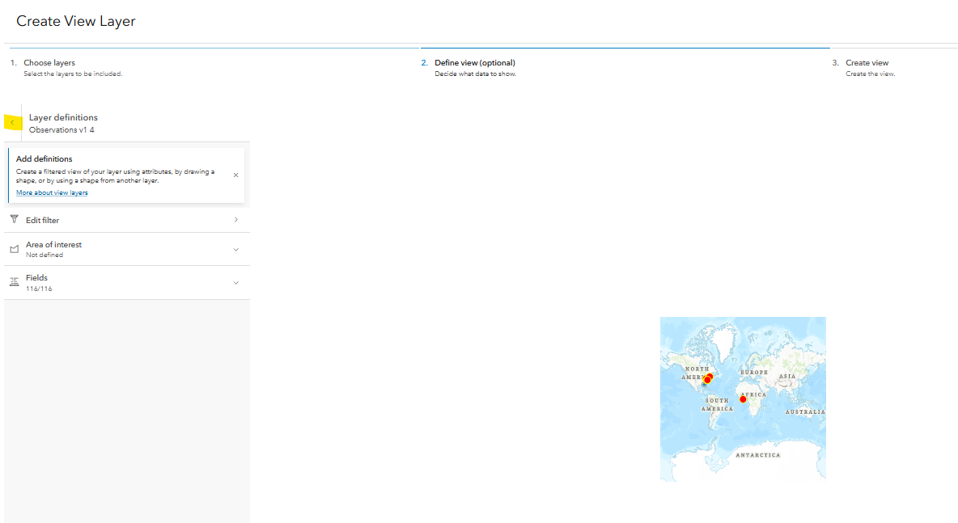
- Within Included layers, select Next at the bottom of the page.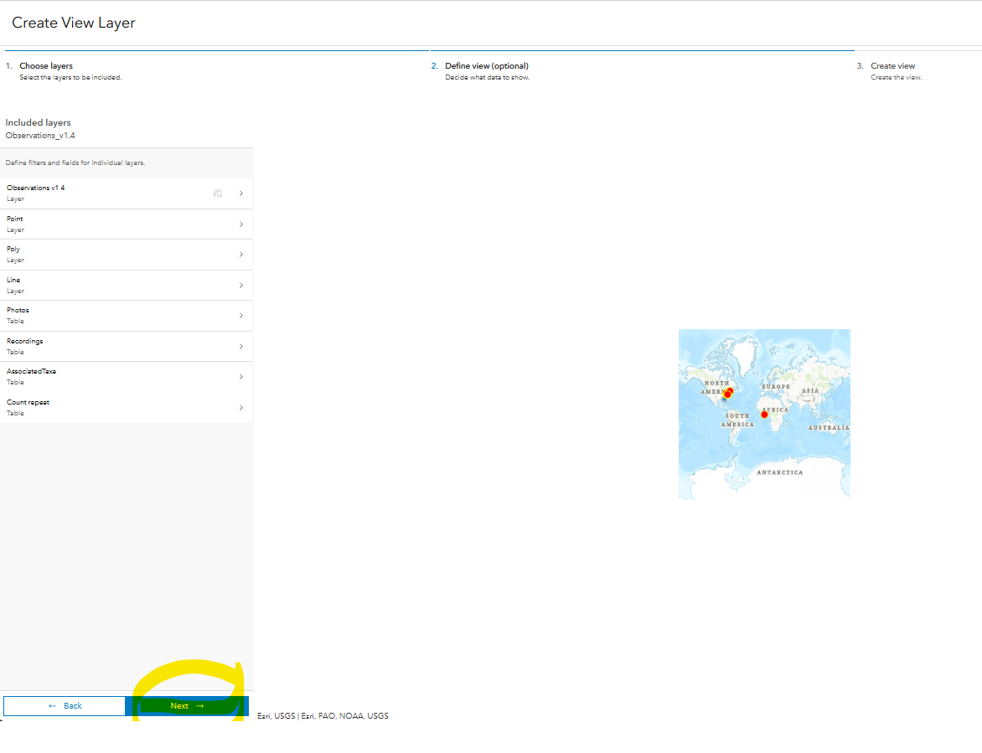
- Provide an appropriate title and Summary and click Create.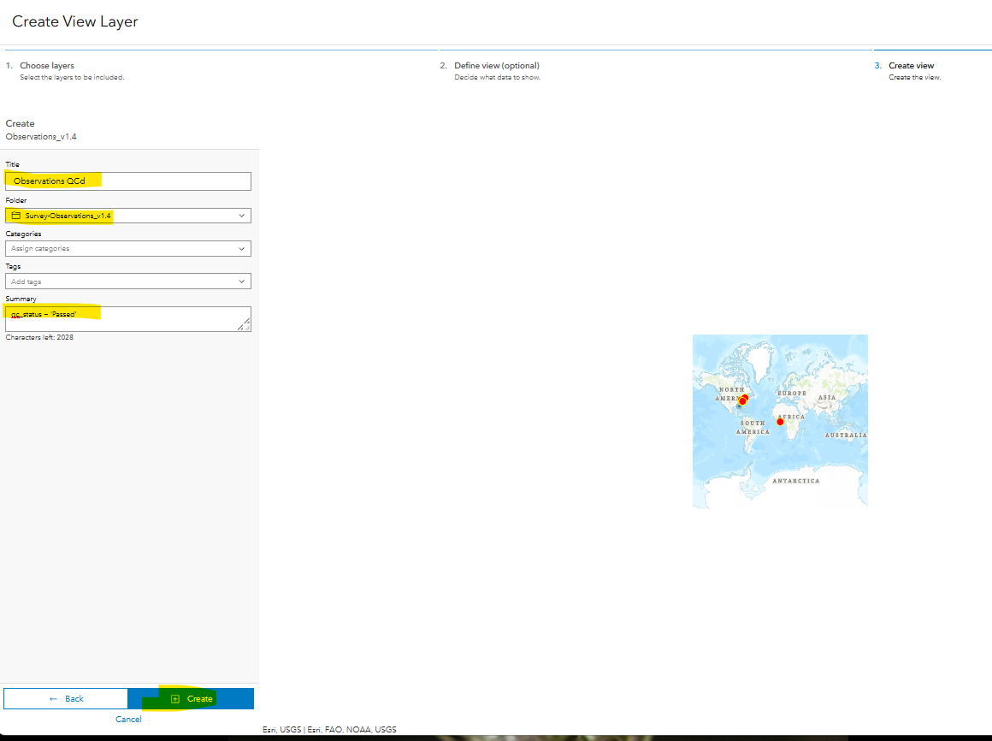
- The view is created and can be shared by clicking the Copy Link icon next to the URL at the bottom of the page.
